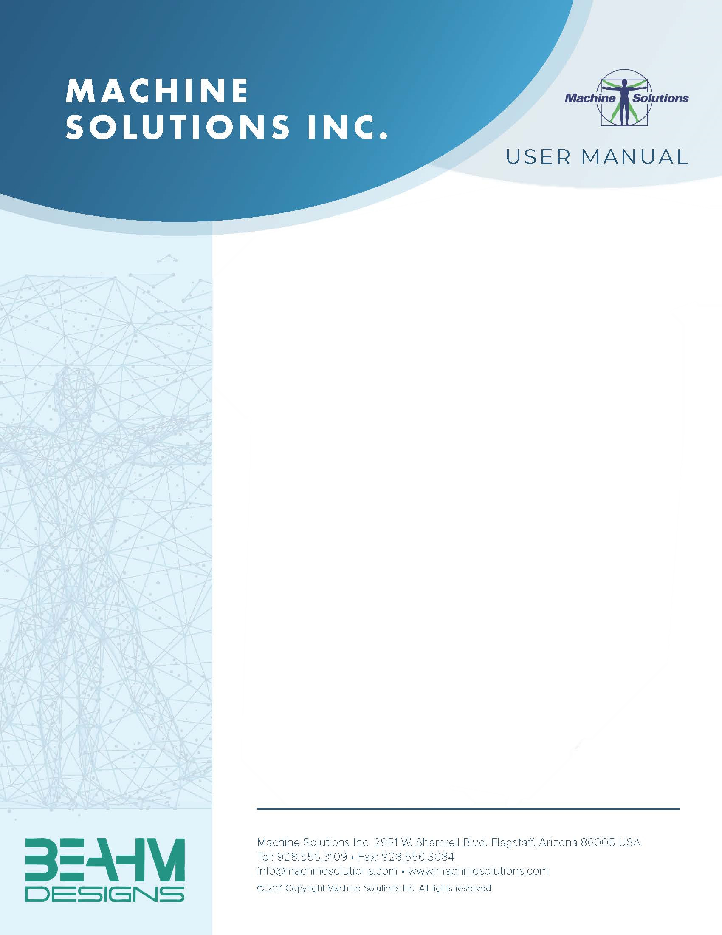

**BEAHM DESIGNS FLARE SYSTEM**

MODEL 610-TF

Machine Solutions Inc. 2951 W. Shamrell Blvd. Flagstaff, Arizona 86005 USA

Tel: 928-556-3109 Fax: 928-556-3084

[Service@machinesolutions.com](mailto:Service@machinesolutions.com) www.machinesolutions.com

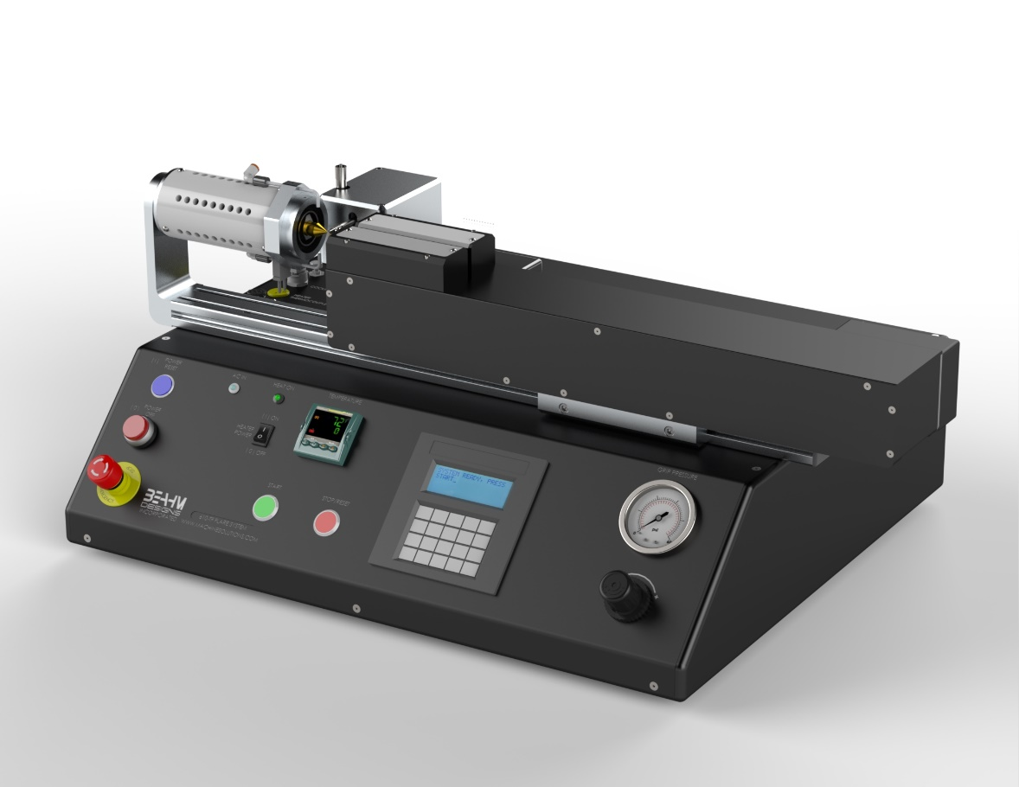

The Machine Solutions Inc. products shown and described in this catalog may be covered by one or more of the following US Patents: #6,629,350, #6,968,607, #6,925,847, #6,988,881, #6,931,899 and #7,069,794. Other US and International Patents Pending.

Machine Solutions, MSI, and 610-TF are trademarks or service marks of Machine Solutions Inc.

Copyright (©) Machine Solutions Inc. All Rights Reserved.

Product images are representative of standard equipment offerings and may differ from delivered equipment.

Table Of Contents

Welcome 4

Machine Description 4

Safety 5

User Alerts 5

Contents 6

Installation 6

Set Up and Configuration 7

System Controls and Features 9

Parameter Settings 11

Run Process 12

Maintenance 13

Diagnostics And Troubleshooting 15

Specifications 16

Critical Parts 17

Customer Support And Satisfaction 18

Warranty And Limitations 19

Welcome

Machine Solutions, Inc. (MSI) would like to take this opportunity to thank you for purchasing your new 610-TF Flare System. At MSI, we are dedicated to bringing innovative process development solutions to both medical device and nonmedical organizations. MSI looks forward to helping your organization provide life-improving devices to your customers, today and tomorrow.

Machine Description

The Beahm Designs Inc. Model 610-TF is a system for the purpose of thermo-forming the ends of thermoplastic tubings and materials by advancing the material over a heated tooling. Once the material is loaded on the system all process parameters are controlled by the system.

Safety

* Place the system on a level, sturdy surface at an ergonomically viable height for the user.
* Use of eye protection when working with compressed gases and heated materials is advised.
* The maximum observed Sound Pressure Level is below 70 dBA.
* Hot dies will become hot during operation and, depending on temperature set-point, can cause severe skin burns if contact occurs.

**Caution: high voltage. Remove power and use safety precautions when servicing.**

**Caution: hot surface. Contact may cause burn. Allow to cool before servicing.**

**Caution: pinch point. Keep hands and body parts clear while in operation.**

User Alerts

Do not use or otherwise operate the machine in any manner other than that in which it is explicitly intended. Examples: Do not attempt to sit on or climb on the equipment, do not place heavy objects or containers of liquid on the machine, do not to insert any foreign objects into the machine and do not attempt to bypass any guards.

**Note: The equipment is not for use with materials that can decompose or ignite below the maximum operating temperature of the machine. Hazards are materials that outgas hazardous substances and or ignite. (260°C/500°F).**

**Note: This equipment is not for use in an ATEX environment.**

Contents

Included with the system are the following contents:

* Benchtop Flare System
* Power cord

Installation

1. Place the system on a level, sturdy surface.
2. Connect the power cord to the main control unit.
3. Connect the air supply hose assembly to the system and then to a clean, dry and filtered compressed air source.

Set Up and Configuration

Proper sizing of the flare dies and alignment of the tooling are crucial to optimizing process results and repeatability. The following guidelines are the recommended methods. However, all applications vary and several iterations of tooling process development may be required and may not follow all of the recommended guidelines.

***Hard Stop***

The hard stop is essential to prevent over or under flaring of the material and works in conjunction with the “Advance Distance” parameter accessed via the system parameter keypad. The position of the hard stop varies greatly with each application and experimentation will be required to optimize the position. The following are general guidelines for set-up.

1. Loosen the mounting fasteners at the rear of the hard stop assembly mount.
2. Position the hard stop as close as possible to the flare geometry.
3. Tighten the mounting fasteners.
4. Measure the distance from the face opposite of the flare tool to the start of the tool flare geometry.
5. Enter this distance as the “Advance Distance.”

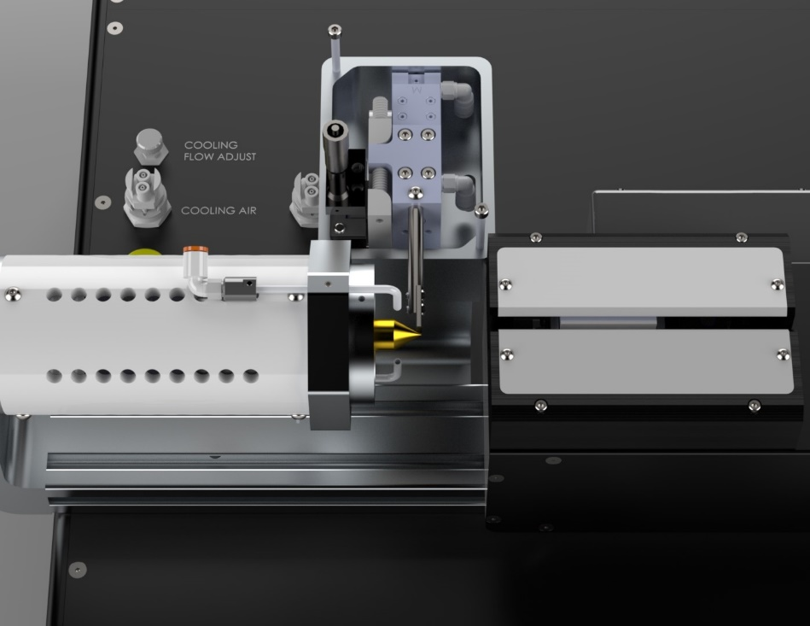

**HARD STOP**

**ADJUSTMENT**

**MOUNTING FASTENERS**

***Thruster Position***

Thruster position should be as close as possible to the flare tool to minimize flex or compression of the material during the flare process.

1. Loosen the two fasteners at the front of the thruster assembly.
2. Position the thruster assembly as required.
3. Tighten the two fasteners.

***Standard Grips***

This is the most forgiving of the tooling.

1. Adjust the pressure such that the tubing does not slip during the process but also does not “grip” the core pin/mandrel within the tube.

***Profiled Grips***

Profiled grips are typically contoured to the material O.D. and combined with the high force grip actuator. The combination is used when the material is of a higher than usual durometer or the flare geometry is challenging, or both.

***System Options***

Many optional accessories are available to enhance the functionality of the system and improve process yield. Contact Beahm Designs’ sales department or visit our web site [www.machinesolutions.com](http://www.machinesolutions.com/) for more information on available accessories and to request a quote. Examples of available accessories are:

-Vision systems with or without on-screen crosshair line generators.

-Laser line generators.

-Extended product support trays/guides

-Product grip nests/alignment tooling

System Controls and Features

Located on the front panel are the following controls and/or displays and their function.

11

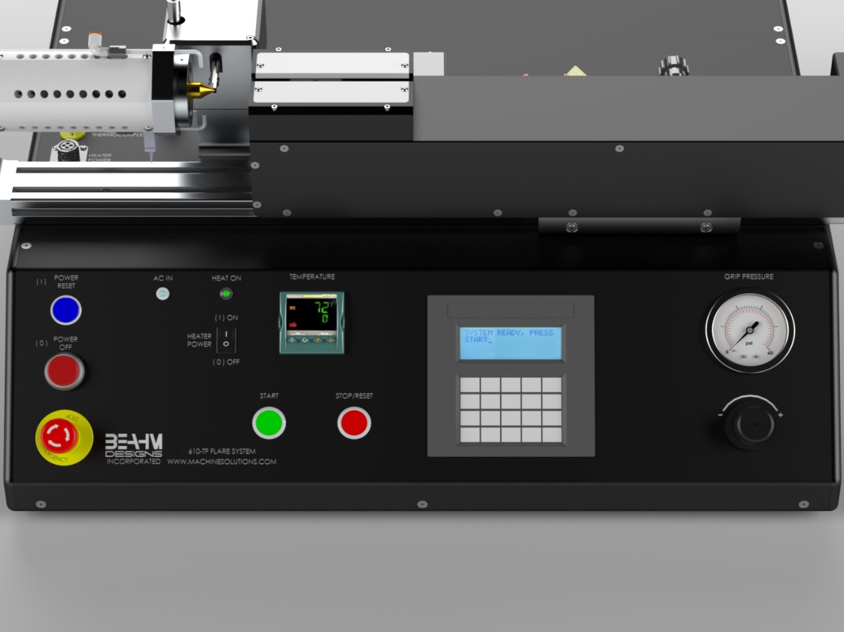

1

3

4

6

7

8

9

10

2

5

**Figure 1. 610-TF Flare System Front Panel**

**Table 1. 610-TF Front Panel Controls and Functions**

|  |  |
| --- | --- |
| **Item** | **Function** |
| 1 | Controls the temperature of the die head. |
| 2 | Indicates when the system power is on by illuminating and off when not illuminated. |
| 3 | Reset the machine, after E-stop or power off is pressed. |
| 4 | Cut all the Power to the machine. |
| 5 | Initiates process sequence. |
| 6 | Cuts all the power and air to the machine.  Reset the E-stop by rotating the switch clockwise until it pops out again. |
| 7 | Interrupts the process sequence and resets the system timer. |
| 8 | Used to enter flare parameters other than temperature. |
| 9 | Loosen to adjust thruster position. Ree-tighten. |
| 10 | Displays the pressure applied to the product grips. |
| 11 | Regulates the pressure of the product grips. |

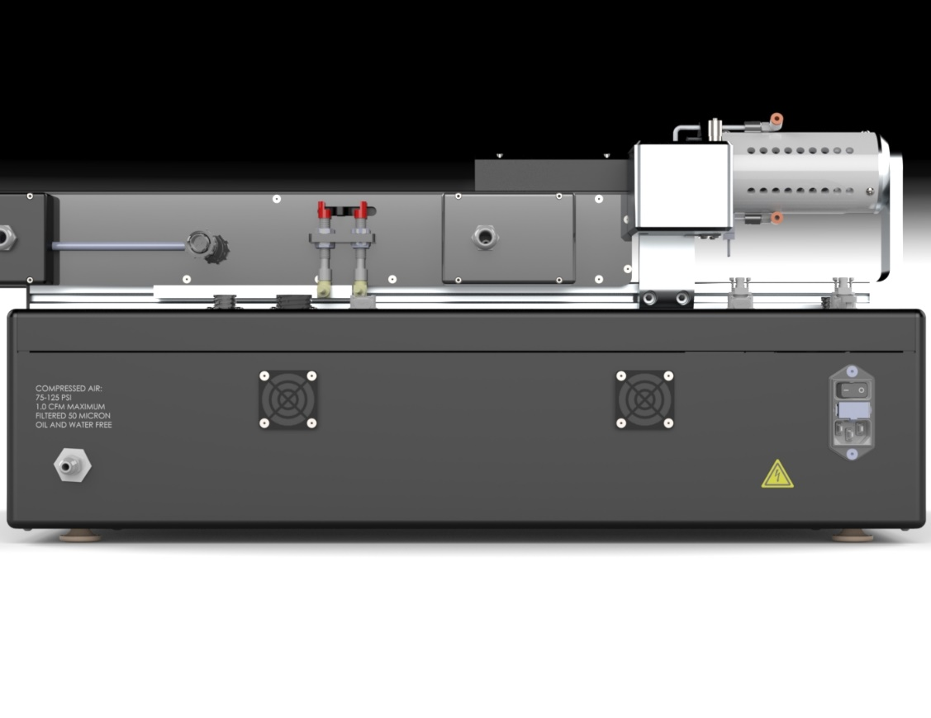

12

13

14

**Figure 2. 610-TF Flare System Back Panel**

**Table 2. Back Panel Controls and Functions**

|  |  |
| --- | --- |
| **Item** | **Function** |
| 12 | Supplies air to machine |
| 13 | Turns system power and air on and off |
| 14 | Connects to power cord |

Parameter Settings

***Temperature***

This is the temperature of the flare tool and typically is not at a set point that melts the material but softens it enough to thermoform it.

* Depress and hold the up or down arrow key of the temperature controller to scroll to the desired temperature. After two seconds the new value will be accepted, and the temperature will ramp to the new set point.

***Flare Distance***

This is the distance required to advance the material over the flare tool to form the required geometry.

* On power up or after depressing the STOP/RESET switch select YES on the HMI keypad and this will be the second parameter displayed.
* Key the value and depress ENTER on the keypad.

***Flare Speed***

This is the speed that the material is advanced over the flare tool to form the required geometry.

* On power up or after depressing the STOP/RESET switch select YES on the HMI keypad and this will be the third parameter displayed.
* Key the value and depress ENTER on the keypad.

***Dwell Duration***

This is the duration of time that the material remains over the flare tube in order to allow the material to remain formed.

* On power up or after depressing the STOP/RESET switch select YES on the HMI keypad and this will be the fourth parameter displayed.
* Key the value and depress ENTER on the keypad.

***Cool Duration***

This is the duration of time that the material is cooled in order to set the flared geometry prior to withdrawal from the tool.

* On power up or after depressing the STOP/RESET switch select YES on the HMI keypad and this will be the second parameter displayed.
* Key the value and depress ENTER on the keypad.

***Adjusting Grip Head Pressure***

* Rotate the regulator knob clockwise or counterclockwise until the pressure gauge displays the desired value.

Run Process

1. Slide the tubing over the flare pin guide mandrel and lightly against the hard stop.
2. Depress the start switch.
3. Upon completion of the process cycle, remove the material from the flare tool.

***Abort Process Sequence***

This process may be aborted at any time during operation.

1. Depress the stop/reset switch.
2. The system will home and the product will be released.
3. Remove product.

Maintenance

**Note: Ensure the machine is unplugged for any servicing or maintenance work.**

**Note: Perform these steps ONLY when the machine is at room temperature.**

Caution: pinch point/crush hazard. Keep fingers, hands, and clothing clear of moving parts.

**Caution: hot surface. Contact may cause burn. Allow to cool before servicing.**

***Cleaning***

1. Use 99% isopropyl alcohol to wipe down the outside of the machine. Do not attempt to clean the inside of the machine. Machine should not be washed down.
2. Cleaning should be with a soft dry cloth only.

***Exchanging Flare Tool***

**Note: Perform these steps ONLY when the flare tool is at room temperature.**

1. Unthread the tool from the heater assembly.
2. Install the replacement tool onto the 10-32 threaded post ensuring the rear of the tool is flush against the heater assembly.

***Exchanging Grip Heads***

1. Remove the two fasteners from each grip head.
2. Replace the grip heads with alternates.
3. Re-install all fasteners.

***Aligning Tooling***

**Note: Alignment should be performed on a prepared product subassembly.**

**Alignment MUST be performed with system power off and heads at ambient temperature.**

**Alignment must be performed on a flat and reasonably level surface.**

1. Prepare a material assembly.
2. Remove the rear, forward pneumatic bulkhead cover.
3. Position the material assembly within the grips but not over the flare tool and manually close the grips.
4. Adjust the Y-axis and Z-axis of the grip assembly until the material is aligned with the flare tool.
5. Run samples to verify alignment.
6. Replace the real bulkhead cover.

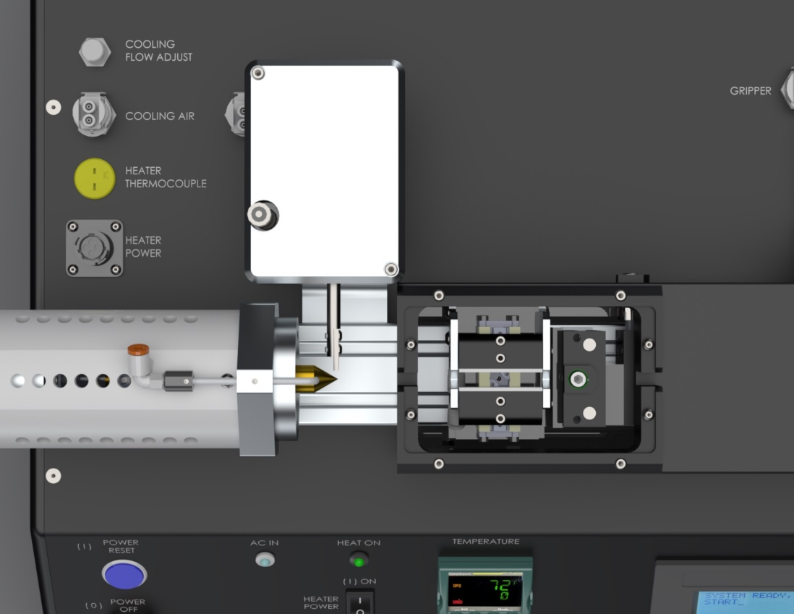

**Y-AXIS ADJUST**

**Z-AXIS ADJUST**

Diagnostics And Troubleshooting

**Table 3. Diagnostics and Troubleshooting**

|  |  |  |
| --- | --- | --- |
| **Issue** | **Possible Causes** | **Solution** |
| Temperature not stable | * Thermocouple loose | * Auto‐tune (MSI recommends process auto-tune @ process temperature.) * Re‐install thermocouple |
| “Open” flashing on temperature controller | * Break in thermocouple wire/ thermocouple failure | * Verify all connections from controller to remote TC jack * Replace thermocouple |
| No heat at Die | * Defective heating element * Defective power control | * Replace heating element |
| .Err code in display | * Temperature controller * .Software failure | * Replace/Reprogram temperature controller |
| System will not power on | * IEC power cord not fully   Connected   * Fuse needs to be replaced | * Verify installation * Replace fuse |

Specifications

**Table 4. System Specifications**

|  |  |  |  |
| --- | --- | --- | --- |
| **Description** | **Range** | **Resolution** | **Accuracy \*** |
| Temperature Controller | Ambient-750°F | 1.0 deg. | +/-.75% F.S. |
| Temperature accuracy at flaring tool | Approx. 3% heat dissipation can be expected at process temperature. | | |
| Hard Stop Advance | 0.1-5 mm | 0.1 mm | +/- 0.1 mm |
| Flare Distance | 0.1-25 mm | 0.1 mm | +/-0.2 mm |
| Flare Speed | 0.1-15 mm/sec | 0.1 mm/sec | +/-0.1 mm/sec |
| Heat Duration | 1-60 seconds | 1.0 sec | +/- .1 sec |
| Cool Duration | 1-60 seconds | 1.0 sec | +/- .1 sec. |
| Grip Pressure | 0-60 psi | 1.0 psi | +/-1.6% F.S. |
| **Optional**  100 psi Gauge Upgrade | 0-100 psi | 5.0 psi | +/-1.6% F.S. |

**\*Note: Accuracies are based on component manufacturers specifications.**

***Facility Requirements***

1. Voltage: 120-240 VAC, 50/60 hz

2. Wattage: 10 amps (500 watts)

3. Compressed Air: 60-125 psi, clean dry compressed air

Critical Parts

For replacement or spare parts, please contact us at [service@machinesolutions.com](mailto:service@machinesolutions.com), or call

928-556-3109.

**Table 5. Critical Parts List**

|  |  |  |
| --- | --- | --- |
| **Part Number** | **Description** | **Quantity** |
| 1330455-003 | 4-WAY VALVE 24 VDC | 3 |
| 1348043-001 | Pressure gauge 0-60 psi | 1 |
| 1343250-001 | 2-way pneumatic valve 24VDC | 1 |
| 1131433-001 | Solid state relay | 1 |
| 1148103-001 | Drive/Controller | 1 |
| 119106-001 | Relay, PLC, 24VDC, Din Rail, 1PDT | 4 |
| 1143287-001 | Relay, 24VDC, Integrated | 1 |
| 1150440-001 | Temperature Controller | 1 |
| 1153590-001 | Heater Cartridge, 120VAC, 1.5in, 100W | 1 |
| 1143133-001 | Thermocouple, K Type, 0.125 OD | 1 |
| 1145600-001 | Contactor | 1 |
| 1148096-001 | HMI | 1 |

Customer Support And Satisfaction

Machine Solutions Inc. is proud of the advanced engineering and quality construction of each piece of equipment that we build. It is our goal to provide equipment that exceeds the expectations of the customer. By implementing the highest standards and applying our experience to provide a quality product, we maintain an ongoing, positive working relationship with all our customers.

Machine Solutions Inc. welcomes your comments and inquiries about our products and services.

Machine Solutions Inc.

2951 West Shamrell Blvd., Suite 107

Flagstaff, AZ 86005

Phone: 928-556-3109

Fax: 928-556-3084

E-Mail: Service@MachineSolutions.com

Warranty And Limitations

***General Warranty***

Machine Solutions Inc. (MSI) warrants its products to be free from defects in material and workmanship in normal everyday use and service for a period of one year from the date of shipment from the factory in Flagstaff, Arizona. MSIs obligation under this warranty shall be limited to the repairing or replacing of the product or parts thereof which upon MSIs inspection reveals them to be defective. MSI reserves the right and option to refund the purchase price in lieu of repair or replacement upon evaluation of the returned original part. Modifications, misuse, attempted repairs by others, improper calibration or operation shall render this guarantee null and void. MSI MAKES NO OTHER WARRANTY REGARDING THIS PRODUCT, INCLUDING ANY EXPRESS OR IMPLIED WARRANTY. SPECIFICALLY, THERE IS NO WARRANTY OF MERCHANTABILITY OF THIS PRODUCT OR OF THE FITNESS OF THE PRODUCT FOR ANY PURPOSES. THE SUITABILITY OF THIS PRODUCT FOR ANY PURPOSE PARTICULAR TO THE CUSTOMER IS FOR THE CUSTOMER, IN ITS SOLE JUDGEMENT, TO DETERMINE. MACHINE SOLUTIONS, INC. ASSUMES NO RESPONSIBILITY FOR THE SELECTION OR USE OF THIS PRODUCT BY CUSTOMER. This product has not been tested or approved by the U.S. Food and Drug Administration or any other agency of the U.S. government. This product is not a consumer product as that term is defined in the Magnuson-Moss Warranty – Federal Trade Commission Improvement Act, 15 U.S.C. § 2301 et seq.

***Software License***

By using this equipment, and/or installing or using any of the software associated with the same, you indicate your acceptance of each of the terms of this license. Upon acceptance, this license will be a legally binding agreement between you and MSI. The terms of this license apply to you and to any subsequent user of the software. If you do not agree to all of the terms of this license (i) do not install or use the software and (ii) return the equipment and the software (collectively, equipment), including all components, documentation and any other materials provided with the equipment, to MSI. The software includes associated media, any printed materials, and any on-line or electronic documentation. Software provided by third parties may be subject to separate end-user license agreements from the manufacturers of such software. This license shall also apply to any updates, bug fixes, or newer versions of the software provided by MSI for use with this equipment.

You may: (1) Use the software only in connection with the operation of the equipment; (2) Transfer the software (including all component parts and printed materials) permanently to another person, but only if the person agrees to accept all of the terms of this license. If you transfer the software, you must at the same time transfer the equipment and all copies of the software (if applicable) to the same person or destroy any copies not transferred; and (3) Terminate this license by destroying the original and all copies of the software (if applicable) in whatever form.

You may not: (1) Loan, distribute, rent, lease, give, sublicense or otherwise transfer the software, in whole or in part, to any other person, except as permitted under the transfer paragraph above; (2) Copy or translate the User Guide included with the equipment; (3) Copy, alter, translate, decompile, disassemble or reverse engineer the software, including but not limited to, modifying the software to make it operate on non-compatible hardware; or (4) Remove, alter or cause not to be displayed, any copyright notices or startup message contained in the software programs or documentation

Title to the software, including the ownership of all copyrights, patents, trademarks, and all other intellectual property rights subsisting in the foregoing, and all adaptations to and modifications of the foregoing shall at all times remain with MSI and its third-party licensors, if any. MSI retains all rights not expressly licensed under this license. Except as otherwise expressly provided in this license, the copying, reproduction, distribution, or preparation of derivative works of the software, or any portion of the equipment, is strictly prohibited. Nothing in this license constitutes a waiver by MSI of its rights under United States copyright law.

***Protection of Intellectual Property***

The equipment and its incorporated technology (collectively referred to herein as the Technology), is protected under issued and pending patents. The Technology is the valuable and proprietary technology, including trade secret technology, belonging to MSI. Much of the Technology is nonpublic and confidential. As our customer, you agree to further assist MSI in the protection of our intellectual property as follows: You agree to keep the Technology you receive confidential at all times, and shall not, without the prior written consent of MSI, disclose the Technology, in whole or in part, to any person outside of your company. You further agree that you shall not reverse engineer, disassemble, decompile, or copy the Technology without the prior written consent of MSI.

In addition, you agree that the equipment will not be used to manufacture anything other than products in which you hold intellectual property rights free of infringement of others. You may not use the equipment to manufacture any product infringing on another’s patented rights. By accepting and using the equipment, you agree to defend and indemnify Machine Solutions, Inc., its officers, directors, employees, and agents, from and against any claims of infringement as a result of your use of the equipment.

***Regulatory Matters***

All equipment validations, product validation, final product QC testing and other testing required by the U.S Food and Drug Administration are the sole responsibility of the customer. Machine Solutions, Inc. shall have no responsibility or liability for the performance of any interventional product on which this equipment is used.