

**BEAHM DESIGNS VERTICAL LAMINATOR**

MODEL 810-A

Machine Solutions Inc. 2951 W. Shamrell Blvd. Flagstaff, Arizona 86005 USA

Tel: 928-556-3109 Fax: 928-556-3084

[Service@machinesolutions.com](mailto:Service@machinesolutions.com) www.machinesolutions.com

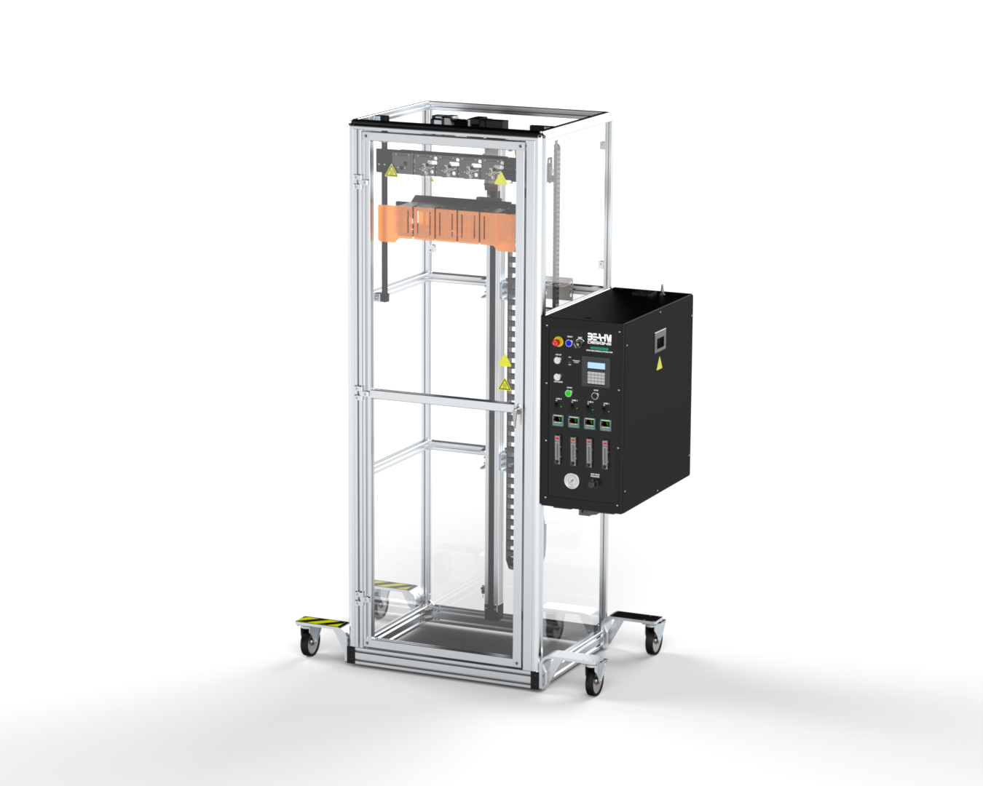

The Machine Solutions Inc. products shown and described in this catalog may be covered by one or more of the following US Patents: #6,629,350, #6,968,607, #6,925,847, #6,988,881, #6,931,899 and #7,069,794. Other US and International Patents Pending.

Machine Solutions, MSI and 810-A are trademarks or service marks of Machine Solutions Inc.

Copyright (©) Machine Solutions Inc. All Rights Reserved.

Product images are representative of standard equipment offerings and may differ from delivered equipment.

Table Of Contents

Welcome 5

Machine Description 5

User Alerts 6

Contents 7

Installation 7

*Emergency Stop Loop and Hardwired Devices* 7

Set Up and Configuration 8

System Controls And Features 9

Calibration 11

Keypad display 12

Recipe Settings and Descriptions 12

Alternate Units 13

Parameter Settings 14

Setting Temperature 14

Adjusting Grip Head Pressure 14

Nozzle/Lamination Profiles 15

Heater Air Flow 16

System Operation 17

Terms and Definitions 17

Maintenance 18

*Cleaning* 18

*Replacing Thermal Nozzles* 18

*Replacing Heater Elements* 21

*Exchanging Vee Guide/insert(s)* 22

*Replace Heater Power Controller* 23

*Aligning Tooling* 24

Diagnostics and troubleshooting 25

Specifications 26

Critical Parts 27

Customer Support And Satisfaction 28

Warranty And Limitations 29

List of Figures

**Figure 1. E-Stop Button** 7

**Figure 2. 810-A Vertical Laminator (Keypad) Front Panel** 10

**Figure 3. Keypad** 12

**Figure 4. Rocker Switch Toggled to “I” (EDIT)** 12

**Figure 5. Setting Temperature On Temperature Controller** 14

**Figure 6. Grip Head Pressure Regulator** 14

**Figure 7. Keypad - Enter Traverse Delay Prompt** 15

**Figure 8. Keypad - Enter Zone Length Prompt** 15

**Figure 9. Keypad - Enter Zone Speed Prompt** 16

**Figure 10. Heater Air Flow Control** 16

**Figure 11: Replacing Thermal Nozzles – Remove Heat Shield** 19

**Figure 12: Replacing Thermal Nozzles – Nozzle Set Screw** 19

**Figure 13. M360 switch on control box** 20

**Figure 14: Replace Heating Elements – Remove/Install Heater** 21

**Figure 15: Exchanging Vee Guide** 22

**Figure 16: Replace Heater Power Controller - Locate Controller** 23

**Figure 17: Aligning Tooling** 24

List of Tables

**Table 1. 810-A Vertical Laminator (Keypad) Control and Display Functions** 9

**Table 2. Alternate Recipe Units** 13

**Table 3. Terms, Definitions, and Descriptions** 17

**Table 4. Diagnostics and Troubleshooting** 25

**Table 5. System Specifications** 26

**Table 6. Critical Parts List** 27

Welcome

Machine Solutions, Inc. (MSI) would like to take this opportunity to thank you for purchasing your new 810-A Vertical Lamination machine. At MSI, we are dedicated to bringing innovative process development solutions to both medical device and nonmedical organizations. MSI looks forward to helping your organization provide life-improving devices to your customers, today and tomorrow.

Machine Description

The Beahm Designs Inc. Model 810-A Laminator is a system for the purpose of progressively recovering heat shrinkable materials onto catheter type shafts by means of traversing a thermal nozzle along the length of the materials at a controlled speed over a set length. The materials are suspended vertically, and the thermal nozzles traverse top to bottom to allow the heat shrink to expand or contract as required.

***Process Overview***

Parameters are established and programmed via the keypad. Materials are assembled and secured in the product grips. Upon initiation of the process cycle the thermal nozzles extend to the product and then begin traversing the length of the materials to the programmed length.

The Shrink Laminator is used to heat shrink material onto up to four catheter assemblies at a time. Variable speed and distance controls allow the shrinking to start at the top or the bottom of the assembly.

The heater array is mounted on the linear actuator; after the heater array has been moved to a convenient loading height, the operator installs the catheters in the grip mechanism. The hot air system is then brought to the correct temperature. When the process is started, the heater array is moved to a start position. The heater assembly is moved out to the catheters, then the heater array is moved down the length of the catheter through three speed zones. The heater array is retracted and returned to the starting position.

A rocker switch is used to control access to the recipe settings.

Safety

* Use of eye protection when working with compressed gases and heated materials is advised.
* The maximum observed Sound Pressure Level is below 70 dBA.

**Caution: heavy. Do not attempt to move the machine manually. Due to its weight, the machine should be moved with a forklift and placed on a reinforced surface. If a forklift is not available, then ensure adequate personnel and mechanical aids are used.**

**Caution: high voltage. Remove power and use safety precautions when servicing.**

**Caution: hot surface. Contact may cause burn. Allow to cool before servicing.**

**Caution: pinch point. Keep hands and body parts clear while in operation.**

User Alerts

Do not use or otherwise operate the machine in any manner other than that in which it is explicitly intended. Examples: Do not attempt to sit on or climb on the equipment, do not place heavy objects or containers of liquid on the machine, do not to insert any foreign objects into the machine and do not attempt to bypass any guards.

**Note: The equipment is not for use with materials that can decompose or ignite below the maximum operating temperature of the machine. Hazards are materials that outgas hazardous substances and or ignite. (400°C/750°F).**

**Note: This equipment is not for use in an ATEX environment.**

# Contents

Included with the system are the following contents:

* Machine Base
* IEC Power Cord
* Compressed Air Supply Hose Assembly

# Installation

1. Place the system on a level, sturdy surface at an ergonomically viable height for the user.
2. Lock casters. Casters should be locked at all times when not moving machine.
3. Connect the power cord to a 240 VAC 50/60 Hz. 1 Ph. 3-wire Outlet.
4. Connect the air supply hose assembly to the system and then to a clean, dry and filtered compressed air source.

## *Emergency Stop Loop and Hardwired Devices*

A single emergency stop twist-to release switch is connected to a safety relay in the electrical enclosure.

**Figure 1. E-Stop Button**

When the safety relay is reset, power is applied to the two main contactors. This energizes the linear actuator motor, and the heater power circuits. The blue lamp in the reset button is also illuminated. The keypad and the 24VDC inputs remain energized regardless of whether the power contactors are closed.

***Overtemperature Controllers***

There are four heater zones on the 810-A Laminator, and each zone has a similar electrical design. Every heating unit includes a mechanical relay that applies power to the semiconductor Solid State Relay (SSR). The state of the heater relay is controlled by the temperature controller output. Each lane has a separate OverTemp (O/T) thermocouple monitored by the over temperature relay. The O/T temperature is set by MSI and is within the control cabinet.

***Motion Drive***

The drive is run in a position mode using the keypad.

***Optional Light Tower***

Light tower option is not available on all 810-A models.

# Set Up and Configuration

Proper sizing of the **thermal nozzle** and alignment of the tooling are crucial to optimizing process results and repeatability. The following guidelines are the recommended methods. However, all applications vary, and several iterations of tooling process development may be required and may not follow all the recommended guidelines.

**Thermal Nozzle Diameter -** The nozzle diameter should be .187”-.25” larger than the material to be processed.

**Thermal Nozzle Width** - The width (length of the thermal nozzle should be as long as possible to

increase the lamination speed. The standard system will accommodate nozzle widths to 1.0”.

Customized configurations can be quoted on request.

**Grip/Positioning Nests -** The vertical position of the grip assembly should be positioned such that the

full lamination length can be accomplished without the catheter touching the floor and with a minimal load height position.

System Controls And Features

**Table 1. 810-A Vertical Laminator (Keypad) Control and Display Functions**

|  |  |
| --- | --- |
| **Item** | **Function** |
| 1 | Engages low voltage power and system air |
| 2 | Engages/disengages all system power and air |
| 3 | Enables access to lamination parameters via the keypad |
| 4 | Manually jog the heater array up or down |
| 5 | Initiates the lamination cycle |
| 6 | Sets and controls the heater temperature at the thermal nozzle |
| 7 | Sets the air flow rate to the thermal nozzle |
| 8 | Displays the grip pressure |
| 9 | Engages/Disengages AC inlet power |
| 10 | Rotated to switch to M360 nozzle |
| 11 | Traverse Parameter interface |
| 12 | Interrupts and resets the system |
| 13 | Toggles heater power on or off |
| 14 | Regulates the grip pressure |

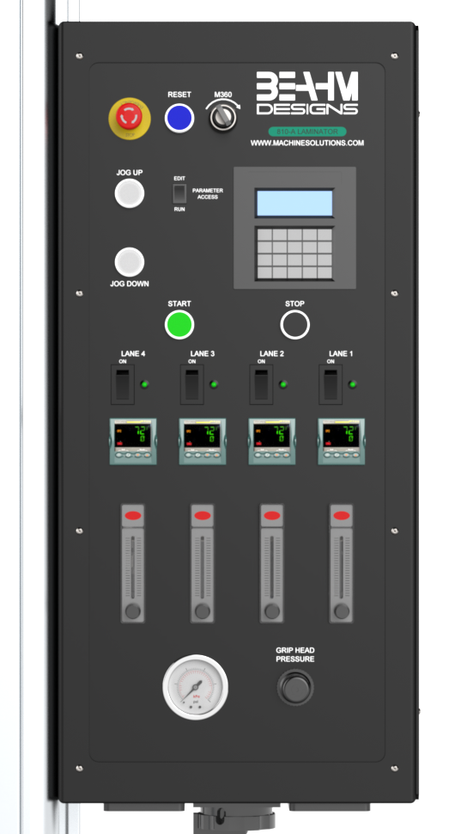

1

2

4

5

3

6

7

8

9

10

11

12

13

14

**Figure 2. 810-A Vertical Laminator (Keypad) Front Panel**

Calibration

**IMPORTANT NOTES:**

**Calibration must be performed by a certified service, preferably with the system in the location of use. Calibration procedures are the domain of these service providers.**

**Calibration refers to the process of verifying that each of the systems’ instruments that controls a process parameter is within manufacturer’s specification.**

**Calibration DOES NOT refer to the process of measuring the temperature at the center of the thermal nozzle and “matching” the value to the temperature controller set point.**

**The measured value at the thermal nozzle will rarely match the temperature controller set point and the delta will increase towards the center of the nozzle.**

**For temperature stability verification it is recommended that the air be measured .062”-.093” from the exit point of one of the flow ports. Stability should be +/-5.0 degrees over one hour or at a minimum over the duration of a typical process cycle (customer/product specific) from what is displayed on screen on temperatures from 0 - 500 degrees F. Stability should be +/-10.0 degrees over one hour or at a minimum over the duration of a typical process cycle (customer/product specific) from what is displayed on screen on temperatures from 500 – 750 degrees F.**

**Flow meters must be verified or calibrated since they cannot be adjusted if out of manufacturers specifications.**

* Calibrate the temperature controller annually.
* Calibrate the linear actuator speed and distance annually.
* Calibrate the pressure gauge annually.

# Keypad display

The keypad provides the primary source of operator interaction with the control system. The laminating system is controlled by the keypad, motion drive and relay logic.

**Figure 3. Keypad**

# Recipe Settings and Descriptions

When the rocker switch is toggled to “I” (EDIT), the recipe can be modified.

**Figure 4. Rocker Switch Toggled to “I” (EDIT)**

The recipe is a collection of setpoints that are directly copied to the machine controls.

## Alternate Units

Speed, distance, and temperature may be shown in alternate units. The recipe is stored in native units of millimeters and degrees Fahrenheit.

**Table 2. Alternate Recipe Units**

|  |  |  |  |
| --- | --- | --- | --- |
| **Recipe Settings** | **Units** | **Range** | **Description** |
| Zone #1 Length | mm | 1 to XXXX (*) | Zone 1 travel length |
| Zone #2 Length | mm | 0 to XXXX (*) | Zone 2 travel length |
| Zone #3 Length | mm | 0 to XXXX (*) | Zone 3 travel length |
| Zone #1 Speed | mm/sec | 0.2 to 25 | Zone 1 speed |
| Zone #2 Speed | mm/sec | 0.2 to 25 | Zone 2 speed |
| Zone #3 Speed | mm/sec | 0.2 to 25 | Zone 3 speed |
| Temperature | ºF | 0 to 750 [s10] | Heater operating temperature |
| Traverse Delay | secs | 1 to 60 | Time to wait at the start position when the heater is extended |

*Refer to **Table *5*. System Specifications**

# Parameter Settings

## Setting Temperature

* Depress and hold the up or down arrow key of the temperature controller to scroll to the desired temperature. After 2 seconds the new value will be accepted, and the temperature will ramp to the new set point.

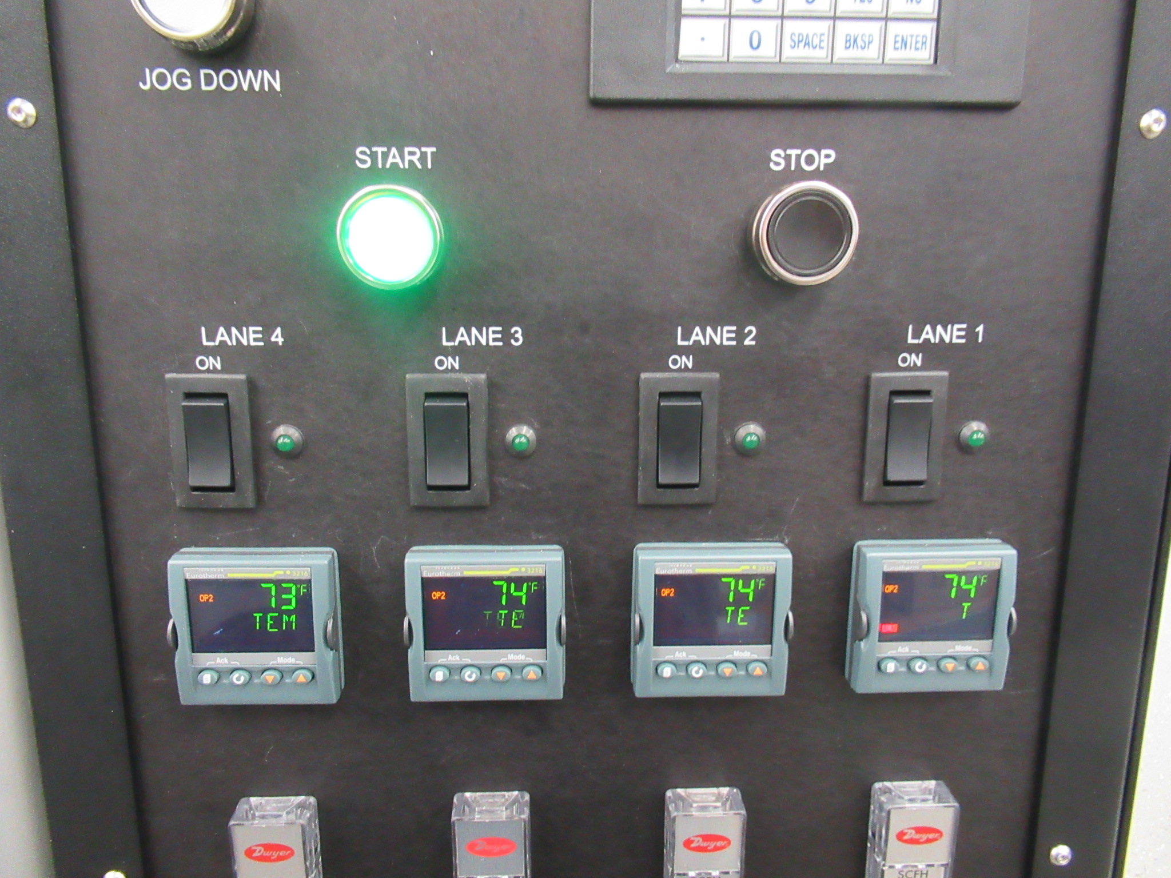

**Figure 5. Setting Temperature On Temperature Controller**

## Adjusting Grip Head Pressure

* Pull knob out and rotate the regulator knob clockwise or counterclockwise until the pressure gauge displays the desired value and then depress knob.

**Figure 6. Grip Head Pressure Regulator**

## Nozzle/Lamination Profiles

* Toggle the Parameter Access switch to “I” (EDIT) and then depress the STOP switch.

Refer to **Figure *4*. Rocker Switch Toggled to “I” (EDIT)**

* Follow keypad screen prompts (based on program loaded) to enter delay parameters and then lamination speed and length for all three zones.
  + Enter Traverse Delay.

**Figure 7. Keypad - Enter Traverse Delay Prompt**

* + Press Enter.
  + Enter Zone #1 Length.

**Figure 8. Keypad - Enter Zone Length Prompt**

* + Press Enter.
  + Enter Zone #1 Speed.

**Figure 9. Keypad - Enter Zone Speed Prompt**

* + Press Enter.
  + Continue entering the Length and Speed for Zone #2 and Zone #3.
  + After the Speed and Length for all three zones have been entered, toggle the Parameter Access switch to “O” to (RUN).

## Heater Air Flow

* Rotate the flow control knob counterclockwise to increase the heater air flow rate, clockwise to decrease the flow rate.

**Figure 10. Heater Air Flow Control**

System Operation

1. Position product within vee grip.
2. Toggle corresponding grip switch to close grip.
3. Repeat for all positions to be utilized.
4. Close cabinet door.
5. Press “START” button
6. Upon completion of the cycle open the cabinet door, secure the product and deactivate the corresponding grip switch to release the product.

Terms and Definitions

**Table 3. Terms, Definitions, and Descriptions**

|  |  |
| --- | --- |
| **Term** | **Definition** |
| Keypad | Traverse Parameter Interface providing an operational interface for a system. |
| I/O | Input and Output signals |
| PID | Proportional, integral, and derivative control method used to maintain the heater temperature at the desired setpoint. |
| SSR | Solid State Relay. The Shrink laminator uses a phase-angle-fired SSR to control the current sent to the heater element. |
| O/T | Overtemp Controller. Separate hardwired device that monitors the heater body for acceptable temperature. |
| SCFH | Standard Cubic Feet per Hour. Heater zone flow rates are manually adjusted. |

# Maintenance

**Note: Ensure the machine is unplugged for any servicing or maintenance work.**

**Note: Perform these steps ONLY when the machine is at room temperature.**

Caution: pinch point/crush hazard. Keep fingers, hands, and clothing clear of moving parts.

**Caution: hot surface. Contact may cause burn. Allow to cool before servicing.**

## *Cleaning*

1. Use 99% isopropyl alcohol to wipe down the outside of the machine. Do not attempt to clean the inside of the machine. The machine should not be washed down.
2. Cleaning should be with a soft dry cloth only.

## *Replacing Thermal Nozzles*

1. Loosen two lower-rear button head screws holding gussets on.
2. Remove four upper button head screws from heat shield and carefully remove heat shield assembly.
3. Loosen the set screw at the side of the nozzle adapter.
4. Slide the nozzle off the heater shield while simultaneously pulling out the thermocouple connector.
5. Install the replacement nozzle by sliding it completely onto the heater shield.

**Note: Ensure nozzle is fully seated against overtemp bracket.**

1. Tighten the lock set screw.
2. Insert the thermocouple connector into the jack.
3. If switching nozzle from open type to M360, rotate the M360 switch located on the control box (Refer to Figure 13. M360 switch on control box)

**Figure 11: Replacing Thermal Nozzles – Remove Heat Shield**

**Figure 12: Replacing Thermal Nozzles – Nozzle Set Screw**

**M360 Switch**

**Figure 13. M360 switch on control box**

## *Replacing Heater Elements*

The quartz heaters used in the 810-A vertical laminator are very fragile. Do not apply stress or pressure to the quartz tube. Take care to shield the quartz tube from impact during removal and install. The heaters may have a fastener installed on the retaining tab. This fastener must be removed before installation.

1. Disconnect system power and air.
2. With the machine OFF disconnect push connectors at the spades of the heater. Disconnect the 2 electrical connections, one on the left and one on the right.
3. Disconnect the air tube at the back of the heater.
4. Loosen the heater retainer on the top of the heater block using a 1/8" Allen Wrench. Set the fastener and washer aside.
5. Pull the heater assembly out of the heater block.
6. Separate the heater retainer from the heater and remove the fitting at the back of the heater.
7. Install the fitting on the replacement heater and reassemble in reverse order from step 4 to step 1.

**Figure 14: Replace Heating Elements – Remove/Install Heater**

## *Exchanging Vee Guide/insert(s)*

1. Remove the fasteners securing the guide to the actuation rail.
2. Position the replacement guide on the rail and align with the mounting holes.
3. Install the fasteners.

**Figure 15: Exchanging Vee Guide**

## *Replace Heater Power Controller*

**Note: Please contact Machine Solutions for part replacement.**

1. Disconnect system power and air.
2. Locate the power controller(s).
3. Loosen terminals **1/L1, 3/L2, 2/T1** and **4/T2** at the top front and rear of the controller.

**Note: Keep track of wire locations. For schematics, contact Machine Solutions.**

1. Remove the ground connection using a flat blade screwdriver.
2. Using a flat blade screwdriver, pull out the DIN rail lock at the bottom-front of the controller.
3. Replace the power controller and secure it by pushing in the DIN rail lock.
4. Re-install parts and wires from previous steps.

**Figure 16: Replace Heater Power Controller - Locate Controller**

## *Aligning Tooling*

**Note: Alignment should be performed on a prepared product subassembly.**

**Alignment MUST be performed with system power off and heater nozzle at ambient temperature.**

1. Open the cabinet door.
2. Remove heat shields as shown in “Replacing Thermal Nozzles”.
3. Secure a .062”-.25” O.D. x 12” mandrel in grip #1
4. Manually extend the heater array assembly.
5. Loosen the nozzle assy. mount fasteners and adjust the nozzle assy. left or right, (X-Axis), until the nozzle is reasonably centered around the mandrel, then secure the fasteners.
6. Adjust the Y-Axis until the nozzle is reasonably centered with the mandrel.
7. Adjust the vee closure micrometer as required until the vee guides are close but not touching the mandrel.

**Figure 17: Aligning Tooling**

Diagnostics and troubleshooting

**Table 4. Diagnostics and Troubleshooting**

|  |  |  |
| --- | --- | --- |
| **Issue** | **Possible Causes** | **Solution** |
| Temperature not stable | * Thermal Nozzle replaced * Thermocouple loose | * Auto‐tune * Re‐install thermocouple |
| S.br | * Break in thermocouple wire * Thermocouple failure | * Verify all connections from controller to remote TC jack * Replace thermocouple |
| No heat at nozzle | * Heater air flow too low * Defective pressure switch * Defective heating element * Defective power control | * Increase air flow * Replace heating element * Contact Machine Solutions |
| .Err code in display | * Temperature controller software failure | * Replace temperature controller |
| System will not power on | * IEC power cord not fully connected | * Verify installation |

Specifications

**Table 5. System Specifications**

|  |  |  |  |
| --- | --- | --- | --- |
| **Description** | **Range** | **Resolution** | **Accuracy** |
| Temperature | 200-750°F | 1.0 deg. | +/-1.0% F.S. |
| Grip Pressure | 0-100 psi | 1.0 psi | +/-1.5% F.S. |
| Length | 1-1750 mm  1-2050 mm  1-2550 mm | .01 mm | 0.10mm/100mm |
| Speed | *0.2/0.3-25 mm/sec.  *(Minimum speed dependent on installed actuator) | 0.1 mm/sec. | +/- 10% |
| Air Flow | 5-50 SCFH | 5.0 SCFH | +/- 7% F.S. |

**Note: Not all nozzles can reach upper temperature of 750°F. Some nozzles are only capable of 600-650°F**

***Facility Requirements***

* Voltage: 240 VAC, 50/60 hz
* Wattage: 1800 Max.
* Compressed Air: 100-125 psi, filtered 50 micron or greater, oil and water free.

# Critical Parts

For replacement or spare parts, please contact us at [service@machinesolutions.com](mailto:service@machinesolutions.com), or call 928-556-3109.

**Table 6. Critical Parts List**

|  |  |  |
| --- | --- | --- |
| **Part Number** | **Description** | **Quantity** |
| 1330445-001 | 4-way valve 24 VDC | 2 |
| 1131433-001 | Heater power SSR | 4 |
| 1343250-001 | 2-way pneumatic valve | 5 |
| 1348088-001 | Toggle valve | 4 |
| 110254-001 | Heating element | 4 |
| 1143287-001 | DPDT Relay | 4 |
| 1143133-001 | 0.125” Thermocouple | 4 |
| 1143992-001 | 0.062” Thermocouple (nozzle TC) | 4 |
| 1148096-001 | Keypad HMI | 1 |
| 1148103-001 | Drive Controller | 1 |
| 1162079-001 | M12 8mm NPN proximity sensor | 1 |
| 110320-001 | Limit Switch | 1 |
| 1343536-001 | Flow Meter | 4 |
| 1343540-001 | Pressure Switch | 4 |
| 1146420-001 | Temp Controller (keypad version) | 4 |

Customer Support And Satisfaction

Machine Solutions Inc. is proud of the advanced engineering and quality construction of each piece of equipment that we build. It is our goal to provide equipment that exceeds the expectations of the customer. By implementing the highest standards and applying our experience to provide a quality product, we maintain an ongoing, positive working relationship with all our customers.

Machine Solutions Inc. welcomes your comments and inquiries about our products and services.

Machine Solutions Inc.

2951 West Shamrell Blvd., Suite 107

Flagstaff, AZ 86005

Phone: 928-556-3109

Fax: 928-556-3084

E-Mail: service@MachineSolutions.com

# Warranty And Limitations

***General Warranty***

Machine Solutions Inc. (MSI) warrants its products to be free from defects in material and workmanship in normal everyday use and service for a period of one year from the date of shipment from the factory in Flagstaff, Arizona. MSIs obligation under this warranty shall be limited to the repairing or replacing of the product or parts thereof which upon MSIs inspection reveals them to be defective. MSI reserves the right and option to refund the purchase price in lieu of repair or replacement upon evaluation of the returned original part. Modifications, misuse, attempted repairs by others, improper calibration or operation shall render this guarantee null and void. MSI MAKES NO OTHER WARRANTY REGARDING THIS PRODUCT, INCLUDING ANY EXPRESS OR IMPLIED WARRANTY. SPECIFICALLY, THERE IS NO WARRANTY OF MERCHANTABILITY OF THIS PRODUCT OR OF THE FITNESS OF THE PRODUCT FOR ANY PURPOSES. THE SUITABILITY OF THIS PRODUCT FOR ANY PURPOSE PARTICULAR TO THE CUSTOMER IS FOR THE CUSTOMER, IN ITS SOLE JUDGEMENT, TO DETERMINE. MACHINE SOLUTIONS, INC. ASSUMES NO RESPONSIBILITY FOR THE SELECTION OR USE OF THIS PRODUCT BY CUSTOMER. This product has not been tested or approved by the U.S. Food and Drug Administration or any other agency of the U.S. government. This product is not a consumer product as that term is defined in the Magnuson-Moss Warranty – Federal Trade Commission Improvement Act, 15 U.S.C. § 2301 et seq.

***Software License***

By using this equipment, and/or installing or using any of the software associated with the same, you indicate your acceptance of each of the terms of this license. Upon acceptance, this license will be a legally binding agreement between you and MSI. The terms of this license apply to you and to any subsequent user of the software. If you do not agree to all of the terms of this license (i) do not install or use the software and (ii) return the equipment and the software (collectively, equipment), including all components, documentation and any other materials provided with the equipment, to MSI. The software includes associated media, any printed materials, and any on-line or electronic documentation. Software provided by third parties may be subject to separate end-user license agreements from the manufacturers of such software. This license shall also apply to any updates, bug fixes, or newer versions of the software provided by MSI for use with this equipment.

You may: (1) Use the software only in connection with the operation of the equipment; (2) Transfer the software (including all component parts and printed materials) permanently to another person, but only if the person agrees to accept all of the terms of this license. If you transfer the software, you must at the same time transfer the equipment and all copies of the software (if applicable) to the same person or destroy any copies not transferred; and (3) Terminate this license by destroying the original and all copies of the software (if applicable) in whatever form.

You may not: (1) Loan, distribute, rent, lease, give, sublicense or otherwise transfer the software, in whole or in part, to any other person, except as permitted under the transfer paragraph above; (2) Copy or translate the User Guide included with the equipment; (3) Copy, alter, translate, decompile, disassemble or reverse engineer the software, including but not limited to, modifying the software to make it operate on non-compatible hardware; or (4) Remove, alter or cause not to be displayed, any copyright notices or startup message contained in the software programs or documentation

Title to the software, including the ownership of all copyrights, patents, trademarks and all other intellectual property rights subsisting in the foregoing, and all adaptations to and modifications of the foregoing shall at all times remain with MSI and its third party licensors, if any. MSI retains all rights not expressly licensed under this license. Except as otherwise expressly provided in this license, the copying, reproduction, distribution or preparation of derivative works of the software, or any portion of the equipment, is strictly prohibited. Nothing in this license constitutes a waiver by MSI of its rights under United States copyright law.

***Protection of Intellectual Property***

The equipment and its incorporated technology (collectively referred to herein as the Technology), is protected under issued and pending patents. The Technology is the valuable and proprietary technology, including trade secret technology, belonging to MSI. Much of the Technology is nonpublic and confidential. As our customer, you agree to further assist MSI in the protection of our intellectual property as follows: You agree to keep the Technology you receive confidential at all times, and shall not, without the prior written consent of MSI, disclose the Technology, in whole or in part, to any person outside of your company. You further agree that you shall not reverse engineer, disassemble, decompile or copy the Technology without the prior written consent of MSI.

In addition, you agree that the equipment will not be used to manufacture anything other than products in which you hold intellectual property rights free of infringement of others. You may not use the equipment to manufacture any product infringing on another’s patented rights. By accepting and using the equipment, you agree to defend and indemnify Machine Solutions, Inc., its officers, directors, employees and agents, from and against any claims of infringement as a result of your use of the equipment.

***Regulatory Matters***

All equipment validations, product validation, final product QC testing and other testing required by the U.S Food and Drug Administration are the sole responsibility of the customer. Machine Solutions, Inc. shall have no responsibility or liability for the performance of any interventional product on which this equipment is used.