Table of Contents

List of Figures 3

List of Tables 4

**Welcome** 6

**Purpose** 6

**Overview** 6

Process Overview 6

**Control System Overview** 7

**Safety** 7

**Installation** 7

Power Requirements 8

Facilities Requirements 8

**Main Power Disconnect Switch** 8

**Emergency Stop Loop and Hardwired Devices** 8

Overtemperature Controllers 8

Temperature Controller Uses Ethernet/IP Comms 9

Servo Drive(s) 9

Remote-In Communication Device 9

Optional Light Tower 9

**Barcode Scanning** 9

Barcode Scanner Connects to PanelView’s USB Port 9

**Multi-Loop Controller Setup** 9

Four Control Loops 9

Auto Tuning Initiated by Digital Input 1 9

Thermocouple Offset 9

**Servo Drives** 9

**Set Up and Configuration** 9

**Controls** 10

**Calibration** 10

Tuning Temperature Controllers 11

**Parameter Settings** 11

Laminator Settings Variables 11

**Panel View Plus HMI Display Description** 13

Data Entry Keypads 13

Main Menu (Screen #01) 14

**PLC Status and HMI Shutdown (Screen #02)** 16

**Settings (Screen #03)** 17

**Auto Tune (Screen #04)** 19

**Heater Actuator (Screen #12)** 20

**Heaters and Heater Airflow (Screen #13)** 22

**Pneumatics and Valves (Screen #14)** 23

**Calibration (Screen #15) *(if applicable)*** 24

**Run Parts (Screen #10)** 25

CYCLE START Pushbutton 26

CYCLE STOP Pushbutton 26

Run Parts Screen without Passcode 27

Passcode Cleared on Laminator Power Up 27

**Recipe Settings and Descriptions** 27

Alternate Units 28

**Recipe Select (Screen #20)** 28

**Recipe Edit (Screen #21)** 30

**HMI Support Screens** 31

Alarm Banner Overlay 31

Alarm Log 32

**Alarms** 33

Alarms while Processing 34

Airflow and Temperature Alarms 34

**Warnings** 34

**Laminator Settings and Recipe Controls** 34

Alternate Display Unit 35

Passcode Required to Change Settings 35

Laminator Settings Variables 35

**System Operation** 37

**Terms and Definitions** 37

**Maintenance** 38

Replacing Thermal Nozzles 38

Exchanging Vee Guide/insert(s) 39

Replace Heating Element(s) 40

Replace Heater Power Controller 41

Aligning Tooling 42

**System Specifications** 43

**Critical Parts List** 44

**Diagnostics (Troubleshooting)** 45

Ethernet Connections and IP Addresses 45

**Appendix** 45

Sequences of Operation 45

Master Control Sequence 45

**Servo Motor Control Sequence** 49

**Airflow and Temperature Controls** 50

Air Flow Controls 50

Heater Overtemperature Control 50

Multi-Loop Temperature Controller 50

Auto Tuning Triggered by the PLC 50

Heater / Airflow Multistate Indicator 50

Thermocouple Offset 51

**Servicing** 51

**Cleaning** 51

**Warranty** 51

**Return Material Authorization (RMA)** 52

# List of Figures

**Figure 1. HMI Keypad** 13

**Figure 2. Main Menu** 14

**Figure 3. Operator screen** 15

**Figure 4. Shutdown Screen** 16

**Figure 5. Settings Screen** 17

**Figure 6. Limit Settings** 18

**Figure 7. Auto Tune Screen** 19

**Figure 8. Heater Actuator Screen** 20

**Figure 9. Heaters and Heater Airflow Screen** 22

**Figure 10. Pneumatics and Valve Screen** 23

**Figure 11. Airflow Calibration Screen** 24

**Figure 12. Run Screen** 25

**Figure 13. Run Parts Screen** 27

**Figure 14. Recipe Select Screen** 29

**Figure 15. Recipe Edit Screen** 30

**Figure 16. Shutdown Screen** 31

**Figure 17. Alarm Banner** 32

**Figure 18. Alarm Log** 33

**Figure 19: Replacing Thermal Nozzles – Remove Heat Shield** 39

**Figure 20: Replacing Thermal Nozzles – Nozzle Set Screw** 39

**Figure 21: Exchanging Vee Guide/Inserts** 40

**Figure 22: Replace Heating Elements - Top Cover Removal** 40

**Figure 23: Replace Heating Elements – Remove/install Heater** 41

**Figure 24: Replace Heater Power Controller - Locate Controller** 42

**Figure 25: Replace Heater Power Controller** 42

**Figure 26: Aligning Tooling** 43

# List of Tables

**Table 1. Set up and Configuration.** 10

**Table 2. Controls** 10

**Table 3. Parameter Settings** 13

**Table 4. HMI Display Descriptions** 15

**Table 5. Shutdown Screen Button Description** 16

**Table 6. Settings Screen Button Description** 17

**Table 7. Limit Screen Button Description** 18

**Table 8. Auto Tune Button Description** 19

**Table 9. HMI Screen Objects - Actuator** 20

**Table 10. Heater Actuator Button Description** 21

**Table 11. Heater Screen Button Description** 23

**Table 12. Pneumatics Screen Button Description** 24

**Table 13. Calibration Screen Objects** 25

**Table 14. HMI Screen Objects** 26

**Table 15. HMI Screen Objects - Run Screen** 26

**Table 16. Alternate Recipe Units** 28

**Table 17. Recipe Screen Button Description** 29

**Table 18. Recipe Edit Screen Button Description** 30

**Table 19. Alarm Message Description** 34

**Table 20. Warning Message Description** 34

**Table 21. Laminator Settings Variables** 37

**Table 22. Terms, Definitions and Descriptions** 38

**Table 23. System Specifications** 43

**Table 24. Critical Spare Parts (contact Machine Solutions for current Price and delivery)** 44

**Table 25. Diagnostics** 45

**Table 26. Ethernet Connections and IP Addresses** 45

**Table 27. Master Control Sequence** 48

**Table 28. Servo Motor Control Sequence and Description** 49

**Table 29. Heater Multistate Indicator and Description** 51

# **Welcome**

Machine Solutions, Inc. (MSI) would like to take this opportunity to thank you for purchasing your new 810-A Vertical Laminator machine. At MSI, we are dedicated to bringing innovative process development solutions to both medical device and nonmedical organizations. The MSI proprietary segmental technology has been successfully implemented in manufacturing clean rooms on five continents, and continues to expand – meeting, growing, and facilitating the abilities of device companies around the globe. MSI looks forward to helping your organization provide life-improving devices to your customers, today and tomorrow.

# **Purpose**

The purpose of this document is to describe the mechanical, electrical and software design of the control system for the Shrink Laminator Model 810-A Touch-Screen. This document includes descriptions of the software packages for theprogrammable logic controller (PLC) files and data structure, and the Human Machine Interface (HMI) display description. This document also includes operator instructions.

# **Overview**

The Machine Solutions Model 810-A Laminator is a system for the purpose of progressively recovering heat shrinkable materials onto catheter type shafts by means of traversing a thermal nozzle along the length of the materials at a controlled speed over a set length. The materials are suspended vertically, and the thermal nozzles traverse top to bottom to allow the heat shrink to contract as required.

## Process Overview

Parameters are established and programmed via the HMI. Materials are assembled and secured in the product grips. Upon initiation of the process cycle the thermal nozzles extend to the product and then begin traversing the length of the materials to the programmed length.

The Shrink Laminator is used to heat shrink material onto up to four catheter assemblies at a time. Variable speed and distance controls allow the shrinking to start at the top or the bottom of the assembly.

The heater array is mounted on the linear actuator; after the heater array has been moved to a convenient loading height, the operator installs the catheters in the grip mechanism. The hot air system is then brought to the correct temperature. When the process is started, the heater array is moved to a start position. The heater assembly is moved out to the catheters, then the heater array is moved down the length of the catheter through as many as six speed zones. The heater array is retracted and returned to the starting position.

The operator can select from a set of 100 recipe files using a barcode scanner. Each file contains the variables used by the process sequence. A passcode is used to control access to the recipe settings, machine settings, and several test screens on the HMI. A passcode of “2694” is hard coded into the passcode logic.

# **Control System Overview**

The control system consists of an Allen-Bradley CompactLogix PLC A-B and an Allen-Bradley PanelView Plus Standard 7 HMI 10” color display terminal. The PLC controls the operation of the linear actuator, the hot air delivery system, and the cooling jet. The HMI provides the operator the means to monitor and control the operation of the laminator and to set up control parameters.

The PLC is a stand-alone controller not dependent on other PLC resources. The PLC uses Ethernet/IP messaging for the communications between the PLC and HMI. The temperature control of the hot air is provided using a multi-loop controller. The multi-loop controller is connected to the PLC using Ethernet/IP communications.

# **Safety**

Caution: high voltage. Remove power and use safety precautions when servicing.

 Caution: hot surface. Contact may cause burn. Allow to cool before servicing.

 Caution: pinch point. Keep hands and body parts clear while in operation.

The maximum observed Sound Pressure Level is below 70 dB(A).

Do not use the equipment other than as prescribed. For example: do not attempt to sit on or climb on the equipment, do not place heavy objects or containers of liquid on the machine, do not to insert any foreign objects into the machine and do not attempt to bypass any guards or otherwise operate the machine in any manner other than that in which it is explicitly intended.

# **Installation**

**Note: The equipment is not for use with materials that can decompose or ignite below the maximum operating temperature of the machine. Hazards are materials that outgas hazardous substances and or ignite. (400C/750F)**

**Note: This equipment is not for use in an ATEX environment.**

1. Place the system on a level, sturdy surface.
2. Lock casters. Casters should be locked at all times when not moving machine.
3. Connect the power cord to the system and then to a 230 VAC 50/60 Hz. 1 Ph. 3-wire Outlet.
4. Connect the air supply hose assembly to the system and then to a clean, dry, and filtered compressed air source.

## Power Requirements

The laminator is fed from a single 208V/1Ø/2W & GND/25A service. The laminator is equipped with a door-interlock disconnect switch followed by a line filter and a 25A circuit breaker. A neutral connection is required to support the 120VAC heater elements. The maximum draw of the laminator is 3.0kVA or 25A. Please note that phase-angle-fired SCR devices are used to limit each heater’s current draw to approximately 5A at 208VAC.

## Facilities Requirements

1. Voltage: 205-245 VACV 50/60 Hz.
2. Wattage: 1800 max.
3. Air: 60-125 psi, 0.5 CFM, filtered 50 micron or greater, oil and water free.

# **Main Power Disconnect Switch**

The door-interlocked disconnect switch can be locked out for service purposes.

# **Emergency Stop Loop and Hardwired Devices**

A single emergency stop twist-to release switch is connected to a safety relay in the electrical enclosure. The emergency stop switch is wired in series with a red extended head stop switch. Both switches must be released, then the power reset button must be pushed.

When the safety relay is reset, power is applied to the two main contactors. This energizes the linear actuator motor, and the heater power circuits. The blue lamp in the reset button is also illuminated. The PLC, HMI, and the 24VDC inputs remain energized regardless of whether the power contactors are closed.

## Overtemperature Controllers

There are four heater zones on the 810-A Laminator, and each zone has a similar electrical design. Every heating unit includes a mechanical relay that applies power to the semiconductor Solid State Relay (SSR). The state of the heater relay is controlled by the PLC output. Each lane has a separate OverTemp (O/T) thermocouple monitored by the PLC. The O/T temperature must be below the overtemp setpoint before the PLC will allow power to the heater zone.

## Temperature Controller Uses Ethernet/IP Comms

The heater temperatures are measured by the multi-zone controller. The controller accepts a setpoint and returns the loop output for each zone using Ethernet/IP communications.

## Servo Drive(s)

The drive is run in a position mode using Ethernet/IP resources in the PLC.

## Remote-In Communication Device

A remote-in communication device is available for all units that operate with a PLC and HMI only. Remote-in communication device is intended for technical support and maintenance. Remote-in communication is set using Ethernet/IP communications.

## Optional Light Tower

Light tower option is not available on all 810A models.

# **Barcode Scanning**

## Barcode Scanner Connects to PanelView’s USB Port

A barcode scanner sends data to the USB port on the HMI. When the operator brings up an alphanumeric keypad, the data from the scanner is written to the PLC.

# **Multi-Loop Controller Setup**

## Four Control Loops

The controller reads 4 Type “K” thermocouples and sets 4 SCR power levels. The setpoint for each loop is passed from the PLC to the controller. The temperature and output level are read back by the PLC.

## Auto Tuning Initiated by Digital Input 1

The controller’s first digital input is used to put all 4 control zones into an autotuning mode. The digital input is driven by a digital output from the PLC.

## Thermocouple Offset

The PLC’s settings support individual offsets that are applied to the controller’s thermocouple reading.

# **Servo Drives**

The drive is run in a position mode using Ethernet/IP resources in the PLC.

# **Set Up and Configuration**

Proper sizing of the **thermal nozzle** and alignment of the tooling are crucial to optimizing process results and repeatability. The following guidelines are the recommended methods, however all applications vary, and several iterations of tooling process development may be required and may not follow all of the recommended guidelines.

|  |  |
| --- | --- |
| **Thermal Nozzle Diameter** | The nozzle diameter should be .187”-.25” larger than the material to be processed. |
| **Thermal Nozzle Width** | The width (length of the thermal nozzle should be as long as possible to increase the lamination speed. The standard system will accommodate nozzle widths to 1.0”. Customized configurations will be quoted upon request. |
| **Grip/Positioning Nests** | The vertical position of the grip assembly should be positioned such that the full lamination length can be accomplished without the catheter touching the floor and with a minimal load height position. |

**Table 1. Set up and Configuration.**

# **Controls**

|  |  |
| --- | --- |
| **Description** | **Function** |
| Power reset switch | Engages low voltage power and system air. |
| Power off switch | Disengages low voltage power and system air. |
| Emergency stop switch | Engages/disengages all system power and air. |
| Power on indicator | Indicates when system power on by illuminating, off when not illuminated. |
| HMI | Traverse Parameter interface. |
| Main power disconnect | Engages/Disengages AC inlet power. |
| Vee Guide Micrometer | Controls amount of closure of vee guide tooling. |
| Grip position lock | Locks the grip array position. |

**Table 2. Controls**

# **Calibration**

**IMPORTANT NOTES:**

1. Calibration must be performed by a certified service, preferably with the system in the location of use. Calibration procedures are the domain of these service providers.
2. Calibration refers to the process of verifying that each of the systems’ instruments that controls a process parameter is within manufacturer’s specification.
3. Calibration DOES NOT refer to the process of measuring the temperature at the center of the thermal nozzle and “matching” the value to the temperature controller set point.
4. The measured value at the thermal nozzle will rarely match the temperature controller set point and the delta will increase towards the center of the nozzle.
5. For temperature stability verification it is recommended that the air be measured .062”-.093” from the exit point of one of the flow ports. Stability should be +/-5.0 degrees over one hour or at a minimum over the duration of a typical process cycle (customer/product specific) from what is displayed on screen on temperatures from 0 - 500 degrees C. Stability should be +/-10.0 degrees over one hour or at a minimum over the duration of a typical process cycle (customer/product specific) from what is displayed on screen on temperatures from 500 – 750 degrees C.
6. Flow meters must be verified or calibrated since they cannot be adjusted if out of manufacturers specifications.
7. Calibrate the temperature controller annually.
8. Calibrate the linear actuator speed and distance annually.
9. Calibrate the pressure gauge annually.
10. Calibrate the Mass Flow Controllers annually if possible (if applicable).

## Tuning Temperature Controllers

Refer to the **Airflow and Temperature Controls** section of this manual. (Page 50)

# **Parameter Settings**

## Laminator Settings Variables

The laminator settings are shown in Table 3. Each setting has a minimum and maximum value that restricts the data entry keypad’s range. The min/max is user adjustable.

|  |  |  |  |
| --- | --- | --- | --- |
| **Laminator Setting** | **Nominal** | Range | **Description** |
| s00. Temperature Units (0 or 1) | 0 = °F | - | Enter a 1 to select °C. |
| s01. Distance Units (0 or 1) | 0 = mm and mm/s | - | Enter a 1 to select inch and IPS. |
| s02. Actuator Homing Speed | 25 | 10-100 | Actuator speed to seek the upper limit switch. Excessive speed into the limit can cause a drive stall trip. |
| s03. Actuator Fast Speed mm/S | 50 | 10-150 | Actuator speed used to find the upper travel limit. Also sets the maximum recipe speed. |
| s04. Actuator Slow Speed mm/S | 10 | 2-100 | Actuator speed to find home position off the upper travel limit. |
| s05 Actuator Acceleration mm/S/sec | 300 | 50-300 | Actuator acceleration for speed changes. The rate is limited by the PLC to a maximum of 1900 steps/mS/sec. |
| s06. Actuator Steps per mm | 5440 | 5000-6000 | Calibration for both axes. Motor has 66536 steps per revolution at the shaft. |
| s07. Maximum Length | 889 | 500-3000 | Sets the tool length. Sets the maximum positions in the recipe. |
| s08. Minimum Start Position mm | 0 | 0-250 | Sets the minimum heater array position relative to the grip elevator so as to avoid tooling crashes when the thruster extends the heater. |
| s09. Heater Overtemperature Set °F | 1000 | 750-1000 | Temperature setting read by the overtemp T/C that disconnects power from the heater. |
| s10. Max Temperature Setpoint °F | 750 | 0-750 | Limits heater setpoint entries. |
| s11. Temp Deviation Limit °F | ±10.0 | 1-100 | Heater deviation band for acceptable temperatures. |
| s12. Heater Cooloff Temperature ºF | 120 | 80-140 | Temperature limit for stopping the airflow through the MFC. |
| s13. Minimum Recipe Speed mm/sec | 0.01 | 0.01-1 | Lowest acceptable recipe speed setting. |
| s14. | 0 | - | Spare |
| s15. Zone MFC Full Scale Flow LPM *(if applicable)* | 47.19 | 40-80 | Calibration value for the heater MFC’s. |
| s16. Zone MFC Deviation Limit LPM *(if applicable)* | ±0.2 | 0.1-10 | Flow deviation limit for heater zone airflow. |
| s17. Zone MFC Minimum Flow Limit *(if applicable)* | 15 | 40-80 | Minimum allowed flow rate for the heaters. |
| s18. Grip Full Scale Pr | 130 | 70-140 | Full pressure rating of the regulator. |
| s19. Grip Deviation Limit | ±5.0 | 0.1-100 | Allowable grip pressure deviation. |
| s20. | 0 | - | Spare |
| s21. Zone 1 Control TC Offset | 0.0 | -25 to 25 | Temperature offset for heater 1. |
| s22. Zone 2 Control TC Offset | 0.0 | -25 to 25 | Temperature offset for heater 2. |
| s23. Zone 3 Control TC Offset | 0.0 | -25 to 25 | Temperature offset for heater 3. |
| s24. Zone 4 Control TC Offset | 0.0 | -25 to 25 | Temperature offset for heater 4. |
| s25. | 0 | - | Spare |
| s26. Use Thruster (0 or 1) | 1=YES | - | Option to disable the heater thruster. |
| s27. Use Barcode Scanner (0 or 1) | 1=YES | - | Option to disable the barcode scanner. Operator must use the scanner to select a recipe. |
| s28. Brake Release Time Delay secs | 0.20 | 0.1 to 2 | Delay to allow the actuator holding brake to release. |
| s29. to s34. | 0 | - | Spare |
| s35. Heater OFF inactivity | 3600 | 0-7200 | The value for timer for heaters to shut down after no activity on machine. |
| s36. Horn On Time | 0=OFF | 0-3600 | Limits length of time horn is on before auto-silencing. Set to ZERO for no horn. |
| s37. Passcode Timeout | 0=NO | 0-9999 | The user passcode is cleared after this time interval when observing the RUN PARTS screen. If set to zero, there is no timeout. |
| s38. User Passcode 1 |  | 1-99999 | Access code for settings and screens. |
| s39. User Passcode 2 |  | 1-99999 | Access code for settings and screens. |

**Table 3. Parameter Settings**

# **Panel View Plus HMI Display Description**

The Human Machine Interface (HMI) provides the primary source of operator interaction with the control system. The laminating system is controlled by the PLC. The HMI reads data from the PLC and allows changes to variables in the PLC. The HMI allows the operator to observe the operation of the system.

## Data Entry Keypads

When a numeric value is to be entered, the operator touches the display, which pulls up a keypad like the one shown below. The label of the keypad shows the range that can be entered with the keypad.

A similar keypad is available to enter the name of the recipe.

**Figure 1. HMI Keypad**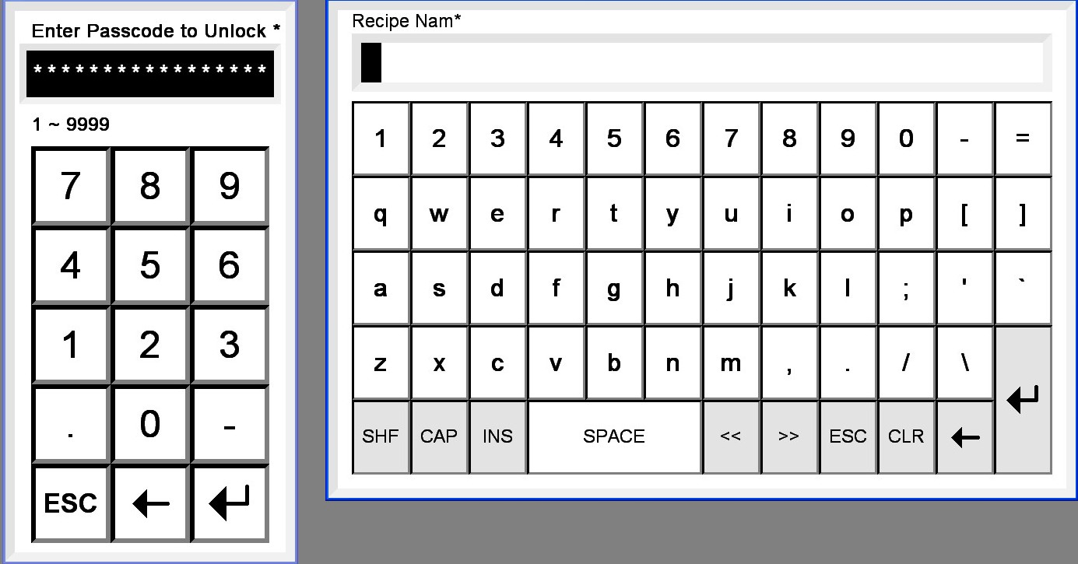

## Main Menu (Screen #01)

The Main Menu screen provides an access point to the remaining screens in the system. Some menu items are hidden unless the passcode has unlocked the HMI. A passcode of “2694” is hard coded into the passcode logic.

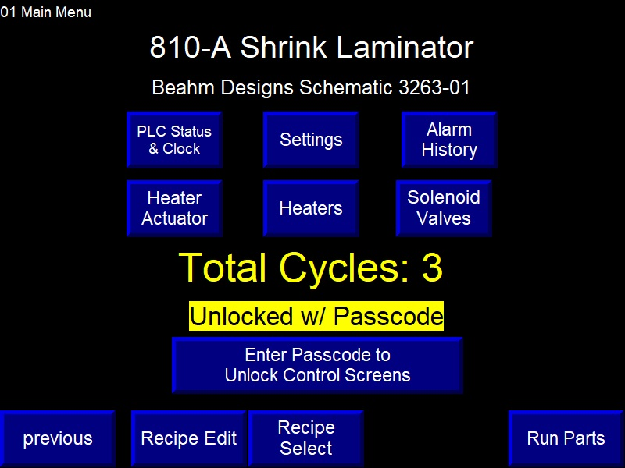

**Figure 2. Main Menu**

|  |  |
| --- | --- |
| **HMI Screen Object Descriptions** | |
| **Item** | **Description** |
| Title | Unit number is read from the PLC. |
| PLC Status Settings  Heater Array Actuator  Grip Elevator Actuator  Heaters, Solenoid Valves, Alarm History  Calibration (if applicable) | Menu Buttons. Made visible when a valid passcode is entered. |
| previous  Run Parts | Menu Buttons. Always visible. |
| Total Cycles | Numeric Readout. Shows the number of times the laminator process has run to completion. |
| Unlocked w/ Passcode | Indicator. Shows a valid passcode is active |
| Enter Passcode to Unlock Screens | Keypad. Used to enter the passcode. |

**Table 4. HMI Display Descriptions**

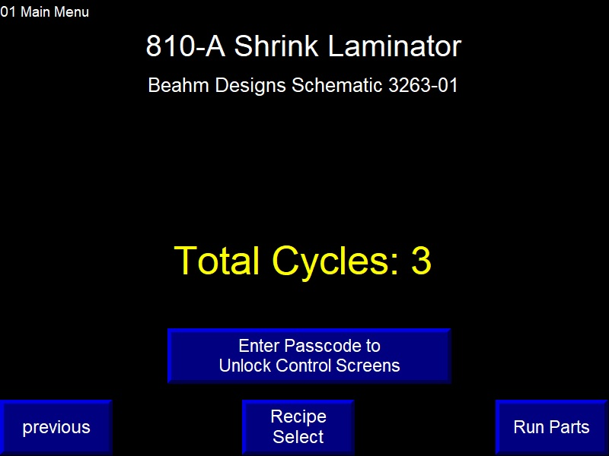This is how the Main Menu screen appears when there is no passcode present.

**Figure 3. Operator screen**

# **PLC Status and HMI Shutdown (Screen #02)**

Enter the passcode to access this screen from the Main Menu. This screen shows the machine model number and some PLC variables. The HMI application can be shut down from this screen.

**Figure 4. Shutdown Screen**

|  |  |
| --- | --- |
| **HMI Screen Object Descriptions** | |
| **Item** | **Description** |
| Menu Buttons | Direct access to specified screens. |
| Model Number | Numeric Readout. |
| PanelView S/W Revision | Text. Manually changed while creating the application file. |
| Power On Hours  PLC Software Revision  Scan Times | Numeric Readouts. Length of time PLC has been running, plus variables to show what software is on the PLC. |
| PLC Memory Battery OK  PLC Memory Battery Low | Indicator. Shows the state of the PLC’s memory battery, located under a cover on the left side of the PLC assembly. |

**Table 5. Shutdown Screen Button Description**

# **Settings (Screen #03)**

This screen is used to change Shrink Laminator settings. A passcode must be entered to make the screen accessible from the Main Menu.

**Figure 5. Settings Screen**

|  |  |
| --- | --- |
| **HMI Screen Object Descriptions** | |
| **Item** | **Description** |
| Menu Buttons | Direct access to specified screens. |
| Settings List | List Selector. Use the arrow keys to navigate to a particular setting. |
| Door Locks Active | Pushbutton. Used to temporarily defeat the door interlocks. Will clear when the passcode is cleared. |
| Change Setting | Keypad. Used to enter a numeric value for the selected list item. |
| Min/Max Enable | Pushbutton. Brings up keypads for the minimum and maximum settings used by the Change Setting keypad. |
| Auto Tune | Menu Button. Access to screen to autotune heaters. |
| Calibration (if applicable) | Menu Button. Access calibration screen for air flow. |
| User Passcode 1 & 2 | Keypads. Sets the user code as a number from 1 to 99999. |
| Passcode Timeout | Keypad. Enter zero for no passcode timeout, otherwise the time delay while using the Run Parts screen to automatically clear the code. |

**Table 6. Settings Screen Button Description**

This screen shows the appearance after the Min/Max Enable button is touched.keypads will disappear if the HMI shifts to another screen.

**Figure 6. Limit Settings**

|  |  |
| --- | --- |
| **HMI Screen Object Descriptions** | |
| **Item** | **Description** |
| Low Limit  High Limit | Keypads. Enter the desired minimum and maximum range for the associated list item. |

**Table 7. Limit Screen Button Description**

# **Auto Tune (Screen #04)**

Use this screen to initiate an Auto Tune of all four lanes. The pushbutton causes a digital output from the PLC to energize the temperature controller. Be sure to start with a cold heater or room temperature. Start it running to the tuning setpoint, THEN turn on the Start Auto Tune button.

**Figure 7. Auto Tune Screen**

|  |  |
| --- | --- |
| **HMI Screen Object Descriptions** | |
| **Item** | **Description** |
| Menu Buttons | Direct access to specified screens. |
| Start Auto Tune | Pushbutton. Starts autotune process |
| Auto Tune Time Left | Numeric Readout. Allows 10 minutes for auto tuning before automatically clearing the Auto Tune Started output. |

**Table 8. Auto Tune Button Description**

# **Heater Actuator (Screen #12)**

Enter the passcode to access this screen from the Main Menu.The screen is used to exercise the servo motor running the linear actuator.

**Figure 8. Heater Actuator Screen**

|  |  |
| --- | --- |
| **HMI Screen Object Descriptions** | |
| **Item** | **Description** |
| Menu Buttons | Direct access to specified screens. |
| Hand/Off/Auto | Interlocked Pushbuttons. Set to AUTO to run the process. Set to HAND to allow use of the controls on this screen. AUTO mode is forced when the CYCLE START button is pushed. |
| Ready for Command | Indicator. Shows the state of the Actuator control sequence. |
| Actuator Position  Actuator Speed | Keypads with Numeric Readout Overlays. Used to monitor and to manually enter position and speed setpoints. |
| Encoder Position  Encoder Speed | Readouts. The Wire Draw Encoder is zeroed when the actuator is homed. The speed is the 1 second count difference. |

**Table 9. HMI Screen Objects - Actuator**

|  |  |
| --- | --- |
| **Heater Array HMI Screen Object Descriptions** | |
| **Item** | **Description** |
| Homed OK  Home Limit Active  Neg Limit Active  Pos Limit Active  Drive Enable Out  AKD Not Fault Relay | Indicators. On/Off status.  PLC digital output  AKD relay output. |
| Fast Jog Selected  Touch for Slow | Pushbutton. Toggles between the fast and slow jog speeds. |
| Jog Up  Jog Down | Pushbuttons. Used to manually move the step motor. |
| Home to Upper Limit | Pushbutton. Causes the actuator to run to the left limit, then sets the zero offset just as the limit switch comes back on. |
| Move to Start  Move to Load  Move from Keypad | Pushbuttons. Once the actuator is homed, these buttons will cause absolute moves from the recipe settings or the keypad. |
| Stop | Pushbutton. Sends the stop motion command. |
| Reset | Pushbutton. Restarts the stepper control sequence. |

**Table 10. Heater Actuator Button Description**

# **Heaters and Heater Airflow (Screen #13)**

Enter the passcode to access this screen from the Main Menu.This screen is used to test the heating controls.

**Figure 9. Heaters and Heater Airflow Screen**

|  |  |
| --- | --- |
| **HMI Screen Object Descriptions** | |
| **Item** | **Description** |
| Menu Buttons | Direct access to specified screens. |
| Heater Status | Indicators. Shows the heater/airflow status as defined in Section **Heater Overtemperature Control page 50.** |
| Hand/Auto | Interlocked Pushbuttons. Set to AUTO to run the process. Set to HAND to allow use of the controls on this screen. AUTO mode is forced when the Run Parts RUN button is pushed. |
| Heater Temp  Heater Setpoint  Loop Output  Overtemp T/C reading | Keypad w/ Numeric Readout Overlay. Used to manually change the temperature setpoint. |
| Heater OFF  touch for ON | Pushbuttons. Toggles the heater run request on and off. Heat will not be applied unless all interlocks are OK. |
| Flowrate Reading *(if applicable)*  Flowrate Setpoint *(if applicable)* | Keypad w/ Numeric Readout Overlay. Used to manually control the Mass Flow Controller (MFC). |
| Airflow OFF  touch for ON *(if applicable)* | Pushbuttons. Toggles the MFC on and off. The MFC will stay on if the heater is above the cool off temperature. The MFC auto-starts when the heater is turned on. |

**Table 11. Heater Screen Button Description**

# **Pneumatics and Valves (Screen #14)**

This screen is used to test the pneumatic components.

**Figure 10. Pneumatics and Valve Screen**

|  |  |
| --- | --- |
| **HMI Screen Object Descriptions** | |
| **Item** | **Description** |
| Menu Buttons | Direct access to specified screens. |
| Main Air Valve  Thruster  Vee Guide  Door Lock Solenoid  Grip Pressure Regulator  Light Tower *(if applicable)* | Interlocked Pushbuttons. Use MANUAL and OFF to test the devices. |
| Thruster Extend Sensor  Door Lock Inputs 1 & 2  Mandrel Present Sensors | Indicators. Shows on/off status. |
| Grip Pressure Read | Keypad overlaid with readouts. Used to enter a temporary setpoint for testing on this screen. |

**Table 12. Pneumatics Screen Button Description**

# **Calibration (Screen #15) *(if applicable)***

This screen is used by the operator to start and stop the laminator air flow calibration process.

**Figure 11. Airflow Calibration Screen**

|  |  |
| --- | --- |
| **HMI Screen Object Descriptions** | |
| **Item** | **Description** |
| Menu Buttons | Direct access to specified screens. |
| Select Air Flow:  Air Flow 1  Air Flow 2  Air Flow 3  Air Flow 4 | Indicator. Grey shows air flow lane selected. |
| Calibration Failed – press Cancel to Retry | Indicator. Shows the state of the air flow control sequence and displays instruction messages. |
| Flow #:  Flowrate Setpoint | Numeric entry box for calibration setpoint. |
| Flow #:  Measured Flowrate | Numeric entry box for calibration flow reading. |
| Start Calibration  Continue  Accept Calibration  Cancel | Pushbuttons. Accessible to start, continue, cancel, and accept calibration. |

**Table 13. Calibration Screen Objects**

# **Run Parts (Screen #10)**

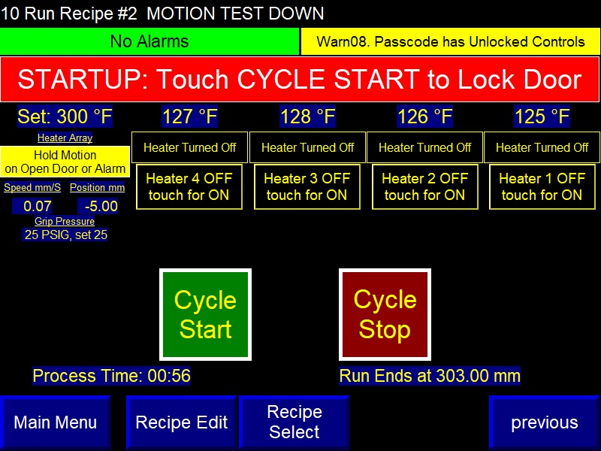This screen is used by the operator to start and stop the laminator and monitor the process.

**Figure 12. Run Screen**

|  |  |
| --- | --- |
| **HMI Screen Object Descriptions** | |
| **Item** | **Description** |
| Menu Buttons | Direct access to specified screens. RECIPE EDIT and RECIPE SELECT are only visible with a good passcode. |
| Run Recipe #1 [NAME]  Run Modified Recipe | Two-state indicator. Shows the recipe number and name. If the recipe has been changed, will show MODIFIED recipe in yellow. |
| Alm##.  Warn##. | Multistate Indicators. Indicators cycle through all alarms and warnings present. See the lists in **Alarms** section and **Warnings** section for descriptions. |
| ERROR: Tripped on Alarm | Multistate Indicator. Shows the state of the Master Control Sequence. |
| Heater Array  Ready for Command | Indicator. Shows the state of the Actuator control sequence. |
| Speed, Position | Numeric Readouts. Shows the actuator speed and position. |

**Table 14. HMI Screen Objects**

|  |  |
| --- | --- |
| **HMI Screen Object Descriptions (Run Parts)** | |
| **Item** | **Description** |
| No Part Present (if applicable) | Indicators. Shows the part present sensor/grip state. |
| Temperature OK | Indicator (each heater). Shows the heater/airflow status as defined in Section **Heater Overtemperature Control, page 50.** |
| 501 ºF, set 500 ºF  15.0 LPM, set 15.0 (if applicable) | Numeric Readouts (each heater). Shows the setpoint and actual value for the temperature and airflow. |
| CYCLE START  CYCLE STOP | Pushbuttons. Used to start and stop the laminator sequence. |
| Horn Silence (if applicable) | Pushbutton. Appears when an alarm is active. Touch to silence the horn. |
| Process Time | Elapsed time for the run. Resets when the next run starts. |
| Runs to xxxx mm | Position of heater array when the run will finish. |
| Encoder Position | Wire Draw Encoder position reading, where the encoder is zeroed when the actuator is homed. |
| Encoder Speed | Counts received in 1 second, then converted to a speed reading. |

**Table 15. HMI Screen Objects - Run Screen**

### CYCLE START Pushbutton

This button is used by the operator when prompted to advance the Master Control Sequence. The operator will be prompted to home the linear actuator, scan a barcode, load the mandrels, and run the process.

### CYCLE STOP Pushbutton

This button is used to reset alarms. If the laminator detects any of the alarms described in Table 19, the CYCLE STOP button is tapped to release the alarm.

Holding the CYCLE STOP button down for 2 seconds through the HMI forces a full Master Control Sequence reset.

### Run Parts Screen without Passcode

The Run Parts screen is slightly different when the passcode has not unlocked the controls. The “Recipe Selected w/ Scanner Only” label shows when the settings require the use of the barcode scanner to select recipes.

**Figure 13. Run Parts Screen**

### Passcode Cleared on Laminator Power Up

Note that a setting is available to automatically clear the passcode after a length of time. The passcode is also cleared when power is first applied to the laminator (first pass of the PLC’s program).

# **Recipe Settings and Descriptions**

Up to 100 recipes can be stored in the PLC. The operator optionally uses a barcode scanner to select a recipe. When a valid passcode is entered, the recipe can be selected from a list. The passcode is required to make alterations and to save a recipe in the database.

Many recipe entries are restricted by the settings noted above. For example, heater temperature is limited by setting s10.

The recipe is a collection of setpoints that are directly copied to the machine controls when the recipe is selected.

## Alternate Units

Speed, distance, and temperature may be shown in alternate units. The recipe is stored in native units of mm and °F.

|  |  |  |  |
| --- | --- | --- | --- |
| **Recipe Settings** | **Units** | **Range** | **Description** |
| Name | ASCII | - | Name stored with the recipe, entered using the alphanumeric keypad of the HMI. |
| Date | ASCII | - | Date of file storage. |
| Barcode | ASCII | - | Barcode string captured and associated with this recipe |
| Temperature | ºF | 0 to 700 [s10] | Heater operating temperature. |
| Load Position | mm | 0 to 2750 [s07] | Position for grip elevator and heater array for loading and unloading. |
| Heater to Grip Offset | mm | 0-508 | Offset applied when the heater array is homed to the bottom of the grip assembly. For example, an offset of 25.4 mm causes the 0 mm position of the array to be one inch below the elevator. |
| Direction (pushbutton) |  | Positive Down or Negative Up | Specifies whether the heating direction is from the top to the bottom of the catheter or starts at the bottom and goes up. |
| Start Position | mm | Computed value | Positive Down: Minimum and Maximum is Grip Start plus Min Start Position [s08].  Negative Up: Minimum is Grip Start plus sum of zone lengths. Max is Max Length [s07]. |
| Start Dwell Time | secs | 0 to 9999 | Time to wait at the start position when the heater is extended. Note that Cooling Dwell Time at end of run is set by [s34] |
| End Dwell Time | secs | 0 to 9999 | Time to wait at the end position when the heater is retracted. |

**Table 16. Alternate Recipe Units**

# **Recipe Select (Screen #20)**

Access to this screen requires the passcode.

Up to 100 recipes can be stored on the Shrink Laminator. The buttons for saving a recipe are only visible when the passcode is entered.

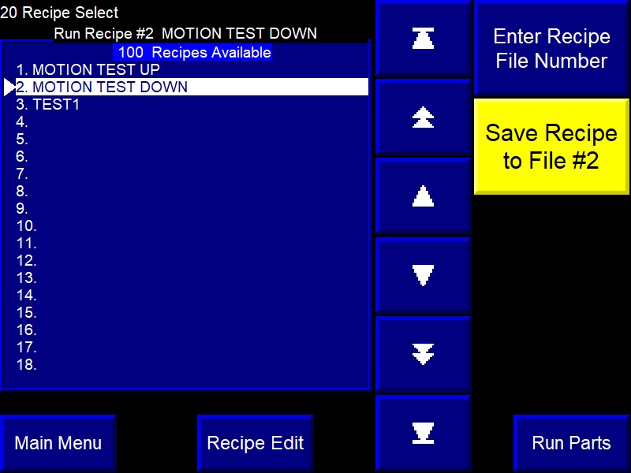If the barcode scanner is used, the 100 files will be searched for a match. The first recipe that has a match will be loaded as the current recipe.

**Figure 14. Recipe Select Screen**

|  |  |
| --- | --- |
| **HMI Screen Object Descriptions** | |
| **Item** | **Description** |
| Menu Buttons | Direct access to specified screens. |
| Enter Recipe File Number | Keypad. Used to set the file number for recipe storage. |
| Save Recipe to File #1. | Pushbutton. The file number is shown on the button. When touched, the user has 5 seconds to touch a CONFIRM button to complete the save. |
| 100 Recipes Available  [Recipe Names on List] | List Selector. Use the middle row of navigation keys to point to the desired recipe. The recipe will be loaded when the screen is changed. |

**Table 17. Recipe Screen Button Description**

# **Recipe Edit (Screen #21)**

Enter the passcode to access this screen from the Main Menu.

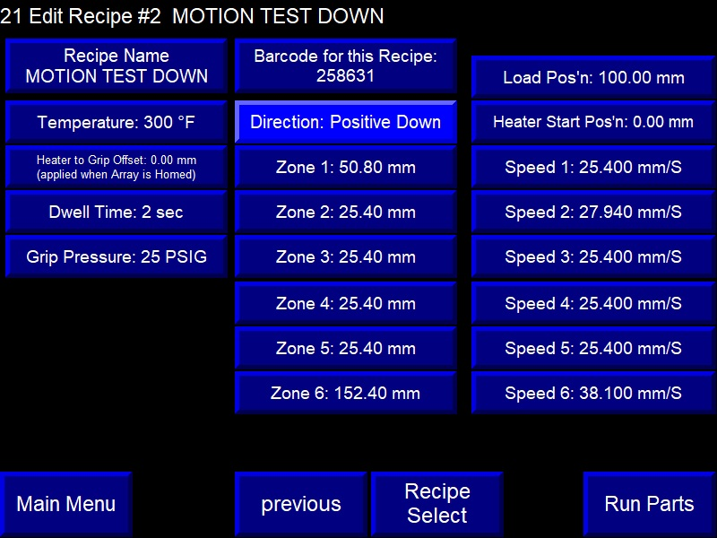This screen is used to change the control settings for the laminator sequence. Each of the variables can be changed by touching the display.

**Figure 15. Recipe Edit Screen**

|  |  |
| --- | --- |
| **HMI Screen Object Descriptions** | |
| **Item** | **Description** |
| Menu Buttons | Direct access to specified screens. |
| Edit Recipe # [NAME] | Shows the currently loaded recipe file number and name. |
| Recipe Name | Alphanumeric keypad. Touch to enter a name for the recipe. |
| Barcode for this Recipe | String Readout. Shows the associated barcode for the recipe |
| Touch to Capture Barcode  Scan Barcode Now! | Pushbutton. Touch to add or change the barcode for the recipe. Button will revert when a code is scanned or after leaving the screen. |
| Temperature through Speed 6, others | Keypads. Each keypad has a minimum and maximum value. The functions of each parameter are reviewed in above sections. |
| Direction: Positive Down or Negative Up | Pushbutton. Negative up selection starts run cycle to traverse from the bottom moving in the up direction. Positive down selection starts run cycle to traverse from the top moving in the down direction |

**Table 18. Recipe Edit Screen Button Description**

# **HMI Support Screens**

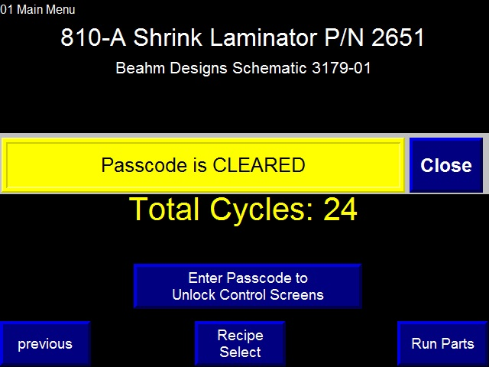The Information Message Banner is triggered by the PLC. The banner automatically closes after 3 seconds, or the CLOSE button can be touched.

**Figure 16. Shutdown Screen**

### Alarm Banner Overlay

The Alarm Banner is triggered by the PLC from the list described in Table 19. Use the CLOSE button to remove the banner.

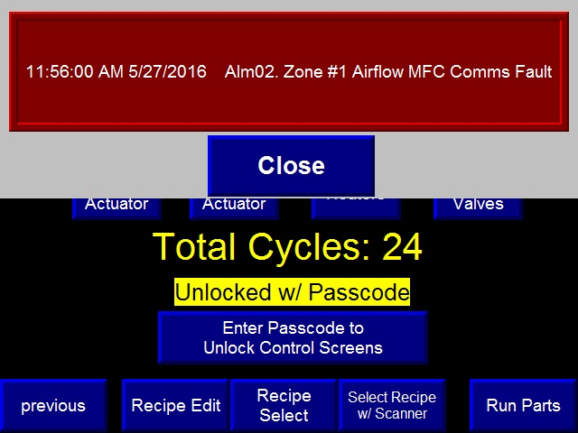If the banner legend is blank, an alarm occurred but has been restored. Check the Alarm Log to determine the specific alarm that triggered the banner.

**Figure 17. Alarm Banner**

### Alarm Log

The Alarm Log holds a record of the last 128 alarm occurrences. The alarm message is saved along with the time the alarm was tripped.

The time is recorded from the HMI’s internal real-time clock. Use the hour/minute/seconds buttons on the PLC Status screen or shut down the application to adjust the HMI clock’s date.

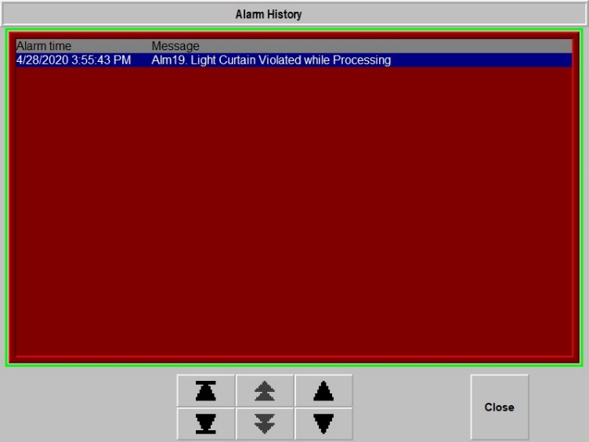Access to this screen is passcode protected.

**Figure 18. Alarm Log**

# **Alarms**

The PLC monitors the laminator for multiple alarm conditions. When an alarm occurs, it brings up an alarm overlay banner on the HMI. The HMI stores the alarm time and the alarm text in an alarm log.

|  |  |
| --- | --- |
| **Alarm Message** | **Comments** |
| Alm00. PLC I/O Module Failure | Fault on one or more Compact I/O modules |
| Alm01. Eurotherm Mini8 Comms Fault | Ethernet communications not OK with temperature controller |
| Alm02. | Spare |
| Alm03. | Spare |
| Alm04. | Spare |
| Alm05. | Spare |
| Alm06. Eurotherm Mini8 Program Fault | Mini8 Temp Controller OK bit not set |
| Alm07. | Spare |
| Alm08. | Spare |
| Alm09. Heater Array Drive Fault | Hardware OK signal lost for heater array |
| Alm10. Heater Broken Thermocouple | No thermocouple report from Mini8 |
| Alm11. Heater Overtemp Controller Trip | PLC thermocouple exceeded shutoff temperature. |
| Alm12. Heater Temp Deviation Trip | Left deviation band while processing |
| Alm13. Heater Airflow Trip | Zone airflow switch OFF while processing |
| Alm14. | Spare |
| Alm15. Thruster Extend Failure | Extend limit not made |
| Alm16. Thruster Retract Failure | Extend limit stayed on |
| Alm17. | Spare |
| Alm18. Heater Array Drive Comms Fault | Ethernet comms failed |
| Alm19. Light Curtain Violated while Processing | Curtain violated while running |
| Alm20. Travel Limit Hit while Processing | Heater array hit overtravel sensor |
| Alm21. to Alm31. | Spares |

**Table 19. Alarm Message Description**

### Alarms while Processing

If an alarm occurs during lamination, the thruster is immediately retracted, and the heater array motion is stopped. The operator must push CYCLE STOP to clear the alarm.

After the alarm is cleared, the heater array and grip elevator are brought to the load position so the faulted parts can be removed.

### Airflow and Temperature Alarms

The airflow and temperature alarms are enabled only when processing.

# **Warnings**

Warnings are shown on the HMI “Run Parts” screen as an aid to the operator.

|  |  |
| --- | --- |
| **Warning Message** | **Comments** |
| Warn00. Controls Not Reset | Safety relay is not reset. |
| Warn01. | Spare |
| Warn02. | Spare |
| Warn03. | Spare |
| Warn04. | Spare |
| Warn05. Light Curtain is Violated *(if applicable)* | Light curtain has been broken/trespassed. |
| Warn06. Doors Interlock is Bypassed | Passcode needed to access the bypass button on the Settings screen. |
| Warn07. | Spare |
| Warn08. Passcode has Unlocked Controls | Correct password has been entered. Controls are unlocked. |
| Warn09. Auto Tuning in Progress | 10-minute tuning time in effect. |
| Warn10. to Warn30. | Spares |
| Warn31. PLC Memory Reloaded from EEPROM! | PLC memory fault has caused the program to reload from the SD card.  Also logged to the alarm log. |

**Table 20. Warning Message Description**

# **Laminator Settings and Recipe Controls**

The settings for the laminator are adjustments that are rarely altered. The recipe controls allow easy process development with storage of the recipe when a good process has been established.

## Alternate Display Unit

The laminator’s native units for distance are millimeters. The native temperature units are degrees Fahrenheit.

The HMI is organized to show the user’s preferred units. For each distance, speed, and temperature on the operating screens, one of two text strings are displayed.

Distance: mm or inch

Speed: mm/S or IPS

Temperature: °F or °C

The settings table and internal recipe storage is maintained in mm and °F.

## Passcode Required to Change Settings

Changes to the settings require the entry of a user passcode. Two different user passcodes are adjustable in the settings. A passcode of “2694” is hard coded into the passcode logic.

The passcode is cleared after a time delay passes when the HMI is displaying the Run Parts screen. The time delay is adjustable in the settings and can be defeated by setting the timeout to ZERO.

## Laminator Settings Variables

The laminator settings are shown in the table below. Each setting has a minimum and maximum value that restricts the data entry keypad’s range. The min/max is user adjustable.

|  |  |  |  |
| --- | --- | --- | --- |
| **Laminator Setting** | **Nominal** | Range | **Description** |
| s00. Temperature Units (0 or 1) | 0 = °F | - | Enter a 1 to select °C. |
| s01. Distance Units (0 or 1) | 0 = mm and mm/s | - | Enter a 1 to select inch and IPS. |
| s02. Actuator Homing Speed | 25 | 10-100 | Actuator speed to seek the upper limit switch. Excessive speed into the limit can cause a drive stall trip. |
| s03. Actuator Fast Speed mm/S | 50 | 10-150 | Actuator speed used to find the upper travel limit. Also sets the maximum recipe speed. |
| s04. Actuator Slow Speed mm/S | 10 | 2-100 | Actuator speed to find home position off the upper travel limit. |
| s05 Actuator Acceleration mm/S/sec | 300 | 50-300 | Actuator acceleration for speed changes. The rate is limited by the PLC to a maximum of 1900 steps/mS/sec. |
| s06. Actuator Steps per mm | 5440 | 5000-6000 | Calibration for both axes. Motor has 66536 steps per revolution at the shaft. |
| s07. Maximum Length | 889 | 500-3000 | Sets the tool length. Sets the maximum positions in the recipe. |
| s08. Minimum Start Position mm | 0 | 0-250 | Sets the minimum heater array position relative to the grip elevator as so to avoid tooling crashes when the thruster extends the heater. |
| s09. Heater Overtemperature Set °F | 1000 | 750-1000 | Temperature setting read by the overtemp T/C that disconnects power from the heater. |
| s10. Max Temperature Setpoint °F | 750 | 0-750 | Limit’s heater setpoint entries. |
| s11. Temp Deviation Limit °F | ±10.0 | 1-100 | Heater deviation band for acceptable temperatures. |
| s12. Heater Cooloff Temperature ºF | 120 | 80-140 | Temperature limit for stopping the airflow through the MFC. |
| s13. Minimum Recipe Speed mm/sec | 0.01 | 0.01-1 | Lowest acceptable recipe speed setting. |
| s14. | 0 | - |  |
| s15. Zone MFC Full Scale Flow LPM *(if applicable)* | 47.19 | 40-80 | Calibration value for the heater MFC’s. |
| s16. Zone MFC Deviation Limit LPM *(if applicable)* | ±0.2 | 0.1-10 | Flow deviation limit for heater zone airflow. |
| s17. Zone MFC Minimum Flow LPM *(if applicable)* | 15 | 40-80 | Minimum allowed flow rate for the heaters. |
| s18. Grip Pressure Regulator Full Scale PSIG | 130 | 70-140 | Full pressure rating of the regulator. |
| s19. Grip Pressure Deviation Limit PSIG | ±2.0 | 0.1-100 | Allowable grip pressure deviation. |
| s20. | 0 | - | Spare |
| s21. Zone 1 Control TC Offset °F | 0.0 | -25 to 25 | Temperature offset for heater 1. |
| s22. Zone 2 Control TC Offset °F | 0.0 | -25 to 25 | Temperature offset for heater 2. |
| s23. Zone 3 Control TC Offset °F | 0.0 | -25 to 25 | Temperature offset for heater 3. |
| s24. Zone 4 Control TC Offset °F | 0.0 | -25 to 25 | Temperature offset for heater 4. |
| s25. | 0 | - | spare |
| s26. Use Thruster (0 or 1) | 1= YES | - | Option to disable the heater thruster. |
| s27. Use Barcode Scanner (0 or 1) | 1= YES | - | Option to disable the barcode scanner. Operator must use the scanner to select a recipe. |
| s28. Brake Release Time Delay secs | 0.20 | 0.1 to 2 | Delay to allow the actuator holding brake to release. |
| s29. to s34. | 0 | - | Spare |
| s35. Heater OFF Inactivity Delay Time secs | 3600 | 0-7200 | Seconds to wait without a process run before shutting off the heaters. |
| s36. Horn ON Time secs | 60 | 0-3600 | Limits length of time horn is on before auto-silencing. Set to ZERO for no horn. |
| s37. Passcode Timeout secs | 0= NO | 0-9999 | The user passcode is cleared after this time interval when observing the RUN PARTS screen. If set to zero, there is no timeout. |
| s38. User Passcode Code 1 | 1 | 1-99999 | Access code for settings and screens. |
| s39. User Passcode Code 2 | 2 | 1-99999 | Access code for settings and screens. |

**Table 21. Laminator Settings Variables**

# **System Operation**

1. Position product within vee grip.
2. Toggle corresponding grip switch to close grip.
3. Repeat for all positions to be utilized.
4. Close cabinet door.
5. Touch “START” on HMI
6. Upon completion of the cycle open the cabinet door, secure the product, and deactivate the corresponding grip switch to release the product.

# **Terms and Definitions**

|  |  |
| --- | --- |
| **Term** | **Definition** |
| A-B | Allen-Bradley |
| PVP | Allen-Bradley touchscreen family |
| Ethernet/IP | Communications protocol for A-B automation equipment |
| HMI | Human Machine Interface providing an operational interface for a system. |
| I/O | Input and Output signals a PLC |
| PLC | Programmable Logic controller |
| PID | Proportional, integral, and derivative control method used to maintain the heater temperature at the desired setpoint. |
| MFC | Mass Flow Controller, used to control airflow through the heater element. |
| SSR | Solid State Relay. The Shrink laminator uses a phase-angle-fired SSR to control the current sent to the heater element. |
| O/T | Overtemp Controller. Separate hardwired device that monitors the heater body for acceptable temperature. |
| LPM | Liters per minute. Heater zone flow rates are manually adjusted. |
| Mini8 | Eurotherm’s Ethernet/IP compatible multi-zone temperature control. |
| UDT | User Data Type. RSLogix5000 method of organizing data. |
| AOI | Add-On Instruction. Custom RSLogix5000 instruction. |
| SCR | Silicon Control Rectifier. Provides maximum control of your heat process, and it can extend heater life. |

**Table 22. Terms, Definitions and Descriptions**

# **Maintenance**

**Note: Perform these steps ONLY when the nozzles are at room temperature.**

**Note: Ensure the machine is unplugged for any servicing or maintenance work.**

## Replacing Thermal Nozzles

1. Loosen lower-rear set screws on heat shield.
2. Remove upper-front button head screws from heat shield and carefully remove heat shield assembly.
3. Loosen the set screw at the side of the nozzle adapter.
4. Slide the nozzle off the heater shield while simultaneously pulling out the thermocouple connector.
5. Install the replacement nozzle by sliding it completely onto the heater shield.

Note: Ensure nozzle is fully seated against overtemp bracket.

1. Tighten the lock set screw.
2. Insert the thermocouple connector into the jack.

**Figure 19: Replacing Thermal Nozzles – Remove Heat Shield**

**Figure 20: Replacing Thermal Nozzles – Nozzle Set Screw**

## Exchanging Vee Guide/insert(s)

1. Remove the fasteners securing the guide to the actuation rail.
2. Position the replacement guide on the rail and align with the mounting holes.
3. Install the fasteners.

**Figure 21: Exchanging Vee Guide/Inserts**

## Replace Heating Element(s)

1. Jog the heater array down to approximately mid-stroke.
2. Remove the fasteners of the heater enclosure top panel.
3. Disconnect the heater power quick-connect terminals.
4. Loosen the heater retainer fastener.
5. Disconnect the heater airline.
6. Pull the heater retainer away from the heater boot.
7. Slide the heater element completely rearward until free of the assembly.
8. Connect airline and fasten heater retainer.
9. Connect heater power quick-connect terminals to heater.
10. Fasten screws on heater enclosure top panel.

**Figure 22: Replace Heating Elements - Top Cover Removal**

**Figure 23: Replace Heating Elements – Remove/install Heater**

## Replace Heater Power Controller

Note: Please contact Machine Solutions for part replacement.

1. Disconnect system power and air.
2. Locate the power controller(s).
3. Using a medium size flat blade screwdriver open the terminal covers.
4. Loosen terminals **1/L1, 3/L2, 2/T1** and **4/T2** at the top front and rear of the controller.

Note: Keep track of wire locations. For schematics, contact Machine Solutions.

1. Pull the signal connector from the front of the controller.
2. Remove the ground connection using a flat blade screwdriver.
3. Using a flat blade screwdriver, pull out the DIN rail lock at the bottom-front of the controller.
4. Replace the power controller and secure it by pushing in the DIN rail lock.
5. Re-install parts and wires from previous steps.
6. Using a small flat blade screwdriver, turn rotary switch COUNTER-CLOCKWISE for 40 full turns.
7. Cycle machine power.

**Figure 24: Replace Heater Power Controller - Locate Controller**

**Figure 25: Replace Heater Power Controller**

## Aligning Tooling

**Note: Alignment should be performed on a prepared product subassembly.**

**Alignment MUST be performed with system power off and heads at ambient temperature.**

1. Open the cabinet door.
2. Remove heat shields as shown in “Replacing Thermal Nozzles”.
3. Secure a .062”-.25” O.D. x 12” mandrel in grip #1
4. Manually extend the heater array assembly.
5. Adjust the vee closure micrometer as required until the vee guides are close but not touching the mandrel.
6. Inspect and compare the gap between the left and right vee guide.
7. Loosen the vee grip actuator fasteners and adjust left or right until the vee guide gap around the mandrel is reasonably even then secure the grip actuator fasteners.
8. Loosen the nozzle assy. mount fasteners and adjust the nozzle assy. left or right, X-Axis, until the nozzle is reasonably centered around the mandrel, then secure the fasteners.
9. Adjust the Y-Axis until the nozzle is reasonably centered with the thermal nozzle.

**Figure 26: Aligning Tooling**

# **System Specifications**

|  |  |  |  |
| --- | --- | --- | --- |
| **Description** | **Range** | **Resolution** | **Accuracy** |
| Temperature | 250-750° F | 1.0 deg. | ± .25% F.S. |
| Grip Pressure | 3-100 psi | 2.0 psi | ± 1.5% F.S. |
| Length | 1-1778 mm  1-2055 mm  1-2550 | 0.1 mm | ± 0.2mm |
| Speed | 0.1-20 mm/sec | 0.1 mm/sec | ± 5% |
| Airflow | 15-35 LPM | 1.0 LPM | ± 1.0% F.S. |

**Table 23. System Specifications**

# **Critical Parts List**

|  |  |  |
| --- | --- | --- |
| **Item** | **P/N** | **Description** |
| 8.6.1 | 1330445-003 | 4-way valve 24 VDC |
| 8.6.2 | 1145807-001 | Heater power SCR |
| 8.6.3 | 1343250-001 | 2-way pneumatic valve |
| 8.6.4 | 1344963-001 | 4-way toggle valve |
| 8.6.5 | 1145607-001 | Bar Code Scanner (optional) |
| 8.6.6 | 1145631-001 | Touch Screen (HMI version only) |
| 8.6.7 | 1145596-001 | PLC (HMI version only) |
| 8.6.8 | 1145622-001 | Motor Drive (HMI version only) |
| 8.6.9 | 110254-001 | Heating element |
| 8.6.10 | 1143786-003 | 8mm proximity sensor PNP NO (HMI version only) |
| 8.6.11 | 1143771-001 | 12mm proximity sensor PNP NO (HMI version only) |
| 8.6.12 | 1143771-003 | 12mm proximity sensor PNP NC (HMI version only) |
| 8.6.13 | 1143287-001 | DPDT Relay (HMI version only) |
| 8.6.14 | 1143133-001 | 0.125” Thermocouple (HMI version only) |
| 8.6.15 | 1143992-001 | 0.062” Thermocouple |
| 8.6.16 | 1345564-001 | Mass Flow Controller (digital flow version) |
| 8.6.17 | 1148096-001 | Keypad HMI (keypad version) |
| 8.6.18 | 1148103-001 | Drive Controller (keypad version) |
| 8.6.19 | 1144980-001 | Limit Switch (keypad version) |
| 8.6.20 | 1150355-001 | Prox. Sensor (keypad version) |
| 8.6.21 | 1146420-001 | Temp Controller (keypad version) |

**Table 24. Critical Spare Parts (contact Machine Solutions for current Price and delivery)**

# **Diagnostics (Troubleshooting)**

|  |  |  |  |
| --- | --- | --- | --- |
|  | **Issue** | **Possible Causes** | **Solution** |
| 8.7.1 | Temperature not stable | Thermal Nozzle replaced.  Thermocouple loose.  MFC flow fluctuation *(if applicable)*.  Tuning on SCR. | Auto-tune  Re-install thermocouple.  Verify air flow.  Contact Machine Solutions. |
| 8.7.2 | S.br (sensor break) | Thermocouple disconnected.  Disconnect of wire between controller and thermal nozzle. | Verify thermocouple/wire connections. |
| 8.7.3 | No heat at nozzle | Heater air flow too low.  Defective heating element.  Defective power control. | Increase air flow.  Replace heating element.  Contact Machine Solutions. |
| 8.7.4 | System will not power on. | Emergency stop switch depressed.  IEC power cord not fully connected. | Rotate switch knob to engage.  Verify installation. |

**Table 25. Diagnostics**

## Ethernet Connections and IP Addresses

These IP addresses are used for system communications. All subnet masks are 255.255.255.0

|  |  |  |
| --- | --- | --- |
| **Name** | Address | **Description** |
| CompactLogix | 192.168.1.150 | PLC’s Ethernet/IP communications port. |
| PanelView Plus CE 1000 | 192.168.1.151 | PVP HMI communications port. |
| Eurotherm Mini8 | 192.168.1.153 | Multi-zone temperature controller port. |
| Heater Array AKD Drive | 192.168.1.155 | Ethernet/IP controlled servo drive. |

**Table 26. Ethernet Connections and IP Addresses**

# **Appendix**

# Sequences of Operation

## Master Control Sequence

The master control sequence boots up the laminator subsystems and serves as the main operator guide for the laminating operation.

Any alarm will cause the sequence to jump to State 31. Touch the CYCLE STOP button to release the alarm. An alarm will retract the heater assembly and stop the actuator motion.

Holding the CYCLE STOP button down for 2 seconds resets the master control sequence.

| **State** | **Master Control Sequence Label** | **Comments** |
| --- | --- | --- |
| 0 | Control System Full Reset | User must release the RESET button to leave this step.  Door lock is released. |
| 1 | Controls Not Reset - Push POWER RESET Button | Master Control Relay is not reset. Clear the emergency stop and push the blue reset button |
| 2 | STARTUP: Opening Main Air Valve | Allows 2 seconds for air to fill system. |
| 3 | STARTUP: Retracting Heaters | Heater must be retracted before moving actuator |
| 4 | STARTUP: Touch CYCLE START to Lock Door | n/a |
| 5 | STARTUP: Waiting for Door to Close | Door lock is de-energized to latch the door. A signal is received when the latch is made.  Note that the MAINTENANCE door is also guarded along with the PROCESS door. |
| 6 |  | N/A |
| 7 | READY: Touch CYCLE START to home Actuator | Homing starts when doors are closed. |
| 8 | HOMING: Homing Grip Elevator | N/A w/o grip elevator.  Starts the grip elevator towards the upper limit. Home (zero) position is just off the upper fixed travel limit. Delays 5 secs before going to the next step. |
| 9 | HOMING: Homing Heater Array | Moves the heater array actuator up until the travel limit on the upper side of the heater array is sensed, then moves to the home (zero) position just after the switch is restored. This upper limit switch is also the lower travel limit for the elevator. |
| 10 | HOMING: Move Actuator to Load Position at [Load Posn] | Moves the heater array down to the height specified in the recipe.  If an alarm has occurred during processing, jump to Step 27 so that parts can be removed.  The door is unlocked after this step. |
| 11 | STARTUP: Use Scanner to Select Recipe | When every power is reset, the operator must select a recipe using the barcode scanner. If the passcode is in effect, pushing the CYCLE START button bypasses this step.  Door lock is released. |
| 12 | STARTUP: Turn on at least one Heater and install the Mandrel | The operator must turn on a heater and load the mandrel to proceed. |
| 13 | STARTUP: Bringing Loaded Heaters up to Temperature | Turns on the MFC at the recipe flowrate. For each heater, the PLC waits for the airflow reading to match the setpoint, then turns on the heater’s mechanical relay. For each heater, the PLC turns on the SSR to send power to the heater. The sequence will stay on this step until all temperatures have stabilized around the setpoint. |
| 14 | LOAD: Load Parts or touch CYCLE START to run empty | The cycle may be run without parts for testing. This step is skipped if parts are present. |
| 15 | LOAD: Touch CYCLE START to Lock Door | Releases the door lock solenoids. |
| 16 | LOAD: Waiting for Door to Close | Holds here until the doors are closed, then go to Step 18. |
| 17 | READY: touch CYCLE START to Move Actuator to Start Position | Ready to move to start position |
| 18 | RUN: Move Heaters to [Heater Start] | Moves actuators to initial position. |
| 19 | READY: touch CYCLE START to Run Parts | Touching CYCLE START begins the laminating cycle.  Touch CYCLE STOP to unlock the door. This jumps the sequence to Step 14. |
| 20 | RUN: Close Vee Guides, Extend Heater, Dwell at Start for [Dwell Time Left] | Thrusts the heater array to the parts.  Closes the Vee Guide.  Counts down the dwell time at the start position. |
| 21 | RUN: Zone [x] at Speed [y] for Length [z] (runs to [End Posn]) | Display while the part is processing.  Moves the heater array actuators through the six recipe zones at the zone speed to the calculated end position. |
| 22 | RUN: Retract Heaters | Pulls heater back from product. |
| 23 | WAITING AT END OF RUN: Touch Cycle Start to Finish | Wait for Operator option is SET in the settings. |
| 24 | END OF RUN: Waiting for Door to Close | Waiting for door to close. |
| 25 | RUN: Move Actuator to Load Position at [FastJogSpeed] | Moves to start position. |
| 26 |  | N/A |
| 27 | UNLOAD FAILED PARTS: Open Door and Remove ALL Parts Now  touch CYCLE START to resume | Waits at this state until all grips are opened. Jumps back to Step 14 when the grips are cleared.  Door lock is released. |
| 28 | UNLOAD: Remove Finished Parts - Touch Cycle Start to Proceed | Returns to Step 14 when CYCLE START is pushed.  Door lock is released. |
| 29 |  | N/A |
| 30 |  | N/A |
| 31 | ERROR: Tripped on Alarm - Touch CYCLE STOP to reset | Alarm state. Stops motion and retracts thruster.  Door lock is released. |

**Table 27. Master Control Sequence**

# **Servo Motor Control Sequence**

The servo motor uses a set of add-on instructions. The PLC uses a control sequence to send commands in the correct order. The control sequence below allows for the operator to manually move the servo motor and supports automatic operation.

The step number drives a multi-state indicator on the Run Parts screen.

|  |  |  |
| --- | --- | --- |
| **Step** | **State Label** | **Description** |
| 0 | Servo Sequence Reset | Reset by master sequence. |
| 1 | Wait for AKD Comms OK | PLC must have good ethernet comms to the AKD drive. |
| 2 | Wait for Controls Reset | Power must be reset. |
| 3 | Shut Down Drive | Stops the drive. |
| 4 | Motor Selected OFF | HAND/OFF/AUTO control set to OFF. |
| 5 | Reset Shutdown | Clears shutdown mode of drive. |
| 6 | Reset Drive Faults | Clears drive faults. |
| 7 | Enable Drive | Turns on PLC output for drive enable/reset. |
| 8 | Ready for Command | Wait for manual or auto command. |
| 9 | Homing: Find Upper Limit | Fast jog to the upper travel limit |
| 10 | Homing: Jog Off Upper Limit | Slow jog down to find electrical zero. |
| 11 | Set Homed OK | Immediate home. Home offset applied in logic. |
| 12 | Jogging Down | Positive Jog. |
| 13 | Jogging Up | Negative Jog. |
| 14 | Hold Motion | Stops motion. |
| 15 | Relative Move | Not used |
| 16 | Move to [Position Reading] | Absolute move, used for START and LOAD moves. |
| 17 | Attempt N159 Error Recovery | Slight jog to clear communication error.  Three attempts allowed. |
| 18-23 |  | Not used |
| 24 | ERROR: Positive Limit Hit | Manual jog. |
| 25 | ERROR: Negative Limit Hit | Manual jog |
| 26 | ERROR: Positive Limit Trip | Unexpected hit. |
| 27 | ERROR: Negative Limit Trip | Unexpected hit. |
| 28 | ERROR: Home Not Found | Not used |
| 29 | ERROR: No Hardware Enable | Not used |
| 30 | ERROR: Motor Software Error | Servo command error detected. |
| 31 | ERROR: Motor Hardware Fault | Fault relay from drive is OFF. |

**Table 28. Servo Motor Control Sequence and Description**

# **Airflow and Temperature Controls**

The process heaters do not use a control sequence, but each heater has multiple interlocks to allow good temperature control.

All four heaters have the same control structure.

## Air Flow Controls

A manual flow control valve is supplied for each of the four zones. The air pressure switch must be activated before power is allowed to the heater.

## Heater Overtemperature Control

The PLC monitors a second thermocouple on the body of the heater. The PLC will allow the heater power relay to close if the temperature is below the O/T unit’s setpoint.

## Multi-Loop Temperature Controller

The Eurotherm Mini8 Loop Controller runs all four heaters. Each loop physically consists of a Type “K” thermocouple and a 4/20 mA heating output. Each loop uses a temperature setpoint to determine how much heating to apply.

The PLC can only change the setpoints in the controller. To turn off heating, the PLC sends a setpoint of 0 °F.

The PLC monitors the HMI pushbutton used by the operator to turn on or off a nozzle zone.

When the zone is turned on, the PLC changes the MFC controller’s setpoint from zero to the airflow setpoint. Once airflow is proven by feedback from the MFC, the PLC will close a relay that allows power to flow to the heater.

At this point, the temperature setpoint is changed from zero to the running setpoint and the Mini8 starts running the heater’s Silicon Control Rectifier (SCR).

The temperature deviation and airflow are monitored by the PLC for use in the control logic.

## Auto Tuning Triggered by the PLC

The Mini8’s program is set up to monitor Digital Input 1 of the Mini8. When energized by the PLC, the Mini8 sets the AutoTune bit on for all four zones.

When auto tuning, start with a cold zone. Turn on the heater to the desired tuning setpoint. Turn on the Auto Tune Start button from the Settings submenu to perform the auto tune.

## Heater / Airflow Multistate Indicator

The state of the heating system is reflected by the readout on a multistate indicator. The indicator is bit-triggered, where the lowest numbered bit is used to select the label.

|  |  |  |
| --- | --- | --- |
| **Bit** | **Heater Multistate Indicator Label** | **Comment** |
| 0 | Controls Not Reset | Power required for heating |
| 1 | Heater T/C Broken! | Broken thermocouple sensed by the input module |
| 2 | Airflow Not Ready | Airflow reading must be within 2% of the setpoint |
| 3 | Heater Turned Off | Heater is not requested to be on |
| 4 | Overtemp Control Trip! | O/T control has detected high temperature |
| 5 | Part Loaded w/o Heater ON | A mandrel is gripped, but the heater is not turned on by the operator. |
| 6 | Tripped on No Temp Increase! | Temperature rise check not passed in time |
| 7 | Heater High Temp Deviation! | More than 5 ºF above setpoint after reaching setpoint |
| 8 | Heater Low Temp Deviation! | More than 5 ºF below setpoint after reaching setpoint |
| 9 | Heater Not Near Setpoint | Heater must stay with 2 ºF of setpoint for 2.5 seconds to be “near setpoint” |
| 10 | Airflow Running to Cool Down | Heater is turned off, but the temperature is still above the cool off temperature setting |
| 11 | Heater at Temp Limit! | not used |
| 12 | Heater is OFF | not used |
| 13 | HS13 | not used |
| 14 | HS14 | not used |
| 15 | Heater Temperature OK | Always on, all other bits are off. |

**Table 29. Heater Multistate Indicator and Description**

## Thermocouple Offset

The offset from Settings s21 to s24 are sent from the PLC to the Eurotherm Mini8 controller. The offset is added to the Mini8’s thermocouple reading.

# **Servicing**

**Please contact Machine Solutions for instructions on specific component replacement.**

# **Cleaning**

Note: All products are cleaned before they are shipped; however, it is recommended that the user clean the exterior of the machine before use.

Use only 100% Isopropyl alcohol to clean this machine.

# **Warranty**

Machine Solutions products are backed by a 1-year warranty on parts and labor. Warranty is void for any product returned if MSI determines that:

1. The asserted defect is not present,
2. The asserted defect is attributed to misuse, improper installation, alteration (label removal and/or destruction, opening or removing external covers without authorization by Machine Solutions), mishandling and/or mishaps.
3. The product was not sold to customer as new.

# **Return Material Authorization (RMA)**

Product may not be returned to Machine Solutions without first contacting MSI Aftermarket for a Return Material Authorization (RMA) number. If it is determined that the Product may be defective, you will be given an RMA number and instructions for Product return. End Users are required to include a copy of the RMA receipt inside the return box, in order to receive replacement product under the warranty. All unauthorized returns i.e., one for which an RMA number has not been issued, will be returned at the customers expense. To request an RMA, please contact us at 928-556-3109 or email [info@machinesolutions.com](mailto:info@beahmdesigns.com)

For additional information on Machine Solutions, 810-A Vertical Laminator, please visit <http://machinesolutions.com/our-products/>