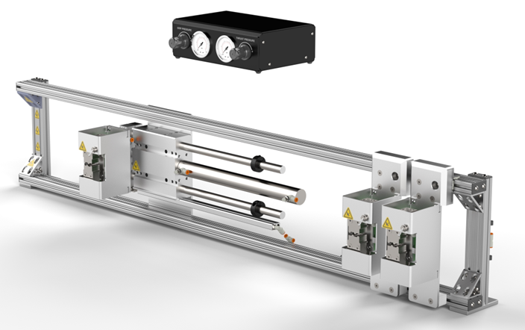

**BEAHM DESIGNS MANDREL STRETCHER**

MODEL C-75

The Machine Solutions Inc. products shown and described in this catalog may be covered by one or more of the following US Patents: #6,629,350, #6,968,607, #6,925,847, #6,988,881, #6,931,899 and #7,069,794. Other US and International Patents Pending.

Machine Solutions, MSI, and C-75 are trademarks or service marks of Machine Solutions Inc.

Copyright (©) Machine Solutions Inc. All Rights Reserved.

Product images are representative of standard equipment offerings and may differ from delivered equipment.

Table of Contents

Table of Contents 3

List Of Figures 4

List Of Tables 4

Welcome 5

Machine Description 5

Safety 5

User Alerts 6

Contents 6

Installation 6

system operation 7

System Controls And Features 8

Parameter Settings 10

Specifications 10

Facility Requirements 10

Maintenance 10

Critical Parts 11

Diagnostics And Troubleshooting 11

Customer Support And Satisfaction 12

Warranty And Limitations 13

List Of Figures

**Figure 1. C-75 Mandrel Stretcher Remote Box Front Panel** 8

**Figure 2. C-75 Gripper Assembly** 9

List Of Tables

**Table 1: Control Box Controls and Functions** 8

**Table 2: Controls and Functions** 9

**Table 3: System Specifications** 10

**Table 4: Critical Spare Parts with Descriptions** 11

**Table 5: Diagnostics and Troubleshooting** 11

Welcome

Machine Solutions, Inc. (MSI) would like to take this opportunity to thank you for purchasing your new C-75 Mandrel Stretcher machine. At MSI, we are dedicated to bringing innovative process development solutions to both medical device and nonmedical organizations. MSI looks forward to helping your organization provide life-improving devices to your customers, today and tomorrow.

Machine Description

The Beahm Designs Inc. Model C-75 Mandrel Stretcher is a system for the purpose of removing a core mandrel from a shaft assembly by means of stretching the mandrel to reduce the diameter.

Safety

* Place the system on a level, sturdy surface at an ergonomically viable height for the user.
* Use of eye protection when working with compressed gases and heated materials is advised.
* The maximum observed Sound Pressure Level is below 70 dBA.

**Caution: pinch point. Keep hands and body parts clear while in operation.**

User Alerts

Do not use or otherwise operate the machine in any manner other than that in which it is explicitly intended. Examples: Do not attempt to sit on or climb on the equipment, do not place heavy objects or containers of liquid on the machine, do not to insert any foreign objects into the machine and do not attempt to bypass any guards.

**Note: This equipment is not for use in an ATEX environment.**

Contents

Included with the system are the following contents:

* Main C-75 stretch frame
* Grip and thrust pressure control box
* Pneumatic activation foot switch

Installation

1. Place the system on a sturdy, and level surface.
2. Secure frame to surface.
3. Connect control box and foot switch to stretch frame.
4. Connect the air supply hose to the system, and then to a clean, dry, and filtered compressed air source.

system operation

1. Ensure all grippers are in open positions.
2. Adjust gripper and thruster pressure.
3. Place mandrel in between thrust and stationary grippers.
4. While holding the mandrel in place toggle the thrust and stationary grippers closed.
5. Take hands away from system and toggle the thruster foot switch.
6. Remove product from grippers.

System Controls And Features

Located on the front are the following controls and/or displays and their function.

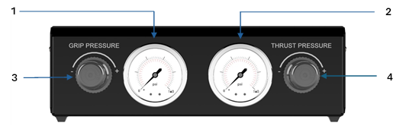

**Figure 1. C-75 Mandrel Stretcher Remote Box Front Panel**

**Table 1: Control Box Controls and Functions**

|  |  |
| --- | --- |
| **Item** | **Function** |
| 1 | Displays air pressure supplied to machine grippers. |
| 2 | Displays air pressure supplied to pneumatic thruster. |
| 3 | Controls gripper air pressure. |
| 4 | Controls thruster air pressure. |



44

**Figure 2. C-75 Gripper Assembly**

**Table 2: Controls and Functions**

|  |  |
| --- | --- |
| **Item** | **Function** |
| 1 | Thrust gripper assembly |
| 2 | Stationary gripper assemblies |
| 3 | Toggles gripper open/close |
| 4 | Sets mandrel stretch distance |
| 5 | Loosen to adjust gripper distance. Tighten to lock down. |

Parameter Settings

* Grip Pressure: 0 PSI to 120 PSI
* Thrust Pressure: 0 PSI to 120 PSI
* Stretch Distance: 0 inches to 13 inches

Specifications

**Table 3: System Specifications**

|  |  |  |  |
| --- | --- | --- | --- |
| **Description** | **Range** | **Resolution** | **Accuracy** |
| Pressure | 0-160 PSI | 4.0 PSI | +/‐ 1.6% F.S. |

## Facility Requirements

* Compressed Air: 120 PSI

Maintenance

**Note: Ensure the machine is unplugged from air for any servicing or maintenance work.**

Caution: pinch point/crush hazard. Keep fingers, hands, and clothing clear of moving parts.

1. Use 99% isopropyl alcohol to wipe down the outside of the machine. Do not attempt to clean the inside of the machine. Machine should not be washed down.
2. Cleaning should be with a soft dry cloth only.

Critical Parts

For replacement or spare parts, please contact us at [service@machinesolutions.com](mailto:service@machinesolutions.com), or call

928-556-3109.

**Table 4: Critical Spare Parts with Descriptions**

|  |  |
| --- | --- |
| **Part Number** | **Description** |
| 1346311-001 | PRESSURE REGULATOR 1/4-NPT PORTS |
| 1361904-001 | GAUGE, 2.5IN DISPLAY, 0-160PSI, 1-4NPT |
| 130118-001 | VALVE, TOGGLE, 4WAY, 2 POSITION |
| 1361727-001 | FOOT SWITCH, VALVE, 5-2, 1-4 NPT, 150 PSI |

Diagnostics And Troubleshooting

**Table 5: Diagnostics and Troubleshooting**

|  |  |  |
| --- | --- | --- |
| **Issue** | **Possible Causes** | **Solution** |
| Air hose coming loose from fittings | Air pressure above 120 PSI being used. | Regulate incoming air to 120 PSI |
| Mandrel slipping from grippers | Grip pressure too low  Wrong mandrel material being used | Raise grip pressure  Change to softer mandrel |
| Mandrel not stretching | Thruster pressure too low  Wrong mandrel material being used | Raise thruster pressure  Change to softer mandrel |

Customer Support And Satisfaction

Machine Solutions Inc. is proud of the advanced engineering and quality construction of each piece of equipment that we build. It is our goal to provide equipment that exceeds the expectations of the customer. By implementing the highest standards and applying our experience to provide a quality product, we maintain an ongoing, positive working relationship with all our customers.

Machine Solutions Inc. welcomes your comments and inquiries about our products and services.

Machine Solutions Inc.

2951 West Shamrell Blvd., Suite 107

Flagstaff, AZ 86005

Phone: 928-556-3109

Fax: 928-556-3084

E-Mail: Service@MachineSolutions.com

Warranty And Limitations

***General Warranty***

Machine Solutions Inc. (MSI) warrants its products to be free from defects in material and workmanship in normal everyday use and service for a period of one year from the date of shipment from the factory in Flagstaff, Arizona. MSIs obligation under this warranty shall be limited to the repairing or replacing of the product or parts thereof which upon MSIs inspection reveals them to be defective. MSI reserves the right and option to refund the purchase price in lieu of repair or replacement upon evaluation of the returned original part. Modifications, misuse, attempted repairs by others, improper calibration or operation shall render this guarantee null and void. MSI MAKES NO OTHER WARRANTY REGARDING THIS PRODUCT, INCLUDING ANY EXPRESS OR IMPLIED WARRANTY. SPECIFICALLY, THERE IS NO WARRANTY OF MERCHANTABILITY OF THIS PRODUCT OR OF THE FITNESS OF THE PRODUCT FOR ANY PURPOSES. THE SUITABILITY OF THIS PRODUCT FOR ANY PURPOSE PARTICULAR TO THE CUSTOMER IS FOR THE CUSTOMER, IN ITS SOLE JUDGEMENT, TO DETERMINE. MACHINE SOLUTIONS, INC. ASSUMES NO RESPONSIBILITY FOR THE SELECTION OR USE OF THIS PRODUCT BY CUSTOMER. This product has not been tested or approved by the U.S. Food and Drug Administration or any other agency of the U.S. government. This product is not a consumer product as that term is defined in the Magnuson-Moss Warranty – Federal Trade Commission Improvement Act, 15 U.S.C. § 2301 et seq.

***Software License***

By using this equipment, and/or installing or using any of the software associated with the same, you indicate your acceptance of each of the terms of this license. Upon acceptance, this license will be a legally binding agreement between you and MSI. The terms of this license apply to you and to any subsequent user of the software. If you do not agree to all of the terms of this license (i) do not install or use the software and (ii) return the equipment and the software (collectively, equipment), including all components, documentation and any other materials provided with the equipment, to MSI. The software includes associated media, any printed materials, and any on-line or electronic documentation. Software provided by third parties may be subject to separate end-user license agreements from the manufacturers of such software. This license shall also apply to any updates, bug fixes, or newer versions of the software provided by MSI for use with this equipment.

You may: (1) Use the software only in connection with the operation of the equipment; (2) Transfer the software (including all component parts and printed materials) permanently to another person, but only if the person agrees to accept all of the terms of this license. If you transfer the software, you must at the same time transfer the equipment and all copies of the software (if applicable) to the same person or destroy any copies not transferred; and (3) Terminate this license by destroying the original and all copies of the software (if applicable) in whatever form.

You may not: (1) Loan, distribute, rent, lease, give, sublicense or otherwise transfer the software, in whole or in part, to any other person, except as permitted under the transfer paragraph above; (2) Copy or translate the User Guide included with the equipment; (3) Copy, alter, translate, decompile, disassemble or reverse engineer the software, including but not limited to, modifying the software to make it operate on non-compatible hardware; or (4) Remove, alter or cause not to be displayed, any copyright notices or startup message contained in the software programs or documentation

Title to the software, including the ownership of all copyrights, patents, trademarks, and all other intellectual property rights subsisting in the foregoing, and all adaptations to and modifications of the foregoing shall at all times remain with MSI and its third-party licensors, if any. MSI retains all rights not expressly licensed under this license. Except as otherwise expressly provided in this license, the copying, reproduction, distribution, or preparation of derivative works of the software, or any portion of the equipment, is strictly prohibited. Nothing in this license constitutes a waiver by MSI of its rights under United States copyright law.

***Protection of Intellectual Property***

The equipment and its incorporated technology (collectively referred to herein as the Technology), is protected under issued and pending patents. The Technology is valuable and proprietary technology, including trade secret technology, belonging to MSI. Much of the Technology is nonpublic and confidential. As our customer, you agree to further assist MSI in the protection of our intellectual property as follows: You agree to keep the Technology you receive confidential at all times, and shall not, without the prior written consent of MSI, disclose the Technology, in whole or in part, to any person outside of your company. You further agree that you shall not reverse engineer, disassemble, decompile, or copy the Technology without the prior written consent of MSI.

In addition, you agree that the equipment will not be used to manufacture anything other than products in which you hold intellectual property rights free of infringement of others. You may not use the equipment to manufacture any product infringing on another’s patented rights. By accepting and using the equipment, you agree to defend and indemnify Machine Solutions, Inc., its officers, directors, employees, and agents, from and against any claims of infringement as a result of your use of the equipment.

***Regulatory Matters***

All equipment validations, product validation, final product QC testing and other testing required by the U.S Food and Drug Administration are the sole responsibility of the customer. Machine Solutions, Inc. shall have no responsibility or liability for the performance of any interventional product on which this equipment is used.