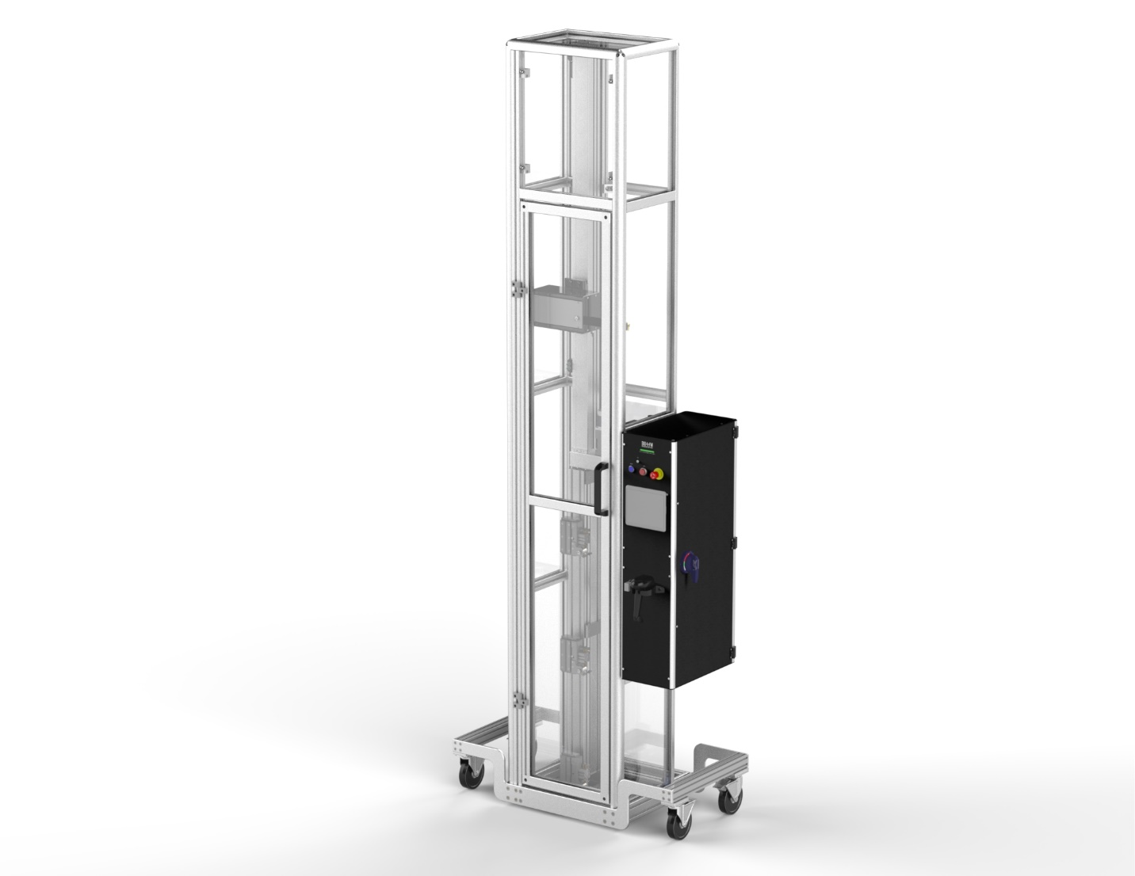
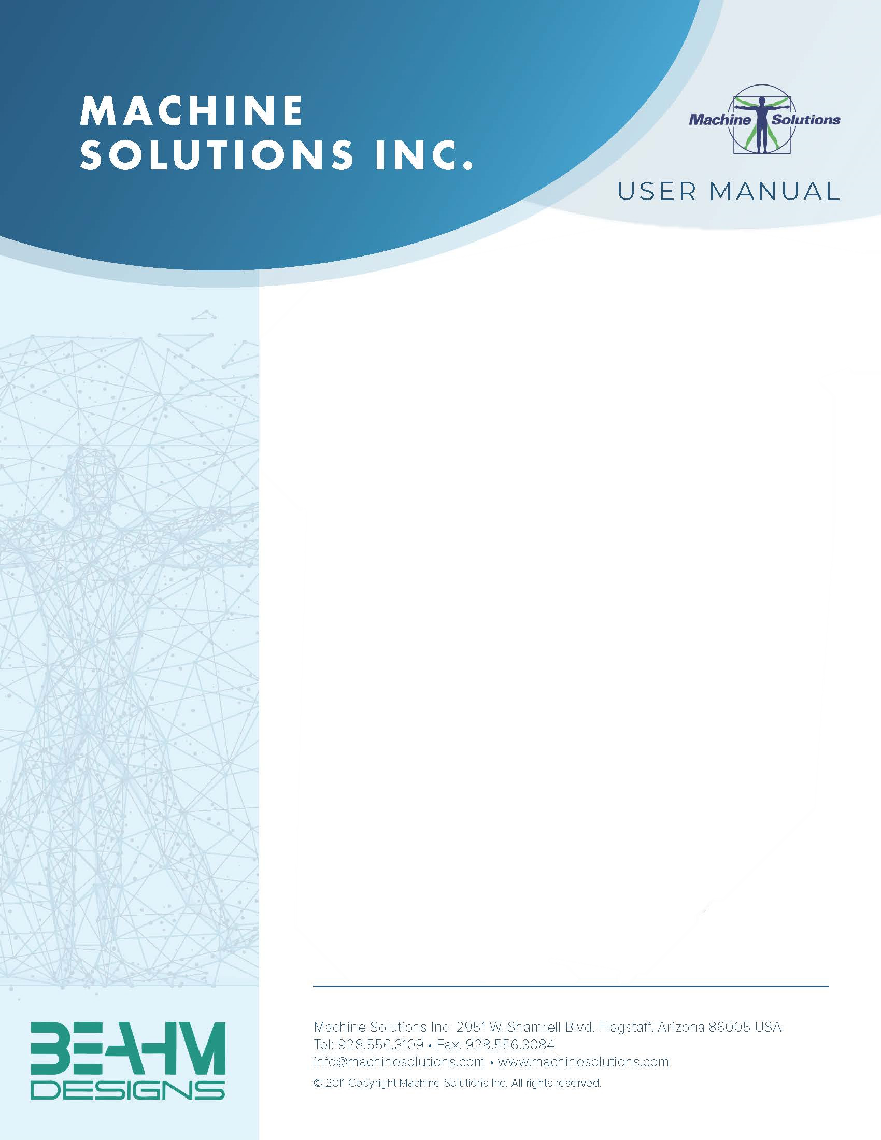
BEAHM DESIGNS MANDREL REMOVER
MODEL C-80
The Machine Solutions Inc. products shown and described in this catalog may be covered by one or more of the following US Patents: #6,629,350, #6,968,607, #6,925,847, #6,988,881, #6,931,899 and #7,069,794. Other US and International Patents Pending.

Machine Solutions, MSI, and C80 are trademarks or service marks of Machine Solutions Inc.
Copyright (©) Machine Solutions Inc. All Rights Reserved.

Product images are representative of standard equipment offerings and may differ from delivered equipment.

Table Of Contents
Table Of Contents 3
List Of Figures 5
List Of Tables 6
Welcome 7
Control System Overview 7
Process Overview 7
Safety 8
Installation 9
Terms And Definitions 9
Controls And Features 10
Electrical System Operation And Features 13
Power Requirements 13
Main Disconnect 13
Disconnect Switch 13
Emergency Stop Loop and Hardwired Devices 13
CompactLogix Programmable Logic Controller System 13
PLC Secure Digital Card 13
Barcode Scanner Connects to PanelView’s USB Port 14
Stepper Motor Control Module 14
ST10 Step Motor Drive Configuration 14
Settings And Recipe Controls 15
Alternate Display Units 15
Passcode Required to Change Settings 15
Settings List 16
Recipe Settings and Descriptions 17
Alternate Units 17
Information Messages 18
Alarms 18
Warnings 19
Sequences Of Operation 20
Master Control Sequence 20
Linear Actuator Motor Control Sequence 22
Panelview Plus HMI Display Description 23
Data Entry Keypads 23
Main Menu (Screen #01) 24
Run Parts (Screen #10) 26
CYCLE START Pushbutton 27
CYCLE STOP Pushbutton 27
Run Parts Screen without Passcode 27
Passcode Cleared on System Power Up 27
Recipe Select (Screen #4) 28
Recipe Edit (Screen #5) 29
Settings (Screen #3) 30
Puller Linear Actuator (Screen #11) 32
Solenoid Valves (Screen #12) 34
Grip Regulators (Screen #13) 35
PLC Status and HMI Shutdown (Screen #2) 36
HMI Support Screens 37
Information Overlay 37
Alarm Banner Overlay 38
Alarm Log 39
Maintenance 40
Critical Parts 43
Customer Support And Satisfaction 44
Warranty And Limitations 45

List Of Figures
Figure 1. C-80 Mandrel Remover Front Panel Controls and Features 10
Figure 2. C-80 Mandrel Remover Back Panel Controls and Features 11
Figure 3. Gripper Open and Close Switch 11
Figure 4. Collet Open and Close Switch 12
Figure 5. Data Entry Keypad 23
Figure 6. Main Menu Screen 24
Figure 7. Main Menu No Password Present Screen 25
Figure 8. Run Parts Screen 26
Figure 9. Run Parts Screen Without Passcode 27
Figure 10. Recipe Select Screen 28
Figure 11. Recipe Edit Screen 29
Figure 12. Settings Screen 30
Figure 13. Settings screen after Min/Max Enable button selected 31
Figure 14. Puller Linear Actuator Screen 32
Figure 15. Solenoid Valves Screen 34
Figure 16. Grip Regulators Screen 35
Figure 17. PLC Status and HMI Shutdown Screen Buttons/Displays and Descriptions 36
Figure 18. Information Message Banner 37
Figure 19. Alarm Banner 38
Figure 20. Alarm Log Screen 39
Figure 21. Stretch Grips Installation 42

List Of Tables
Table 1. C-80 Mandrel Remover Control and Display Functions 10
Table 2. Machine Settings 16
Table 3. Recipe Settings and Descriptions 17
Table 4. Information Messages 18
Table 5. Alarm Messages 18
Table 6. Warning Messages 19
Table 7. Master Control Sequence 20
Table 8. Linear Actuator Motor Control Sequence State Labels 22
Table 9. Main Menu Screen Buttons/Displays and Descriptions 24
Table 10. Run Parts Screen Buttons/Displays and Descriptions 26
Table 11. Recipe Select Screen Buttons/Displays and Descriptions 28
Table 12. Recipe Edit Screen Buttons/Displays and Descriptions 29
Table 13. Settings Screen Buttons/Displays and Descriptions 30
Table 14. Settings Screen after Min/Max button selected Buttons/Displays and Descriptions 31
Table 15. Puller Actuator Screen Buttons/Displays and Descriptions 32
Table 16. Linear Actuator Screen Buttons/Displays and Descriptions 33
Table 17. Solenoid Valves Screen Buttons/Displays and Descriptions 34
Table 18. Grip Regulators Screen Buttons/Displays and Descriptions 35
Table 19. PLC Status and HMI Shutdown Screen Buttons/Displays and Descriptions 36

Welcome
Machine Solutions, Inc. (MSI) would like to take this opportunity to thank you for purchasing your new C-80 Mandrel Remover machine. At MSI, we are dedicated to bringing innovative process development solutions to both medical device and nonmedical organizations. MSI looks forward to helping your organization provide life-improving devices to your customers, today and tomorrow.

Control System Overview
The control system consists of an Allen-Bradley CompactLogix PLC (A-B P/N 1769- L24ER-QBFC1B) and an Allen-Bradley PanelView Plus Compact Edition HMI (A-B P/N 2711PC-T6C20D8) 6” color display terminal. The PLC controls the operation of a linear actuator and a triple gripping system (HMI controlled grips on Auto machine only). The human machine interface (HMI) provides the operator with the means to monitor and control the operation of the puller and to set up control parameters.

Process Overview
The Mandrel Removal System is a tool used to extract the core mandrel from a catheter assembly. Variable speed and distance controls allow control of the extraction process.

The mandrel is gripped by a collet mounted on the linear actuator. The product is gripped at several positions fixed to the frame.

When the process is started, the collet is moved up through three speed zones. After the mandrel and product are removed from the tool, the collet is returned to the starting position.

The operator can select a recipe from a set of 100 recipe files using a barcode scanner. Each file contains the variables used by the process sequence.

A passcode is used to control access to the recipe settings, machine settings, and several test screens on the HMI.

Safety

- Place the system on a level, sturdy surface at an ergonomically viable height for the user.
- Use of eye protection when working with compressed gases and heated materials is advised.
- The maximum observed Sound Pressure Level is below 70 dB(A).

 Caution: high voltage. Remove power and use safety precautions when servicing.
 Caution: pinch point. Keep hands and body parts clear while in operation.

Installation
- Place the system on a level, sturdy surface.
- Lock casters
- Connect the power cord to 120/240 VAC 50/60 Hz. Outlet. Confirm voltage on machine label.
- Connect the air supply hose assembly to the system and then to a clean, dry, and filtered compressed air source.

Terms And Definitions

Term | Definition
A-B | Allen-Bradley
PVP | Allen-Bradley touchscreen family
Ethernet/IP | Communications protocol for A-B automation equipment
HMI | Human Machine Interface providing an operational interface for a system.
I/O | Input and Output signals a PLC
PLC | Programmable Logic controller
UDT | User Data Type. RSLogix5000 method of organizing data.
AOI | Add-On Instruction. Custom RSLogix5000 instruction.

Controls And Features
Located on the front and rear panels are the following controls and features.
1
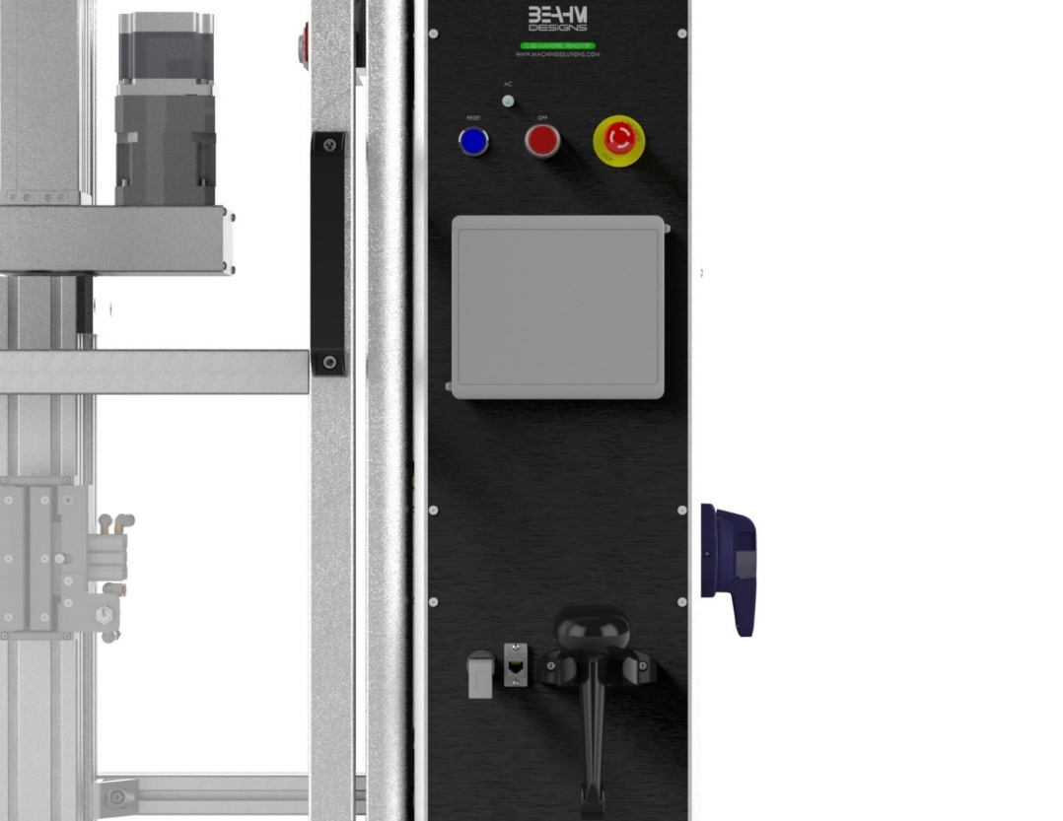
2
3
Figure 1. C-80 Mandrel Remover Front Panel Controls and Features

Table 1. C-80 Mandrel Remover Control and Display Functions
 | Description | Function
1 | Reset Button
2 | Stop Button
3 | E-Stop
4 | Air Connection Valve
5 | Gripper Open/Close Switch
6 | Collet Open/Close Switch

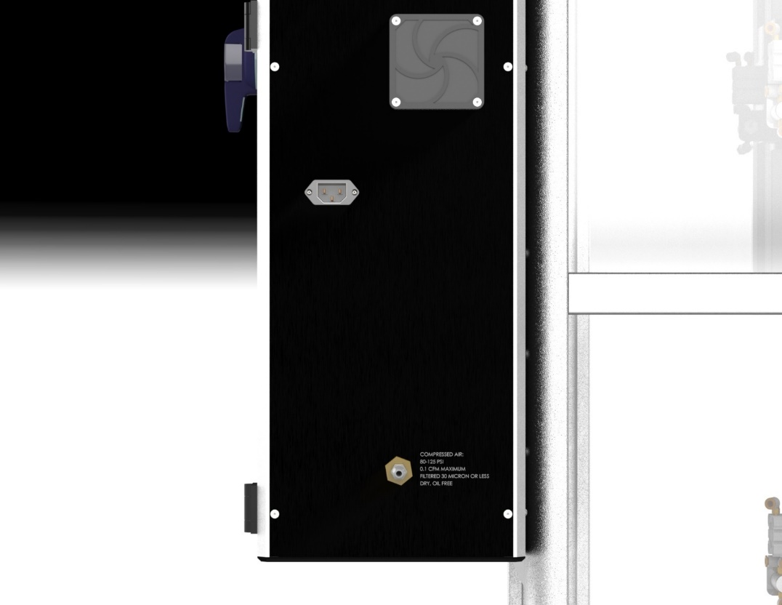
4
Figure 2. C-80 Mandrel Remover Back Panel Controls and Features

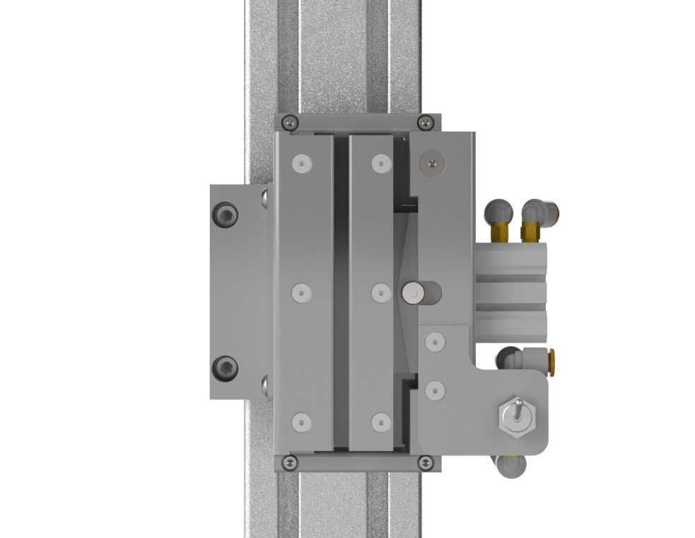
5
Figure 3. Gripper Open and Close Switch

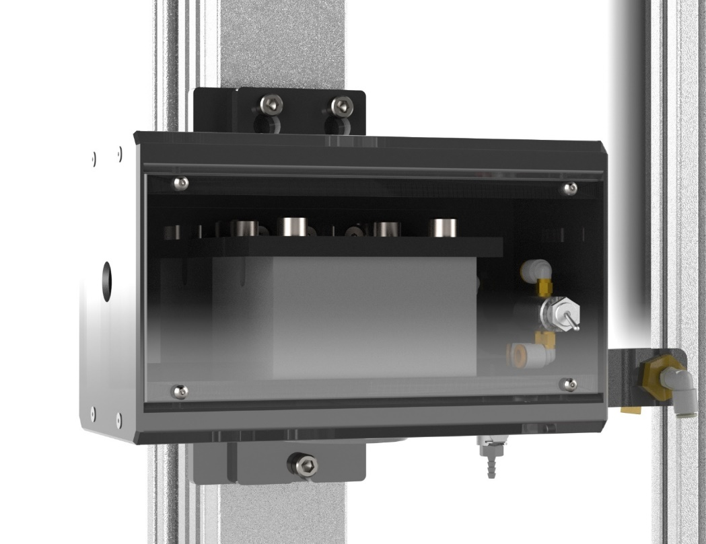
6
Figure 4. Collet Open and Close Switch

Electrical System Operation And Features
Please see the electrical drawing set for full details of the electrical system.

Power Requirements
The C-80 is fed from a single 120V or 240V/1Ø/2W & GND/15A service. The tool is equipped with an IEC line filter feeding a door-interlocked disconnect switch followed by a 15A circuit breaker.

Main Disconnect
The plug can be removed from the IEC line filter for disconnect purposes.

Disconnect Switch
The door-interlocked disconnect switch can be locked out for service purposes.

Emergency Stop Loop and Hardwired Devices
A single emergency stop twist-to release switch is connected to a safety relay in the electrical enclosure. The emergency stop switch is wired in series with a red extended head stop switch. When the safety relay is active, the PLC and HMI remain energized. The safety relay will need to be reset to have machine functionality.

To reset the safety relay, both switches must be released, then the reset button must be pushed. The blue reset button illuminates, and power is applied to the two main contactors. This energizes the outputs of the PLC and the linear actuator motor.

CompactLogix Programmable Logic Controller System
The PLC system is built around a CompactLogix 1769-L24ER-QBFC1B PLC. The processor supports I/O modules for digital inputs, digital outputs, analog inputs, and analog outputs. The linear actuator is positioned using a stepper motor control module.

PLC Secure Digital Card
The PLC supports a 1GB SD Card memory backup. If a processor fault is detected, the stored program will be reloaded to the PLC’s memory. Please note that user changes to the settings and the recipes may be lost in this event.

No memory battery is required for this model of PLC.

Barcode Scanner Connects to PanelView’s USB Port
A Symbol LS2208 barcode scanner sends data to the USB port on the HMI. When the operator brings up an alphanumeric keypad, the data from the scanner is written to the PLC.

Stepper Motor Control Module
The ST10 Step Motor Driver takes step and direction pulses from the AMCI 3601 single-axis step motor controller.

ST10 Step Motor Drive Configuration
The Applied Motion Product’s ST10 step motor drive is configured to a motor resolution of 6600 steps/mm. The steps/mm value in the setting has been factory set to ensure proper travel distances.
The IP address table has switch setting 3 configured for address 192.168.1.154

Settings And Recipe Controls

The settings for the mandrel remover are adjustments that are rarely altered. The recipe controls allow easy process development with storage of the recipe when a good process has been established.

Alternate Display Units
The tool’s native units for distance are millimeters.
The HMI is organized to show the user’s preferred units. For each distance and speed on the operating screens, one of two text strings are displayed.

Distance: | mm | or | inch
Speed: | mm/S | or | IPS

The settings table and internal recipe storage is maintained in mm.

Passcode Required to Change Settings
Changes to the settings require the entry of a user passcode. Two different user passcodes are adjustable in the settings. A passcode of “2694” is hard coded into the passcode logic.
The passcode is cleared after a time delay passes when the HMI is displaying the Run Parts screen. The time delay is adjustable in the settings and can be defeated by setting the timeout to ZERO.

Settings List
The machine settings are shown in the table below. Each setting has a minimum and maximum value that restricts the data entry keypad’s range. The min/max is user- adjustable.

Table 2. Machine Settings
Machine Setting | Nominal | Range | Description
s00. Use Barcode Scanner (0 or 1) | 1= YES | - | Operator must use the scanner to select a recipe.
s01. Distance Units (0 or 1) | 0 = mm and mm/s | - | Enter a 1 to select inch and IPS.
s02. Actuator Homing Speed mm/S | 4 | 1-6 | Actuator speed to seek the upper limit switch. Excessive speed into the limit can cause a drive stall trip.
s03. Actuator Fast Speed mm/S | 6 | 1-6 | Actuator speed used to find the upper travel limit. Also sets the maximum recipe speed.
s04. Actuator Slow Speed mm/S | 1 | 1-6 | Actuator speed to find home position off the upper travel limit.
s05 Actuator Acceleration mm/S/sec | 10 | 1-20 | Actuator acceleration for speed changes. The  rate is limited by the PLC to a maximum of 1900 steps/mS/sec.
s06. Actuator Steps per mm | 6500 | 200-20000 | Calibration for stepper motor.
s07. Maximum Length | 1100 | 500-3000 | Sets the tool length. Sets the maximum positions in the recipe.
s08. Minimum Recipe Speed mm/sec | 0.01 | 0.01-1 | Lowest acceptable recipe speed setting.
s09. Grip Pressure Regulator Full Scale PSIG | 130 | 70-140 | Full pressure rating of the regulator.
s10. Grip Pressure Deviation Limit PSIG | ±2.5 | 0.1-100 | Allowable grip pressure deviation.
s11. to s16. |  |  | spare
s17. Passcode Timeout secs | 0= NO | 0-9999 | The user passcode is cleared after this time interval when observing the RUN PARTS screen. If set to zero, there is no timeout.
s18. User Passcode Code 1 | 1 | 1-9999 | Access code for settings and screens.
s19. User Passcode Code 2 | 2 | 1-9999 | Second access code.

Recipe Settings and Descriptions
100 different recipes are stored in the PLC. The operator optionally uses a barcode scanner to select a recipe. With a valid passcode entered, the recipe can be selected from a list. The passcode is required to make alterations and to save a recipe to the database.
Many recipe entries are restricted by the settings noted above. For example, heater temperature is limited by setting s10.
The recipe is a collection of setpoints that are directly copied to the machine controls when the recipe is selected.

Alternate Units
Speeds, distances, and temperatures may be shown in alternate units. The recipe is stored in native units of mm and °F.

Table 3. Recipe Settings and Descriptions
Recipe Settings | Units | Range | Description
Name | ASCII | - | Name stored with the recipe, entered using the alphanumeric keypad of the HMI.
Date | ASCII | - | Date recipe was saved or altered
Barcode | ASCII | - | Barcode string captured and associated with this recipe
Offset | mm | -15 to 100 | Sets the home offset of the puller.
Collet Grip Pressure | PSIG | 0 to 100 [s19] | Setting for the grip pressure regulator.
Product Grip Pressure | PSIG | 0 to 100 [s19] | Setting for the grip pressure regulator.
Zone 1 Length | mm | 1 to X1 | First heater zone length. The maximum length is 540 mm [s07].
Zone 2 Length | mm | 1 to X2 | 2nd heater zone length. X2 = [s07] – X1
Zone 3 Length | mm | 1 to X3 | 3rd heater zone length. X3 = [s07] – X2
Zone 1 Speed | mm/S | 0.01 [s13] to  6.0 [s03] | Actuator speed for Zone 1
Zone 2 Speed | mm/S | 0.01 [s13] to  6.0 [s03] | Actuator speed for Zone 2
Zone 3 Speed | mm/S | 0.01 [s13] to  6.0 [s03] | Actuator speed for Zone 3

Information Messages
Information Messages are overlays triggered by the PLC. The messages are cleared from the display after a few seconds.

Table 4. Information Messages
Information Messages | Description
Passcode Required to Change this Item | Access code required.
Entry was too High or Low | Appears if a blank recipe was selected,  indicates one or more recipe settings was changed.
Passcode is CLEARED | Access code was cleared by timeout or entry of an invalid code.
Barcode Saved into this Recipe | Confirms barcode association was successful
Barcode Match - First Match File Selected | Match was found for the barcode with an existing recipe.
No Match Found for this Barcode | No recipe file matched the scanned code.

Alarms
The PLC monitors the C-80 for multiple alarm conditions. When an alarm occurs, it brings up an alarm overlay banner on the HMI. The HMI stores the alarm time and the alarm text in an alarm log.

Table 5. Alarm Messages
Alarm Message | Comments
Alm00. PLC I/O Module Failure | Fault on one or more Compact I/O modules
Alm01. Collet Grip Pressure Fault | Pressure deviation exceeds value.
Alm02. Product Grip Pressure Fault | Pressure deviation exceeds value.
Alm03. Puller Actuator Fault | Drive error.
Alm04. Puller Upper Limit Trip | Proximity sensor detected puller box.
Alm05. Puller Lower Limit Trip | Proximity sensor detected puller box.
Alm06. – Alm30. | spares
Alm31. PLC Memory Reloaded from SD Card | Recipes will be lost if the memory was replaced. The SD card can be used to  “preload” a new PLC.

Warnings
Warnings are shown on the HMI “Run Parts” screen as an aid to the operator.

Table 6. Warning Messages
Warning Message | Comments
Warn00. Controls Not Reset | Safety relay is not reset.
Warn01. Door is Not Locked
Warn02. Door Interlock is Bypassed | Passcode needed to access the bypass button on the Settings screen.
Warn03. Passcode has Unlocked Controls
Warn04. to Warn31. | spare

Sequences Of Operation

Master Control Sequence
The master control sequence boots up the tool subsystems and serves as the main operator guide for the extraction operation.
Any alarm will cause the sequence to jump to State 31. Touch the CYCLE STOP button to release the alarm. An alarm will stop the actuator motion.
Holding the CYCLE STOP button down for 2 seconds resets the master control sequence.

Table 7. Master Control Sequence
Master Control Sequence Label | Comments
Mandrel Removal System Full Reset | User must release the RESET button to leave this step.  Door lock is released.
Controls Not Reset - Push RESET Button | Master Safety Relay is not reset. Clear the  emergency stop and push the blue reset button
STARTUP: Opening Main Air Valve | Allows 2 seconds for air to fill system.
STARTUP: Touch CYCLE START to Lock Door
STARTUP: Waiting for Door to Close | Door lock is de-energized to latch the door. A signal is received when the latch is made.
READY: Touch CYCLE START to home Actuator | Homing starts when doors are closed.
HOMING: Homing Puller to Home Offset | Actuator finds and clears the home limit sensor. The recipe offset position is applied.
HOMING: Move Puller to Zero Position | Moves the actuator to mechanical zero.
Master Control Sequence Label | Comments
STARTUP: Use Scanner to Select Recipe | When every power is reset, the operator must select a recipe using the barcode scanner. If the passcode is in effect, pushing the CYCLE START button bypasses this step.  Door lock is released.
STARTUP: Move Puller to Zero Position | Returns collet to the load position after a run.
LOAD: Set Collet Grip | For auto: Use the HMI button to close the collet grip.  For manual: Toggle the valve, then press the HMI button.  Note that the pressure regulators must provide sufficient pressure to move the grips.
LOAD: Set Product Grip | For auto: Use the HMI button to close the product grips.  For manual: Toggle the valves, then press the HMI button.
READY: Touch CYCLE START to proceed | Touching CYCLE START begins the cycle.
READY: Waiting for Door to Close
RUN: Zone X at Speed Y for Distance Z | Pulls the mandrel from the product. X, Y, and Z are filled in as the process runs.
UNLOAD: Release Product Grip | For auto: Use the HMI button to open the product grip.  For manual: toggle the product valves open, then press the HMI button.
UNLOAD: Release Collet Grip | For auto: Use the HMI button to open the collet grip.  For manual: toggle the collet valve open, then press the HMI button.
UNLOAD: Remove Part – Touch CYCLE START to proceed.
UNLOAD: Waiting for Door to Close | Wait for door, then return to Step 11
ERROR: Tripped on Alarm - Touch CYCLE STOP to reset | Alarm state. Stops motion.  Door lock is released.

Linear Actuator Motor Control Sequence
The step motor module on the PLC sends step and direction signals to the linear actuator step motor drive. The PLC uses a control sequence to send module commands in the correct order. The control sequence below allows for the operator to manually move the stepper motor and supports automatic operation.

Table 8. Linear Actuator Motor Control Sequence State Labels
State Label | Description
Step Sequence Reset | Reset by master sequence
Stepper Module Not Ready | PLC must have good comms to step module.
Wait for Controls Reset | Power must be reset to the stepper drive
Wait for Module OK | Module ready to accept commands.
Motor Selected OFF | HAND/OFF/AUTO control set to OFF.
Writing Module Config | Sending configuration words to the module
Switch to Command Mode | Tells the module to go to command mode
Actuator Ready at [Position Reading] | Wait for manual or auto command.
Homing: Find CCW Limit | Fast jog to the upper travel limit
Homing: Jog CW of CCW Limit | Slow jog down to find electrical zero.
Set Homed OK | Sends PRESET POSN command, defining the home offset as 0 mm.
Jogging Positive Up | Jogging.
Jogging Negative Down | Jogging.
Hold Motion | Stops motion. Absolute moves are soft stopped; blend moves are immediately stopped.
Relative Move | not used
Move to [Position Reading] | Absolute move, used for START and LOAD moves
ERROR: Positive Limit Hit | Manual jog.
ERROR: Negative Limit Hit | Manual jog
ERROR: Positive Limit Trip | Unexpected hit.
ERROR: Negative Limit Trip | Unexpected hit.
ERROR: Home Not Found | not used
ERROR: No Hardware Enable | not used
ERROR: Motor Software Error | Module command/config error detected
ERROR: Motor Hardware Fault | Fault relay from drive is OFF.

Panelview Plus HMI Display Description
The Human Machine Interface (HMI) provides the primary source of operator interaction with the control system. The laminating system is controlled by the Allen-Bradley PLC. The HMI reads data from the PLC and allows changes to variables in the PLC. The HMI allows the operator to observe the operation of the system.

Data Entry Keypads
When a numeric value is to be entered, the operator touches the display, which pulls up a keypad similar to the one shown below. The label of the keypad shows the range that can be entered with the keypad.

A similar keypad is available to enter the name of the recipe.
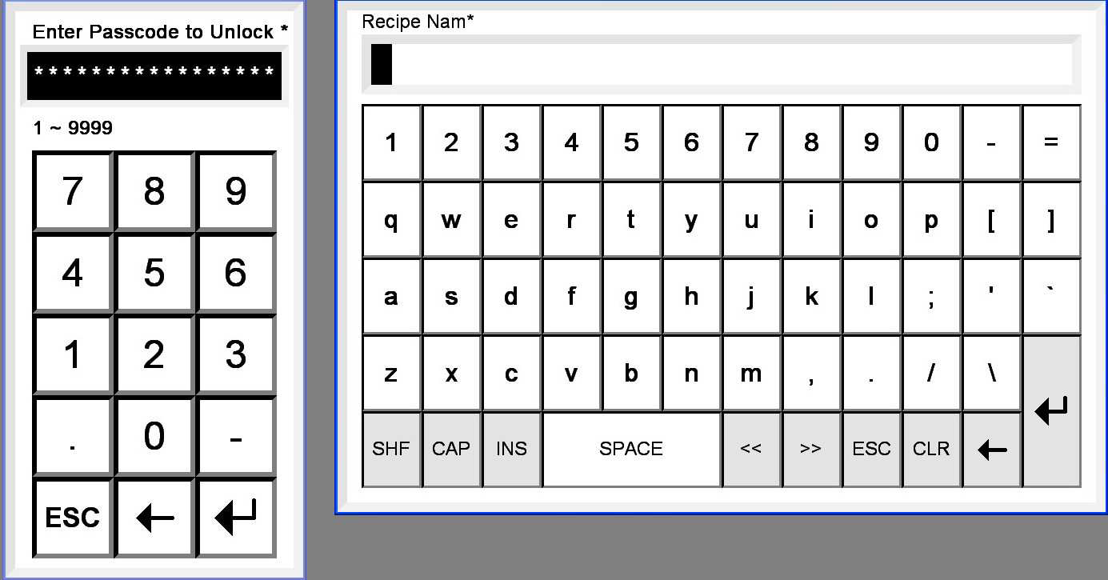

Figure 5. Data Entry Keypad

Main Menu (Screen #01)
The Main Menu screen provides an access point to the remaining screens in the system. Some menu items are hidden unless the passcode has unlocked the HMI.
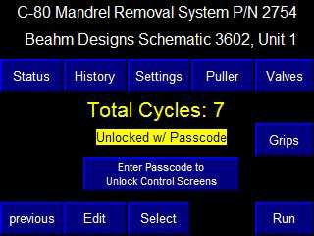
Figure 6. Main Menu Screen

Table 9. Main Menu Screen Buttons/Displays and Descriptions
HMI Screen Object Descriptions
Item | Description
Title | Unit number is read from the PLC.
Status, History, Settings Puller, Valves, Grips, Edit | Menu Buttons. Made visible when a valid passcode is entered.
Select | Menu Button. Not Visible when Barcode Scanner is used.
previous Run Parts | Menu Buttons. Always visible.
Total Cycles | Numeric Readout. Shows the number of times the machine process has run to completion.
Unlocked w/ Passcode | Indicator. Shows a valid passcode is active
Enter Passcode to Unlock Screens | Keypad. Used to enter the passcode.
This is how the Main Menu appears when there is no passcode present. The “Select Recipe w/Scanner is used when Setting s27 is set to require the operator to use a barcode for recipe selection.
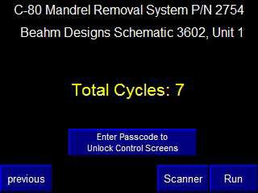

Figure 7. Main Menu No Password Present Screen

Run Parts (Screen #10)
This screen is used by the operator to start and stop the tool and monitor the process.
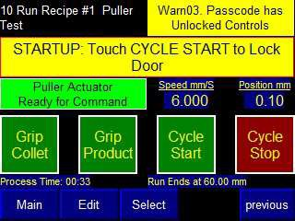
Figure 8. Run Parts Screen

Table 10. Run Parts Screen Buttons/Displays and Descriptions
HMI Screen Object Descriptions
Item | Description
Menu Buttons | Direct access to specified screens. RECIPE EDIT and RECIPE SELECT are only visible with a good passcode
Run Recipe #1 [NAME] Run Modified Recipe | Two-state indicator. Shows the recipe number and name. If the recipe has been changed, will show MODIFIED recipe in yellow.
Alm01. Warn12. | Multistate Indicators. Indicators cycle through all alarms and warnings present. See the lists in Section 4.6 and Section 4.7 for descriptions
STARTUP: Touch CYCLE  START to Lock Door | Multistate Indicator. Shows the state of the Master Control Sequence. The various possible states are described in Section 5.1 above.
Puller Actuator Ready for Command | M/S Indicator. Shows the state of the actuator control sequence. See also Section 5.2 for details
Speed, Position | Numeric Readouts. Shows the actuator’s speed and position.
CYCLE START CYCLE STOP | Pushbuttons. Used to start and stop the machine sequence.

CYCLE START Pushbutton
This button is used by the operator when prompted to advance the Master Control Sequence. The operator will be prompted to home the linear actuators, scan a barcode, load the mandrels, and run the process.

CYCLE STOP Pushbutton
This button is used to reset alarms. If the machine detects any of the alarms described in Section 4.6, the CYCLE STOP button is tapped to release the alarm.

Holding the CYCLE STOP button down for 2 seconds forces a full Master Control Sequence reset.

Run Parts Screen without Passcode
The Run Parts screen is slightly different when the passcode hasn’t unlocked the controls. The “Recipe Selected w/ Scanner Only” label shows when the settings require the use of the barcode scanner to select recipes.
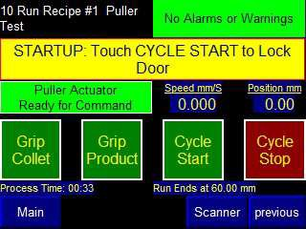
Figure 9. Run Parts Screen Without Passcode

Passcode Cleared on System Power Up
Note that a setting is available to automatically clear the passcode after a length of time. The passcode is also cleared when power is first applied to the machine (first pass of the PLC’s program).

Recipe Select (Screen #4)
Access to this screen requires the passcode.

100 recipes can be stored on the Mandrel Removal System. The buttons for saving a recipe are only visible when the passcode is entered.

If the barcode scanner is used, the 100 files will be searched for a match. The first recipe that has a match will be loaded as the current recipe.
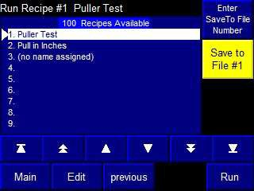
Figure 10. Recipe Select Screen

Table 11. Recipe Select Screen Buttons/Displays and Descriptions
HMI Screen Object Descriptions
Item | Description
Menu Buttons | Direct access to specified screens.
Enter Recipe File Number | Keypad. Used to set the file number for recipe storage.
Save Recipe to File #1. | Pushbutton. The file number is shown on the button. When touched, the user has 5 seconds to touch a CONFIRM button to complete the save.
100 Recipes Available [Recipe Names on List] | List Selector. Use the middle row of navigation keys to point to the desired recipe. The recipe will be loaded when the screen is changed.

Recipe Edit (Screen #5)
Access to this screen requires the passcode.

This screen is used to change the control settings for the sequence. Each of the variables can be changed by touching the display.
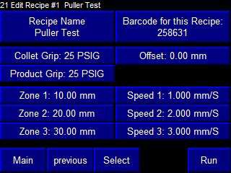
Figure 11. Recipe Edit Screen

Table 12. Recipe Edit Screen Buttons/Displays and Descriptions
HMI Screen Object Descriptions
Item | Description
Menu Buttons | Direct access to specified screens.
Edit Recipe # [NAME] | Shows the currently loaded recipe file number and name.
Recipe Name | Alphanumeric keypad. Touch to enter a name for the recipe.
Barcode for this Recipe | Alphanumeric keypad. Touch, then scan the barcode for the recipe.
Offset, Collet Grip, Product Grip, Zones, Speeds 6 | Keypads. Each keypad has a minimum and maximum value. The functions of each parameter are reviewed in Section 4.4 above.

Settings (Screen #3)
This screen is used to change settings. A passcode must be entered to make the screen accessible from the Main Menu.
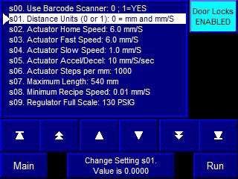

Figure 12. Settings Screen

Table 13. Settings Screen Buttons/Displays and Descriptions
HMI Screen Object Descriptions
Item | Description
Menu Buttons | Direct access to specified screens.
Settings List | List Selector. Use the arrow keys to navigate to a particular setting.
Door Locks Active | Pushbutton. Used to temporarily defeat the door interlocks. Will clear when the passcode is cleared.
Change Setting | Keypad. Used to enter a numeric value for the selected list item.
Min/Max Enable | Pushbutton. Brings up keypads for the minimum and maximum settings used by the Change Setting keypad. Requires the 2694  factory passcode for visibility.

This screen shows the appearance after the Min/Max Enable button is touched. The keypads will disappear if the HMI shifts to another screen.

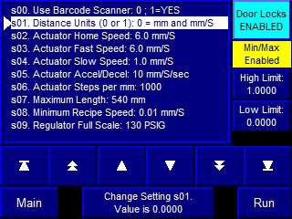

Figure 13. Settings screen after Min/Max Enable button selected

Table 14. Settings Screen after Min/Max button selected Buttons/Displays and Descriptions
HMI Screen Object Descriptions
Item | Description
Low Limit High Limit | Keypads. Enter the desired minimum and maximum range for the associated list item.

Puller Linear Actuator (Screen #11)
Access to this screen is from the Main Menu when a good passcode has been entered. The screen is used to exercise each step motor running the linear actuators.
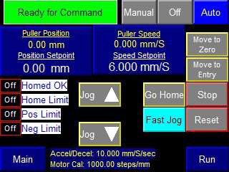
Figure 14. Puller Linear Actuator Screen

Table 15. Puller Actuator Screen Buttons/Displays and Descriptions
HMI Screen Object Descriptions
Item | Description
Menu Buttons | Direct access to specified screens.
Hand/Off/Auto | Interlocked Pushbuttons. Set to AUTO to run the process. Set to HAND to allow use of the controls on this screen. AUTO mode is forced when the CYCLE START button is pushed.
Ready for Command | M/S Indicator. Shows the state of the Actuator control sequence. See also Section 5.2 for details
Actuator Position Actuator Speed | Keypads with Numeric Readout Overlays. Used to monitor and to manually enter position and speed setpoints.

Table 16. Linear Actuator Screen Buttons/Displays and Descriptions
Linear Actuator HMI Screen Object Descriptions
Item | Description
Homed OK  Neg Limit Active  Pos Limit Active Home LS Active | Indicators. Shows the status of the travel limits and whether the stepper control module has problems.
Fast Jog Selected Touch for Slow | Pushbutton. Toggles between the fast and slow jog speeds.
Jog Up Jog Down | Pushbuttons. Used to manually move the step motor.
Go Home | Pushbutton. Causes the actuator to run to the left limit, then sets the zero offset just as the limit switch comes back on.
Move to Zero Move from Keypad | Pushbuttons. Once the actuator is homed, these buttons will cause absolute moves from the recipe settings or the keypad.
Stop | Pushbutton. Sends the stop motion command.
Reset | Pushbutton. Restarts the stepper control sequence.

Solenoid Valves (Screen #12)
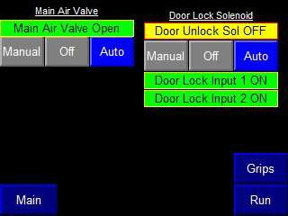
Access to this screen is from the Main Menu when a good passcode has been entered. This screen is used to test the pneumatic components.
Figure 15. Solenoid Valves Screen

Table 17. Solenoid Valves Screen Buttons/Displays and Descriptions
HMI Screen Object Descriptions
Item | Description
Menu Buttons | Direct access to specified screens.
Main Air Manual/Off/Auto | Interlocked Pushbuttons. Turns the main air valve on and off.
Door Lock Manual/Off/Auto | Interlocked Pushbuttons. Turns the unlock solenoid on and off.
Main Air Valve Open Door Unlock Sol OFF Door Lock Input 1 ON  Door Lock Input 2 ON | Indicators.

Grip Regulators (Screen #13)
The regulators are turned on whenever the controls are reset. This screen allows setpoint changes in MANUAL mode. AUTO mode uses the current recipe’s setpoints.
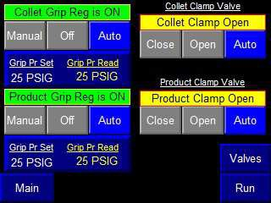
Figure 16. Grip Regulators Screen

Table 18. Grip Regulators Screen Buttons/Displays and Descriptions
HMI Screen Object Descriptions
Item | Description
Menu Buttons | Direct access to specified screens.
Manual/Off/Auto | Interlocked Pushbuttons. Forces the device ON or OFF when not in AUTO.
Collet Grip Reg is ON Product Grip Reg is ON Collet Clamp Open  Product Clamp Open | Indicators.
Grip Pressure Set  Grip Pressure Reading | Keypad w/Readouts. Shows the setpoint and pressure feedback reading in PSIG.

PLC Status and HMI Shutdown (Screen #2)
Access to this screen is from the Main Menu when a good passcode has been entered. This screen shows the machine model number and some PLC variables. The HMI application can be shut down from this screen.
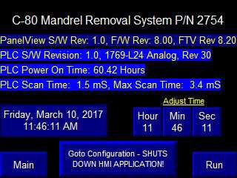
Figure 17. PLC Status and HMI Shutdown Screen Buttons/Displays and Descriptions

Table 19. PLC Status and HMI Shutdown Screen Buttons/Displays and Descriptions
HMI Screen Object Descriptions
Item | Description
Menu Buttons | Direct access to specified screens.
Model Number. | Numeric Readout. Taken from the PLC in case of more than one unit.
PanelView S/W Revision | Text. Manually changed while creating the application file.
Power On Hours  PLC Software Revision Scan Times | Numeric Readouts. Length of time PLC has been running, plus variables to show what software is on the PLC.
PLC Memory Battery OK PLC Memory Battery Low | Indicator. Shows the state of the PLC’s memory battery, located under a cover on the left side of the PLC assembly.

HMI Support Screens

Information Overlay
The Information Message Banner is triggered by the PLC from the list described in Section Information Messages. The banner automatically closes after 3 seconds, or the CLOSE button can be touched.
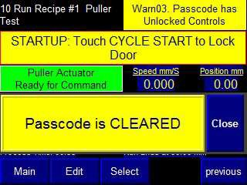
Figure 18. Information Message Banner

Alarm Banner Overlay
The Alarm Banner is triggered by the PLC from the list described in Section Alarms. Use the CLOSE button to remove the banner.

If the banner legend is blank, an alarm occurred but has been restored. Check the Alarm Log to determine the specific alarm that triggered the banner.

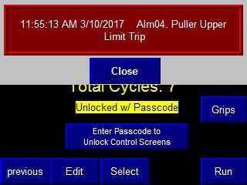
Figure 19. Alarm Banner

Alarm Log
The Alarm Log holds a record of the last 128 alarm occurrences. The alarm message is saved along with the time the alarm was tripped.

The time is taken from the HMI’s internal real-time clock. Shut down the application (see Section PLC Status and HMI Shutdown (Screen #2)) to adjust the clock.

Access to this screen is passcode protected.

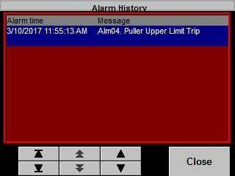
Figure 20. Alarm Log Screen

Maintenance

Note: Ensure the machine is unplugged for any servicing or maintenance work.


Caution: pinch point/crush hazard. Keep fingers, hands, and clothing clear of moving parts.

Caution: high voltage. Remove power and use safety precautions when servicing.

Cleaning

- Use 99% isopropyl alcohol to wipe down the outside of the machine. Do not attempt to clean the inside of the machine. The machine should not be washed down.
- Cleaning should be with a soft dry cloth only.

Exchanging Collets
- Using a 5/32” hex wrench, loosen the collet retention screw a couple turns on the left side of the collet gripper assembly. Take care to not fully remove screw.
- Using the provided 5C collet wrench unscrew the collet.
- Remove collet and set aside.
- Install replacement collet using the collet wrench.
Note: Take care not to overtighten collet. Overtightening collet will result in mandrel not fitting in collet opening.
- Using 5/32” wrench, tighten the collet retention screw.

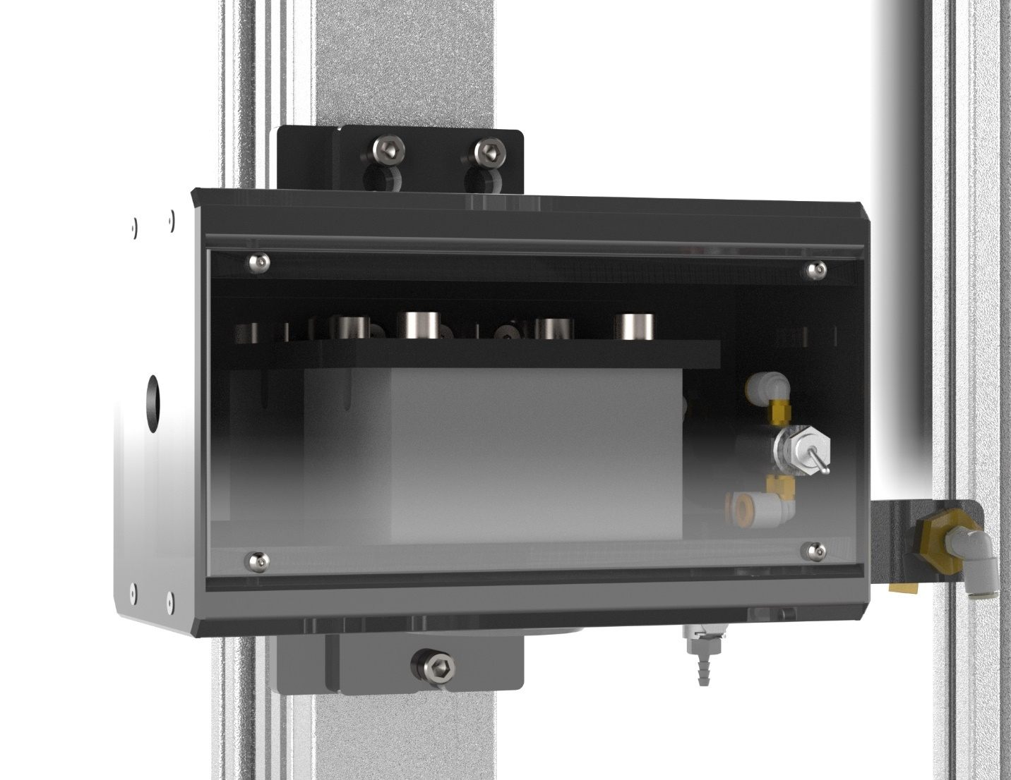
AIR FITTING
RETENTION SCREW

Stretch Grips Installation
- Unplug air fitting on collet grip assembly.
- Loosen the three socket head cap screws that fasten the collet grip assembly to the actuator.
- Lift up and pull collet gripper assembly. Set aside.
- Take actuator mount stretch gripper assembly and set onto the three socket head screws.
Note: actuator mount stretch gripper will have the same air fitting as the collet grip assembly. Shown above.
- Tighten three socket heads cap screws.
- Re-install air fitting.
- Install tee nuts onto lower rail.
Note: Depending on where you wish to place the lower stretch grip you may need to temporarily remove one more grip assemblies from the rail.
- Install lower alignment block onto tee nuts.
- Set extrusion mount stretch grip assembly onto the alignment block and align tee nuts under mounting holes.
- Tighten socket head cap screws onto tee nuts. Re-install air tube onto push fitting.

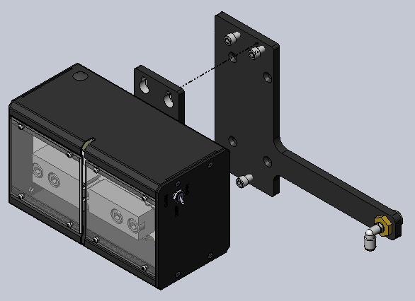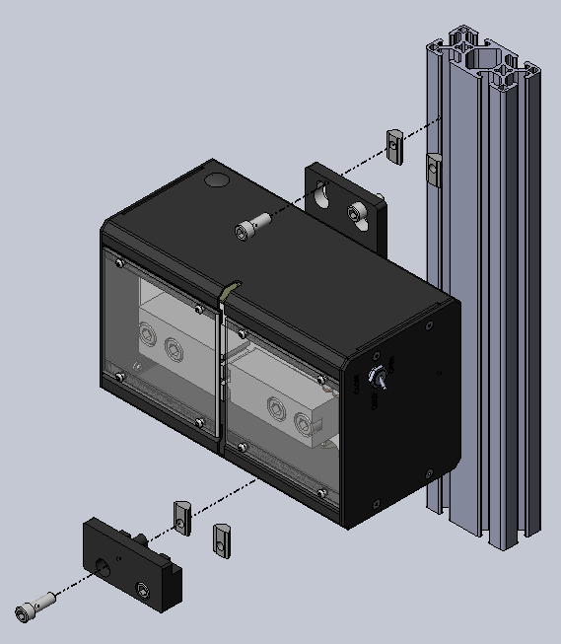

Figure 21. Stretch Grips Installation

Critical Parts
For replacement or spare parts, please contact us at service@machinesolutions.com, or call
928-556-3109.

Description | Part Number | Quantity
POWER SUPPLY, 48VDC, 10A | 1134326-001 | 1
POWER SUPPLY, DIN, 90W, 3.75A, 24VDC | 1149765-001 | 1
CONTACTOR, IEC 9A, AC1 16A, 600V/3P, 1 NC, 24VDC | 1145600-001 | 2
DRIVE CONTROL, DC STEPPER, ST SERIES, ETHERNET/IP | 1153240-001 | 1
HMI, TOUCHSCREEN, 6INCH, ALLEN BRADLEY | 1147244-001 | 1
REGULATOR, ELEC-PNE, 1500LPM, 90 PLG, FLAT BRKT | 1345768-015 | 2

Customer Support And Satisfaction
Machine Solutions Inc. is proud of the advanced engineering and quality construction of each piece of equipment that we build. It is our goal to provide equipment that exceeds the expectations of the customer. By implementing the highest standards and applying our experience to provide a quality product, we maintain an ongoing, positive working relationship with all our customers.
Machine Solutions Inc. welcomes your comments and inquiries about our products and services.

Machine Solutions Inc.
2951 West Shamrell Blvd., Suite 107
Flagstaff, AZ 86005

Phone: 928-556-3109
Fax: 928-556-3084
E-Mail: service@MachineSolutions.com

Warranty And Limitations

General Warranty

Machine Solutions Inc. (MSI) warrants its products to be free from defects in material and workmanship in normal everyday use and service for a period of one year from the date of shipment from the factory in Flagstaff, Arizona. MSIs obligation under this warranty shall be limited to the repairing or replacing of the product or parts thereof which upon MSIs inspection reveals them to be defective. MSI reserves the right and option to refund the purchase price in lieu of repair or replacement upon evaluation of the returned original part. Modifications, misuse, attempted repairs by others, improper calibration or operation shall render this guarantee null and void. MSI MAKES NO OTHER WARRANTY REGARDING THIS PRODUCT, INCLUDING ANY EXPRESS OR IMPLIED WARRANTY. SPECIFICALLY, THERE IS NO WARRANTY OF MERCHANTABILITY OF THIS PRODUCT OR OF THE FITNESS OF THE PRODUCT FOR ANY PURPOSES. THE SUITABILITY OF THIS PRODUCT FOR ANY PURPOSE PARTICULAR TO THE CUSTOMER IS FOR THE CUSTOMER, IN ITS SOLE JUDGEMENT, TO DETERMINE. MACHINE SOLUTIONS, INC. ASSUMES NO RESPONSIBILITY FOR THE SELECTION OR USE OF THIS PRODUCT BY CUSTOMER. This product has not been tested or approved by the U.S. Food and Drug Administration or any other agency of the U.S. government. This product is not a consumer product as that term is defined in the Magnuson-Moss Warranty – Federal Trade Commission Improvement Act, 15 U.S.C. § 2301 et seq.

Software License

By using this equipment, and/or installing or using any of the software associated with the same, you indicate your acceptance of each of the terms of this license. Upon acceptance, this license will be a legally binding agreement between you and MSI. The terms of this license apply to you and to any subsequent user of the software. If you do not agree to all of the terms of this license (i) do not install or use the software and (ii) return the equipment and the software (collectively, equipment), including all components, documentation and any other materials provided with the equipment, to MSI. The software includes associated media, any printed materials, and any on-line or electronic documentation. Software provided by third parties may be subject to separate end-user license agreements from the manufacturers of such software. This license shall also apply to any updates, bug fixes, or newer versions of the software provided by MSI for use with this equipment.

You may: (1) Use the software only in connection with the operation of the equipment; (2) Transfer the software (including all component parts and printed materials) permanently to another person, but only if the person agrees to accept all of the terms of this license. If you transfer the software, you must at the same time transfer the equipment and all copies of the software (if applicable) to the same person or destroy any copies not transferred; and (3) Terminate this license by destroying the original and all copies of the software (if applicable) in whatever form.

You may not: (1) Loan, distribute, rent, lease, give, sublicense or otherwise transfer the software, in whole or in part, to any other person, except as permitted under the transfer paragraph above; (2) Copy or translate the User Guide included with the equipment; (3) Copy, alter, translate, decompile, disassemble or reverse engineer the software, including but not limited to, modifying the software to make it operate on non-compatible hardware; or (4) Remove, alter or cause not to be displayed, any copyright notices or startup message contained in the software programs or documentation

Title to the software, including the ownership of all copyrights, patents, trademarks and all other intellectual property rights subsisting in the foregoing, and all adaptations to and modifications of the foregoing shall at all times remain with MSI and its third party licensors, if any. MSI retains all rights not expressly licensed under this license. Except as otherwise expressly provided in this license, the copying, reproduction, distribution, or preparation of derivative works of the software, or any portion of the equipment, is strictly prohibited. Nothing in this license constitutes a waiver by MSI of its rights under United States copyright law.

Protection of Intellectual Property

The equipment and its incorporated technology (collectively referred to herein as the Technology), is protected under issued and pending patents. The Technology is the valuable and proprietary technology, including trade secret technology, belonging to MSI. Much of the Technology is nonpublic and confidential. As our customer, you agree to further assist MSI in the protection of our intellectual property as follows: You agree to keep the Technology you receive confidential at all times, and shall not, without the prior written consent of MSI, disclose the Technology, in whole or in part, to any person outside of your company. You further agree that you shall not reverse engineer, disassemble, decompile, or copy the Technology without the prior written consent of MSI.
In addition, you agree that the equipment will not be used to manufacture anything other than products in which you hold intellectual property rights free of infringement of others. You may not use the equipment to manufacture any product infringing on another’s patented rights. By accepting and using the equipment, you agree to defend and indemnify Machine Solutions, Inc., its officers, directors, employees, and agents, from and against any claims of infringement as a result of your use of the equipment.

Regulatory Matters
All equipment validations, product validation, final product QC testing and other testing required by the U.S Food and Drug Administration are the sole responsibility of the customer. Machine Solutions, Inc. shall have no responsibility or liability for the performance of any interventional product on which this equipment is used.

