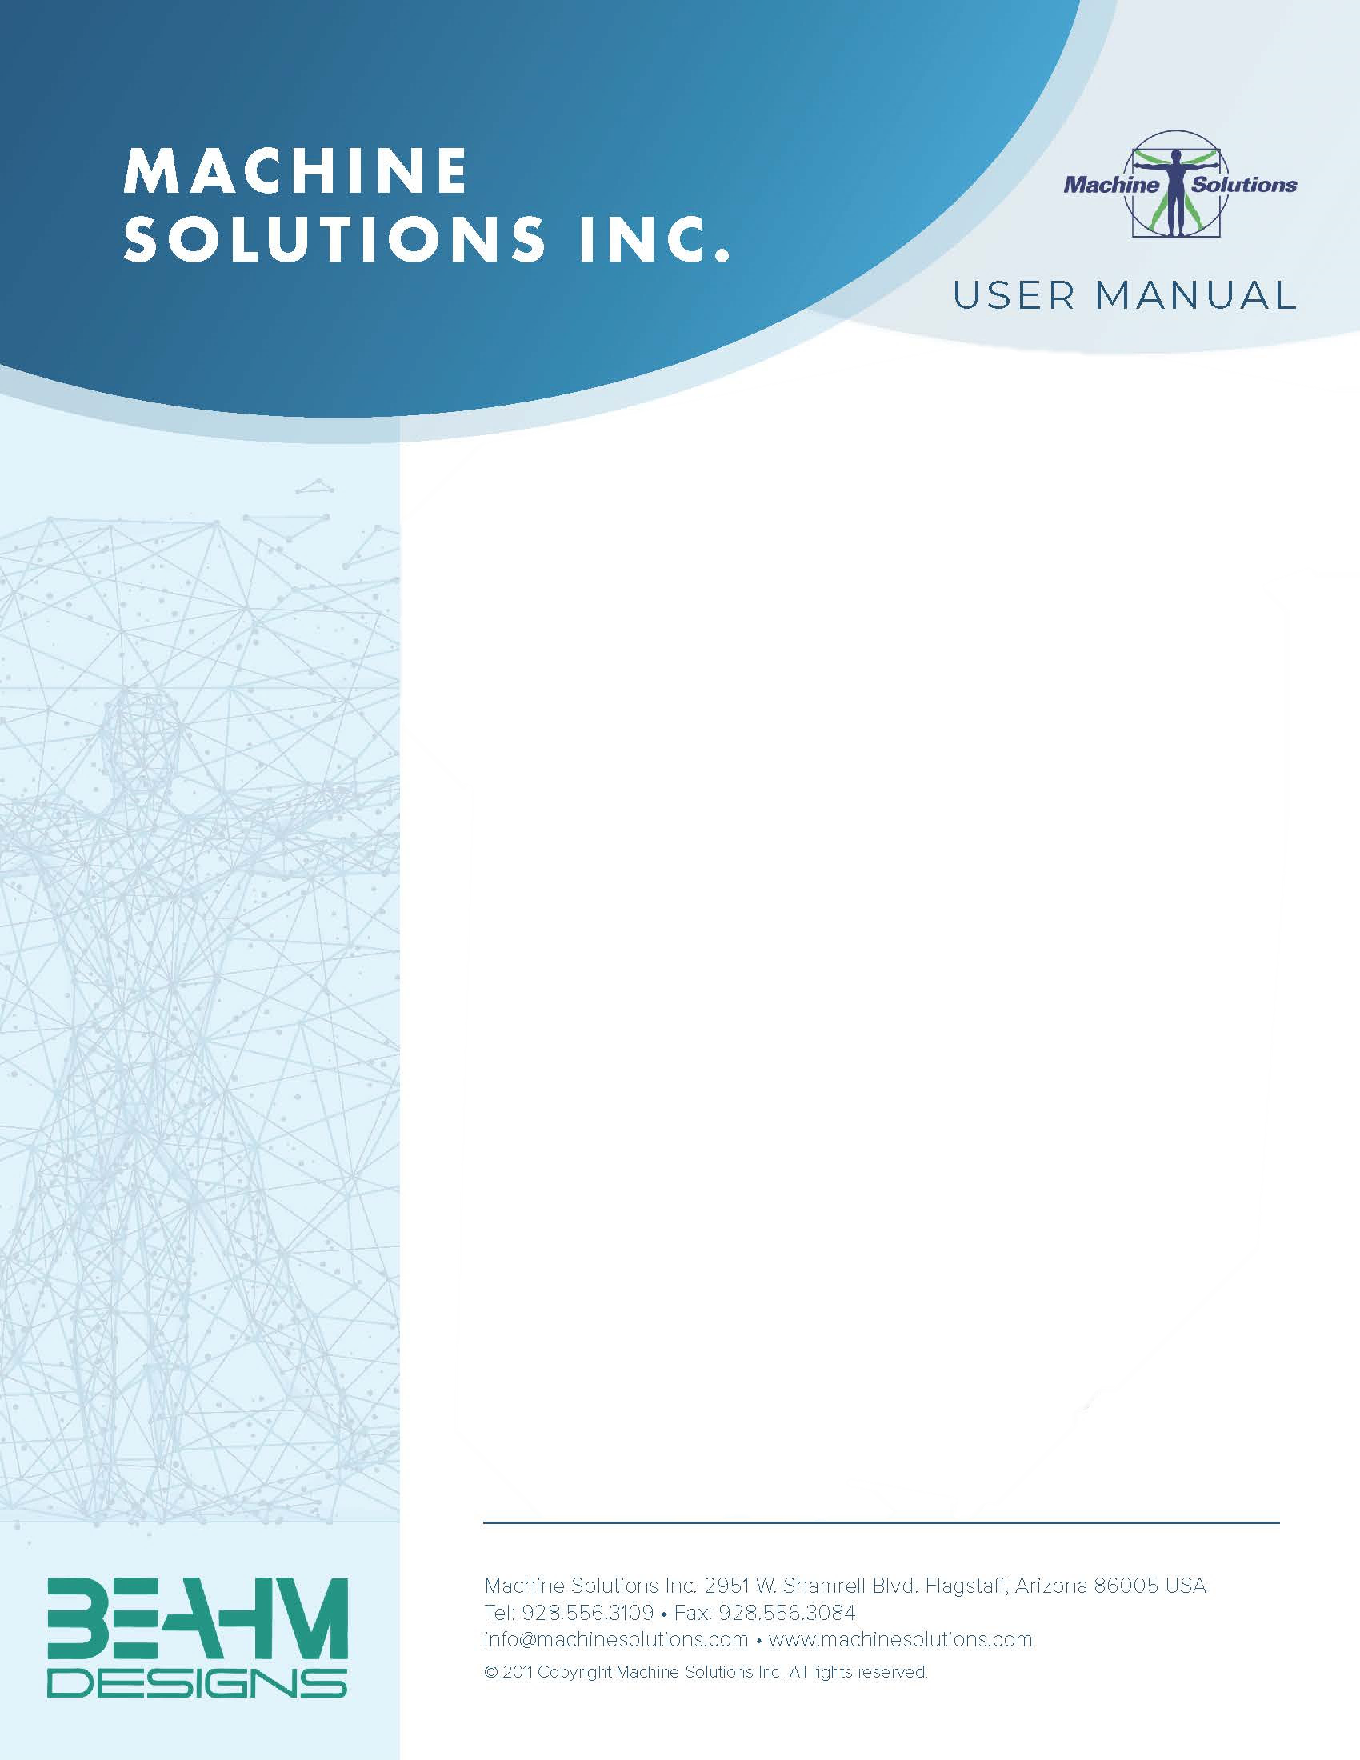

**BEAHM DESIGNS MANDREL STRETCHER**

MODEL C-85

Machine Solutions Inc. 2951 W. Shamrell Blvd. Flagstaff, Arizona 86005 USA

Tel: 928-556-3109 Fax: 928-556-3084

[Service@machinesolutions.com](mailto:Service@machinesolutions.com) www.machinesolutions.com

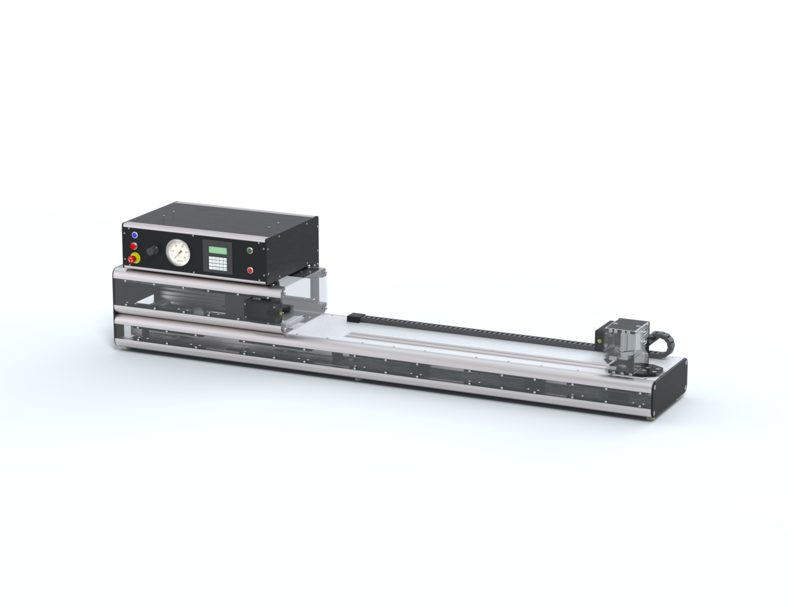

The Machine Solutions Inc. products shown and described in this catalog may be covered by one or more of the following US Patents: #6,629,350, #6,968,607, #6,925,847, #6,988,881, #6,931,899 and #7,069,794. Other US and International Patents Pending.

Machine Solutions, MSI, and C-85 are trademarks or service marks of Machine Solutions Inc.

Copyright (©) Machine Solutions Inc. All Rights Reserved.

Product images are representative of standard equipment offerings and may differ from delivered equipment.

Table of Contents

Welcome 5

Machine Description 5

Safety 6

User Alerts 6

Contents 7

Installation 7

Set Up and Configuration 8

System Controls and Features 9

Parameter Settings (Low Force Model) 11

Run Process 11

Maintenance 12

Diagnostics And Troubleshooting 14

Specifications 15

Calibration 16

Critical Parts 17

Customer Support And Satisfaction 18

Warranty And Limitations 19

List of Figures

**Figure 1: Grip Assembly Fasteners** 8

**Figure 2: C-85 Mandrel Stretcher Low Force Model Front Panel** 9

**Figure 3: C-85 Mandrel Stretcher High Force Model Front Panel** 10

**Figure 4. Fuse Replacement; Main Power** 12

**Figure 5. Power Entry Module Fuses** 13

List of Tables

**Table 1: C-85 Mandrel Stretcher Low Force Model Functions** 9

**Table 2. C-85 Mandrel Stretcher High Force Model Functions** 10

**Table 3: Diagnostics and Troubleshooting** 14

**Table 4: System Specifications** 15

**Table 5: Critical Spare Parts List** 17

Welcome

Machine Solutions, Inc. (MSI) would like to take this opportunity to thank you for purchasing your new C-85 Mandrel Stretcher machine. At MSI, we are dedicated to bringing innovative process development solutions to both medical device and nonmedical organizations. MSI looks forward to helping your organization provide life-improving devices to your customers, today and tomorrow.

Machine Description

The Beahm Designs Inc. Model C-85 Mandrel Stretcher is a system for the purpose of removing a core mandrel from a shaft assembly by means of stretching the mandrel to reduce the diameter.

Safety

* Place the system on a level, sturdy surface at an ergonomically viable height for the user.
* Use of eye protection when working with compressed gases and heated materials is advised.
* The maximum observed Sound Pressure Level is below 70 dBA.

**CAUTION: High voltage. Remove power and use safety precautions when servicing.**

**CAUTION: Pinch point. Keep hands and body parts clear while in operation.**

User Alerts

Do not use or otherwise operate the machine in any manner other than that in which it is explicitly intended. Examples: Do not attempt to sit on or climb on the equipment, do not place heavy objects or containers of liquid on the machine, do not to insert any foreign objects into the machine, and do not attempt to bypass any guards.

**Note: The equipment is not for use with materials that can decompose or ignite below the maximum operating temperature of the machine. Hazards are materials that outgas hazardous substances and or ignite. (260°C/500°F)**

**Note: This equipment is not for use in an ATEX environment.**

Contents

Included with the system are the following contents:

* IEC Power Cord

Installation

1. Place the system on a level, sturdy surface.
2. Connect the power cord to the system and then to a 110-120 VAC 50/60 Hz. outlet.
3. Connect the air supply hose assembly to the system and then to a clean, dry, and filtered compressed air source.

Set Up and Configuration

Proper positioning of the shaft grips and grip pressure can be key parameters of an optimized removal process. Due to the unique properties of each type of shaft assembly, experimentation will be required for each shaft configuration.

1. **Grip Positioning** - Loosen the four fasteners at the rear bracket of the grip assembly and then reposition the grip. Tighten the four fasteners to secure the position.

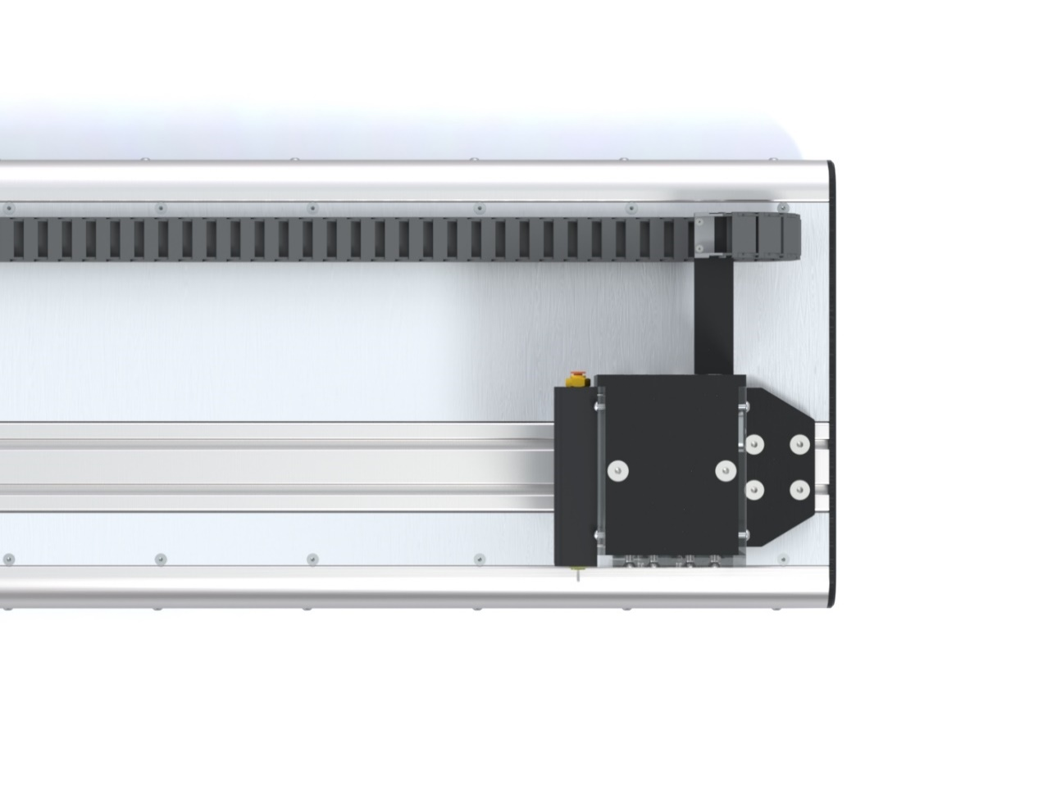

**Grip Switch**

**Figure 1: Grip Assembly Fasteners**

System Controls and Features

Located on the front panel are the following controls and/or displays and their function.

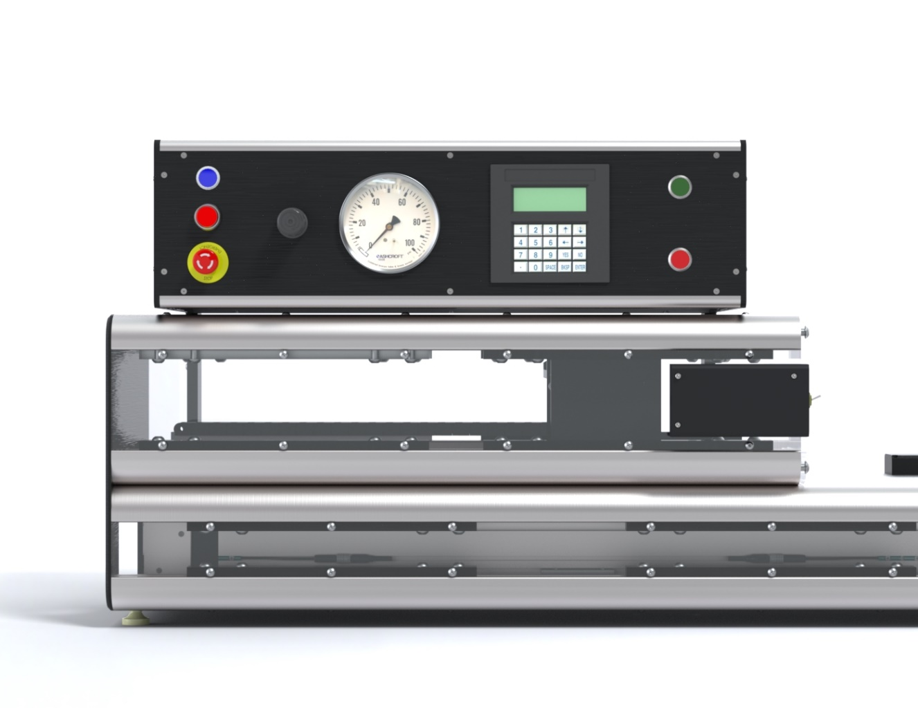

2

3

4

8

7

6

5

1

9

**Figure 2: C-85 Mandrel Stretcher Low Force Model Front Panel**

**Table 1: C-85 Mandrel Stretcher Low Force Model Functions**

|  |  |
| --- | --- |
| **Item** | **Function** |
| **1** | Controls the pressure to the product grips |
| **2** | Engages system power and air  (Low force model only) |
| **3** | Disengages system power and air  (Low force model only) |
| **4** | Interrupts all system power and air |
| **5** | Displays the grip pressure |
| **6** | Inputs traverse speed and distance parameters and displays operator prompts  (Low force model only) |
| **7** | Initiates process sequence  (Low force model only) |
| **8** | Interrupts the process sequence  (Low force model only) |
| **9** | Toggles the shaft grips open/close |

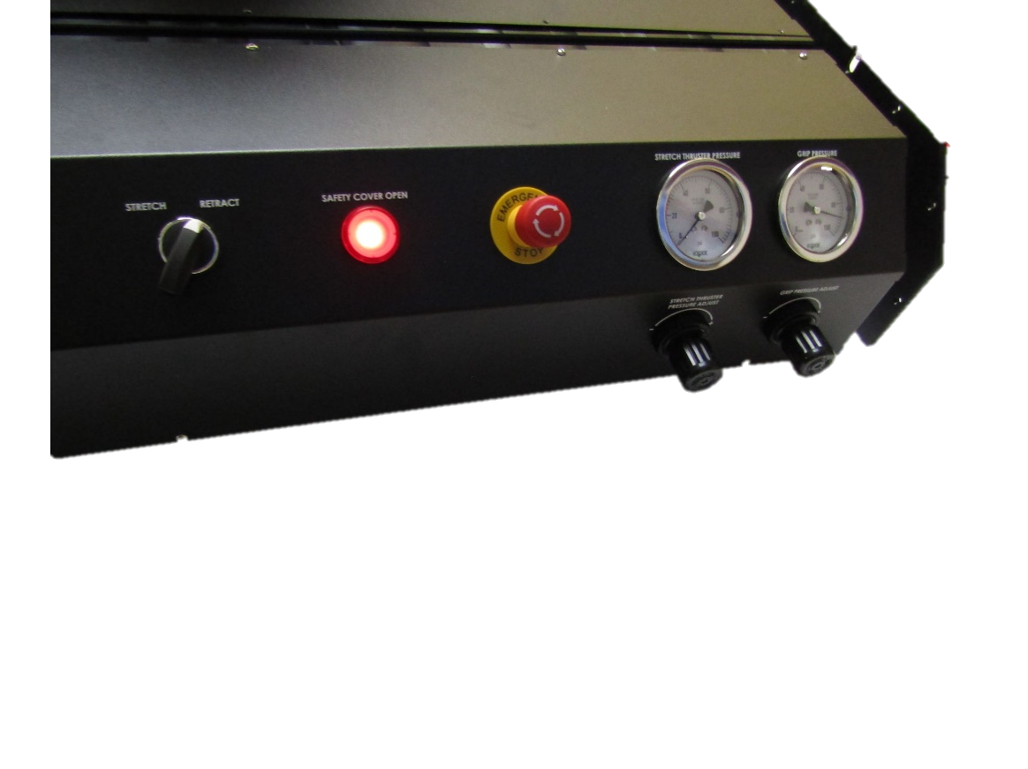

5

6

3

1

7

4

2

**Figure 3: C-85 Mandrel Stretcher High Force Model Front Panel**

**Table 2. C-85 Mandrel Stretcher High Force Model Functions**

|  |  |
| --- | --- |
| **Item** | **Function** |
| **1** | Interrupts all system power and air |
| **2** | Illuminates when safety cover is open |
| **3** | Extends and retracts stretch thrust cylinder  (High force model only) |
| 4 | Controls the pressure to the product stretch thrust cylinder  (High force model only) |
| 5 | Displays the stretch thrust cylinder pressure.  (High force model only) |
| **6** | Displays the grip pressure |
| **7** | Controls the pressure to the product grips |

Parameter Settings (Low Force Model)

1. **Draw Distance** - On the HMI keypad, enter the length in mm.
2. **Draw Speed** - On the HMI keypad enter the draw speed in mm/sec.

Run Process

1. On initial power up, if the grip assembly is not in the “home” position the HMI will display the prompt “PRESS START TO RESET SYSTEM.”

Press the **START** button to reset the system.

1. Once reset, the HMI will display the prompt “PRESS YES TO ACCESS STRETCH SPEED AND LENGTH, NO TO RUN CURRENT.”

If **YES** is selected: System parameters will be accessed.

If **NO** is selected: The system will run the last entered values, even after a power cycle.

1. If **YES** is selected:

Stretch length in mm: Enter the desired stretch length value in mm.

Stretch speed in mm: Enter the desired speed value in mm/sec.

1. System is ready, start button illuminated, and HMI will display the prompt “SYSTEM IS READY, PRESS START.”
2. Position the mandrel within the grips and activate the grips by toggling the grip switch up.
3. Press the **START** button to start the process and the HMI will display the message “IN PROCESS.”
4. Upon completion of the stretch, deactivate the grips by toggling the grip switch down and remove the mandrel. The HMI will display the prompt “Stretch complete.” Remove the product and then press START.”
5. Press the **START** button. The system is moving to the home position and the HMI displays the message “System Resetting.”

Maintenance

**Note: Ensure the machine is unplugged for any servicing or maintenance work.**

**Note: Perform these steps ONLY when the tooling is at room temperature.**

Caution: pinch point/crush hazard. Keep fingers, hands, and clothing clear of moving parts.

***Cleaning***

1. Use 99% isopropyl alcohol to wipe down the outside of the machine. Do not attempt to clean the inside of the machine. The machine should not be washed down.
2. Cleaning should be with a soft dry cloth only.

***Fuse Replacement***

The machine has two fuses located in the power entry module on the back of the machine.

1. To replace a blown fuse, remove machine power by unplugging the power cord from the machine.
2. Remove the cover of the power entry module using a screwdriver in the screwdriver slot (see **Figure 4**).

Important: A blown fuse may indicate machine malfunction. If a fuse blows before exceeding its expected lifespan, then perform troubleshooting procedures. Contact MSI if the problem persists.

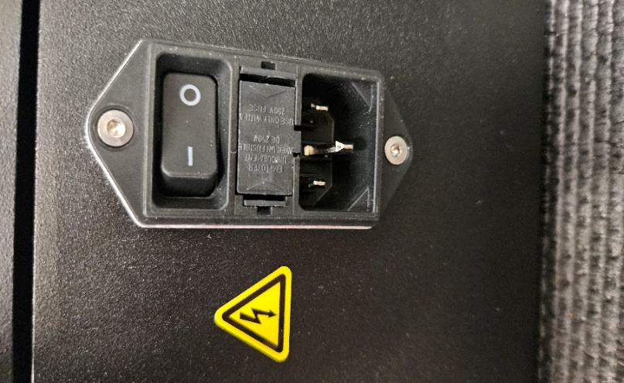

Power entry module

Screwdriver slot

**Figure 4. Fuse Replacement; Main Power**

1. Remove the fuse holder (see **Figure 5**).

**Figure 5. Power Entry Module Fuses**

1. Remove the old fuse from the holder.
2. Insert the new fuse. Orientation of the fuse is not important.
3. Reinsert fuse holder. Ensure the left and right sides clip into place.

Diagnostics And Troubleshooting

**Table 3: Diagnostics and Troubleshooting**

|  |  |  |
| --- | --- | --- |
| **Issue** | **Possible Causes** | **Solution** |
| System will not power on | * Emergency stop switch depressed * IEC power cord not fully connected | * Rotate switch knob to engage * Verify installation |
| Actuator does not traverse  (Low Force model only) | * Software error * Faulty drive | * Cycle power to reset drive * Replace drive |
| Thrust does not Stretch/Retract  (High force model only) | * Kinked or damaged air lines * Air not on | * Fix damaged or kinked air lines * Turn air on |

Specifications

**Table 4: System Specifications**

|  |  |  |  |
| --- | --- | --- | --- |
| **Description** | **Range** | **Resolution** | **Accuracy** |
| Distance | 1-330mm | 0.1mm | +/-0.05mm/100mm |
| Speed  (Standard model only) | 1-15mm/sec. | 0.1 mm/sec. | +/- 5% |
| Pressure | 0-100 psi | 2.0 psi | +/-2.0% F.S. |

***Facility Requirements***

* Voltage: 108‐240 VAC 50/60 Hz.
* Wattage: 500 max.
* Compressed Air: 100-125 psi, 0.5 CFM, filtered 50 micron or greater, oil and water free.

Calibration

**Important Notes:**

* **It is recommended that calibration be performed by a certified service, preferably with the system in the location of use. Calibration procedures are the domain of these service providers.**
* **Calibration refers to the process of verifying that each of the systems’ instruments that control a process parameter is within manufacturers’ specification.**

1. Calibrate the pressure gauge annually.
2. Calibrate the actuator speed and distance annually.

Critical Parts

For replacement or spare parts, please contact us at [service@machinesolutions.com](mailto:service@machinesolutions.com), or call

928-556-3109.

**Table 5: Critical Spare Parts List**

|  |  |  |
| --- | --- | --- |
| **Part Number** | **Description** | **Quantity** |
| 1148103-001 | DRIVE/CONTROLLER | 1 |
| 1148096-001 | HMI KEYPAD | 1 |
| 1330445-003  (High force model only) | VALVE, MAC, SOLENOID, 24VDC, 5-2, PLUG-IN | 1 |
| 1145600-001 | CONTACTOR | 1 |
| 1143287-001 | RELAY, 24VDC, INTEGRATED | 1 |
| 1143312-001 | POWER SUPPLY, 24VDC | 1 |
| 1120542-001 | POWER SUPPLY, 48VDC | 1 |
| 1344963-001 | VALVE, TOGGLE, 4 WAY, 2 POSITION | 2 |

Customer Support And Satisfaction

Machine Solutions Inc. is proud of the advanced engineering and quality construction of each piece of equipment that we build. It is our goal to provide equipment that exceeds the expectations of the customer. By implementing the highest standards and applying our experience to provide a quality product, we maintain an ongoing, positive working relationship with all our customers.

Machine Solutions Inc. welcomes your comments and inquiries about our products and services.

Machine Solutions Inc.

2951 West Shamrell Blvd., Suite 107

Flagstaff, AZ 86005

Phone: 928-556-3109

Fax: 928-556-3084

E-Mail: Service@MachineSolutions.com

Warranty And Limitations

***General Warranty***

Machine Solutions Inc. (MSI) warrants its products to be free from defects in material and workmanship in normal everyday use and service for a period of one year from the date of shipment from the factory in Flagstaff, Arizona. MSIs obligation under this warranty shall be limited to the repairing or replacing of the product or parts thereof which upon MSIs inspection reveals them to be defective. MSI reserves the right and option to refund the purchase price in lieu of repair or replacement upon evaluation of the returned original part. Modifications, misuse, attempted repairs by others, improper calibration or operation shall render this guarantee null and void. MSI MAKES NO OTHER WARRANTY REGARDING THIS PRODUCT, INCLUDING ANY EXPRESS OR IMPLIED WARRANTY. SPECIFICALLY, THERE IS NO WARRANTY OF MERCHANTABILITY OF THIS PRODUCT OR OF THE FITNESS OF THE PRODUCT FOR ANY PURPOSES. THE SUITABILITY OF THIS PRODUCT FOR ANY PURPOSE PARTICULAR TO THE CUSTOMER IS FOR THE CUSTOMER, IN ITS SOLE JUDGEMENT, TO DETERMINE. MACHINE SOLUTIONS, INC. ASSUMES NO RESPONSIBILITY FOR THE SELECTION OR USE OF THIS PRODUCT BY CUSTOMER. This product has not been tested or approved by the U.S. Food and Drug Administration or any other agency of the U.S. government. This product is not a consumer product as that term is defined in the Magnuson-Moss Warranty – Federal Trade Commission Improvement Act, 15 U.S.C. § 2301 et seq.

***Software License***

By using this equipment, and/or installing or using any of the software associated with the same, you indicate your acceptance of each of the terms of this license. Upon acceptance, this license will be a legally binding agreement between you and MSI. The terms of this license apply to you and to any subsequent user of the software. If you do not agree to all of the terms of this license (i) do not install or use the software and (ii) return the equipment and the software (collectively, equipment), including all components, documentation and any other materials provided with the equipment, to MSI. The software includes associated media, any printed materials, and any on-line or electronic documentation. Software provided by third parties may be subject to separate end-user license agreements from the manufacturers of such software. This license shall also apply to any updates, bug fixes, or newer versions of the software provided by MSI for use with this equipment.

You may: (1) Use the software only in connection with the operation of the equipment; (2) Transfer the software (including all component parts and printed materials) permanently to another person, but only if the person agrees to accept all of the terms of this license. If you transfer the software, you must at the same time transfer the equipment and all copies of the software (if applicable) to the same person or destroy any copies not transferred; and (3) Terminate this license by destroying the original and all copies of the software (if applicable) in whatever form.

You may not: (1) Loan, distribute, rent, lease, give, sublicense or otherwise transfer the software, in whole or in part, to any other person, except as permitted under the transfer paragraph above; (2) Copy or translate the User Guide included with the equipment; (3) Copy, alter, translate, decompile, disassemble or reverse engineer the software, including but not limited to, modifying the software to make it operate on non-compatible hardware; or (4) Remove, alter or cause not to be displayed, any copyright notices or startup message contained in the software programs or documentation

Title to the software, including the ownership of all copyrights, patents, trademarks, and all other intellectual property rights subsisting in the foregoing, and all adaptations to and modifications of the foregoing shall at all times remain with MSI and its third-party licensors, if any. MSI retains all rights not expressly licensed under this license. Except as otherwise expressly provided in this license, the copying, reproduction, distribution, or preparation of derivative works of the software, or any portion of the equipment, is strictly prohibited. Nothing in this license constitutes a waiver by MSI of its rights under United States copyright law.

***Protection of Intellectual Property***

The equipment and its incorporated technology (collectively referred to herein as the Technology), is protected under issued and pending patents. The Technology is the valuable and proprietary technology, including trade secret technology, belonging to MSI. Much of the Technology is nonpublic and confidential. As our customer, you agree to further assist MSI in the protection of our intellectual property as follows: You agree to keep the Technology you receive confidential at all times, and shall not, without the prior written consent of MSI, disclose the Technology, in whole or in part, to any person outside of your company. You further agree that you shall not reverse engineer, disassemble, decompile, or copy the Technology without the prior written consent of MSI.

In addition, you agree that the equipment will not be used to manufacture anything other than products in which you hold intellectual property rights free of infringement of others. You may not use the equipment to manufacture any product infringing on another’s patented rights. By accepting and using the equipment, you agree to defend and indemnify Machine Solutions, Inc., its officers, directors, employees, and agents, from and against any claims of infringement as a result of your use of the equipment.

***Regulatory Matters***

All equipment validations, product validation, final product QC testing and other testing required by the U.S Food and Drug Administration are the sole responsibility of the customer. Machine Solutions, Inc. shall have no responsibility or liability for the performance of any interventional product on which this equipment is used.