**BEAHM DESIGNS**

***Process Automation Bonder MA-280 Model***

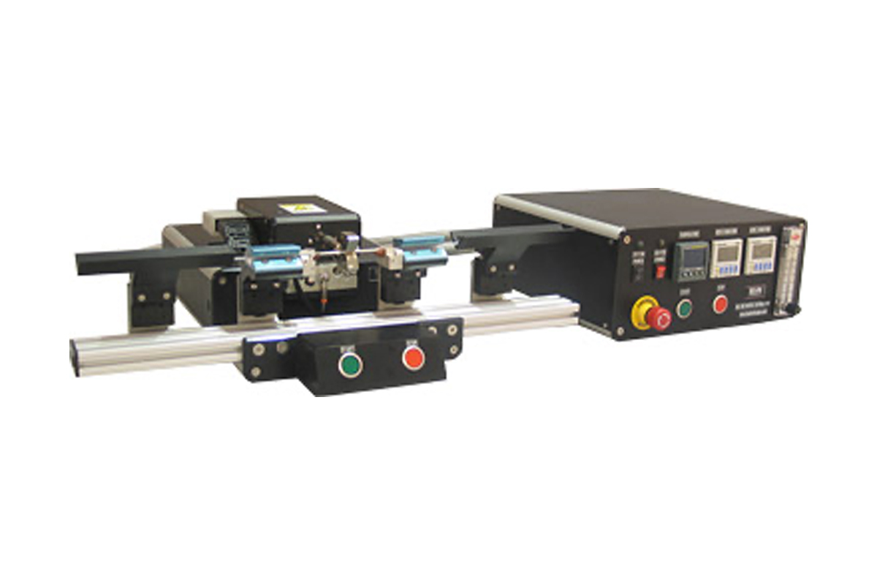

Table of Contents

**List of Tables** 3

Welcome 4

Purpose 4

Overview 4

Contents 4

Installation 4

Safety 5

User Alerts 5

Set Up and Configuration 6

Controls and Functions 7

Parameter Settings 8

System Operation 9

**Tuning Temperature Controllers (Eurotherm Model 3216e)** 9

**Run Process** 9

Maintenance 9

**Exchanging Thermal Nozzle** 10

**Exchanging Grip Heads** 10

**Aligning Tooling** 10

Operational Requirements 12

**System Specifications** 12

**Calibration** 12

**Critical Spare Parts** 14

**Diagnostics (Troubleshooting)** 14

**Facility Requirements** 14

Warranty 15

# **List of Tables**

**Table 1: Controls and Functions** 7

**Table 2: System Specifications** 12

**Table 3: Critical Spare Parts with Descriptions** 14

**Table 4: Diagnostics and Troubleshooting** 14

# Welcome

Machine Solutions, Inc. (MSI) would like to take this opportunity to thank you for purchasing your new MA-280, Process Automation Bonder. At MSI, we are dedicated to bringing innovative process development solutions to both medical device and nonmedical organizations. MSI looks forward to helping your organization provide life-improving devices to your customers, today and tomorrow.

# Purpose

The purpose of this document (*Original Instructions)* is to describe the electrical and software design of the control system for the Process Automation Bonder, MA-280 model. This document also includes operator instructions.

# Overview

The Beahm Designs Inc. Model MA-280 is a system for the purpose of thermal bonding or welding thermoplastic components to other materials by means of applying heated air to the materials through a precision nozzle. The system features integrated timed cooling and dual product grips for hands free operation.

# Contents

Included with the system are the following contents:

* Automation Base and Control Unit
* IEC Power Cord
* Compressed Air Supply Hose Assembly

# Installation

1. Place the system on a level, sturdy surface at an ergonomically viable height for the user.
2. Connect the electrical and pneumatic umbilicals to the die base unit.
3. Connect the power cord to the main control unit.
4. Connect the air supply hose assembly to the system and then to a clean, dry, and filtered compressed air source.

# Safety

* Use of eye protection when working with compressed gases and heated materials is advised.
* The maximum observed Sound Pressure Level is below 70 dB(A).
* Die jaws will become hot during operation and, depending on temperature set-point, can cause severe skin burns if contact occurs.

**CAUTION: High voltage. Remove power and use safety precautions when servicing.**

**CAUTION: Hot surface. Contact may cause burn. Allow to cool before servicing.**

**CAUTION: Pinch point. Keep hands and body parts clear while in operation.**

# User Alerts

Do not use the equipment other than as prescribed. Examples: Do not attempt to sit on or climb on the equipment. Do not place heavy objects or containers of liquid on the machine. Do not insert any foreign objects into the machine and do not attempt to bypass any guards or otherwise operate the machine in any manner other than that in which it is explicitly intended.

**NOTE: The equipment is not for use with materials that can decompose or ignite below the maximum operating temperature of the machine. Hazards are materials that outgas hazardous substances and or ignite. (260°C/500°F).**

**NOTE: This equipment is not for use in an ATEX environment.**

# Set Up and Configuration

Proper sizing of the thermal nozzle and alignment of the tooling are crucial to optimizing process results and repeatability. The following guidelines are the recommended methods. However, all applications vary, and several iterations of tooling process development may be required and may not follow all the recommended guidelines.

1. **Thermal Nozzle Diameter** - The nozzle diameter should be .187”-.25” larger than the material to be processed.
2. **Thermal Nozzle Width** - The width of the thermal nozzle should be sized equal or slightly greater (approximately 1.0mm) than the length of the overlap of the materials.
3. **Grip/Positioning Nests** - This is themost forgiving of the tooling. The included, standard vee configurations are more than adequate for most applications. More important than the guide design and dimensions is alignment with the die heads. Refer to the maintenance section for the alignment procedure.

Customized nests and tooling are available. Contact Machine Solutions sales to review the application and request a quote.

1. **System Options -** Many optional accessories are available to enhance the functionality of the system and improve process yield. Contact Machine Solutions sales department or visit our web site [www.machinesolutions.com](http://www.machinesolutions.com/) for more information on available accessories and to request a quote.

Examples of available accessories are:

-Vision systems with or without on-screen crosshair line generators.

-Laser line generators.

-Extended product support trays/guides.

-Product grip nests/alignment tooling.

Installation instructions are included with each specific accessory.

# Controls and Functions

Located on the front and rear panels are the following controls and/or displays and their function.

|  |  |
| --- | --- |
| **Description** | **Function** |
| **Reset switch** | Reengages system power. |
| **Power Off** | Disengages system power |
| **Start switch** | Initiates process sequence. |
| **Stop** | Interrupts the process sequence and resets timer. |
| **Temperature controller** | Controls the temperature of the thermal nozzle. |
| **Heat Duration Timer** | Controls the duration that the die heads are closed and/or in contact with the product. |
| **Cool Duration Timer** | Controls the duration the cooling air flows |
| **Heater Air Flow Meter** | Controls heater air flow rate. |
| **Cooling Air Flow Meter** | Controls the cooling air flow rate. |

**Table 1: Controls and Functions**

Cooling Air Flow Meter

Grip Pressure Gauge

Cool Duration Timer

Heat Duration Timer

Temperature Controller

Pressure Adjust Knob

Heater Air Flow Meter

Stop

Start

E-Stop

Reset Button

**Figure 1: MA-280 Process Automation Bonder Front Panel**

Air Connection valve

Power Entry module

TC Connector

**Figure 2: MA-280 Process Automation Bonder Back Panel**

# Parameter Settings

1. **Temperature** - Depress and hold the **up** or **down arrow** key of the temperature controller to scroll to the desired temperature. After two seconds the new value will be accepted, and the temperature will ramp to the new set point.
2. **Heat Duration** - Depress the upper or lower half of the corresponding time digit to change its value. Depress the **stop/reset** switch to reset the timer to the new value.
3. **Cool duration** - Depress the upper or lower half of the corresponding time digit to change its value. Depress the **stop/reset** switch to reset the timer to the new value.
4. **Heater Air Flow** - Rotate the flow meter knob clockwise or counterclockwise until the meter displays the desired value.

# System Operation

## Tuning Temperature Controllers (Eurotherm Model 3216e)

**Note: Auto-tuning can be performed at any temperature set point within the system operating specifications. This machine needs to be auto tuned at the temperature and air flow that your product will be processed at.**

1. Ensure heater power is off and heater is at room temperature.
2. Enter the process temperature setpoint using the or buttons.
3. Press until ***R.TUN*** is displayed.
4. Press or to select **On**.
5. Press **to begin the auto tune process.**
6. **Turn heater power ON.**

Please note, after following this sequence, auto tune can take several minutes to start and complete.

A full description of auto-tune and the purpose of other parameters in the level 2 list is given in the 3200 Manual located online at <https://www.eurotherm.com/download/3200-engineering-manual-ha028651-iss-15/>

## Switching from Fahrenheit to Celsius

**If the system is equipped with the Eurotherm model 3216, use the following instructions:**

1. Press and hold the page button (left most) until Lev 1 appears.
2. Press up arrow to Lev 2 appears.
3. Press scroll to code 0.
4. Press up arrow key for code 2.
5. Press scroll button until units appear.
6. Press up or down arrow key to select C.

## Run Process

1. Position the components to be processed between the grip heads and in the tooling nests.
2. Depress the start button or foot switch to initiate the process sequence.
3. Upon completion of the cooling cycle, remove the completed subassembly.

**NOTE: If process needs to be interrupted, press, and hold the red stop button.**

**NOTE: If the timer needs to be reset, quickly press, and release the red stop button.**

# Maintenance

1. Use 99% isopropyl alcohol to wipe down the outside of the machine. Do not attempt to clean the inside of the machine. The machine should not be washed down.
2. Cleaning should be with a soft dry cloth only.

**NOTE: Ensure the machine is unplugged for any servicing or maintenance work.**

**NOTE: Perform these steps ONLY when the die heads are at room temperature.**

## Exchanging Thermal Nozzle

1. Loosen the set screw at the top of the nozzle adapter.
2. Slide the nozzle while simultaneously removing the thermocouple connector.
3. Install the replacement nozzle/thermocouple connector.
4. Tighten the set screw in the adapter.

## Exchanging Grip Heads

1. Remove the fasteners in each grip head.
2. Replace the grip head with the alternate.
3. Re‐install the mounting fasteners.

## Aligning Tooling

**NOTE**: **Alignment should be performed on a prepared product subassembly.**

**NOTE: Alignment MUST be performed with system power off and heads at ambient temperature.**

**NOTE: Alignment MUST be performed on a flat and reasonably level surface.**

1. Remove the front shield base plate.
2. Prepare an assembly.
3. Position the assembly within the Vee guide/grip assemblies.
4. Set the heater temperature to ≤ 100°.
5. Set the heat duration to 9999 seconds.
6. Adjust the Z-axis of each grip assembly as required such that the subassembly is centered within the thermal nozzle diameter.
   1. Remove one side plate at a time. Loosen the two screws underneath the grip assembly. Adjust the Z-axis using the screw in front of the grip assembly (shown in green).

Re-attach the side plate then adjust the grip assembly. (Refer to pictures on the following pages.)

1. Adjust the Y-axis of each grip assembly until the product is centered with the nozzle diameter.
   1. Turn green set screws to adjust the Y-axis (Y-axis top view shown below).

# Operational Requirements

## System Specifications

|  |  |  |  |
| --- | --- | --- | --- |
| **Description** | **Range** | **Resolution** | **Accuracy** |
| Temperature | 250-750° F | 1.0 deg. | +/‐.25% F.S. |
| Heat Duration | 1-9999 seconds | 1.0 sec. | +/‐0.1 sec. |
| Cool Duration | 1-9999 seconds | 1.0 sec. | +/‐0.1 sec. |
| Heater Air Flow | 25-50 SCFH | 5.0 SCFH | +/- 6% F.S |
| Cooling Air Flow | 3-30 SCFH | 5.0 SCFH | +/- 5% F.S |

**Table 2: System Specifications**

## Calibration

**IMPORTANT NOTES:**

**It is recommended that calibration be performed by a certified service, preferably with the system in the location of use. Calibration procedures are the domain of these service providers.**

**Calibration refers to the process of verifying that each of the systems’ instruments that control a process parameter is within manufacturers’ specification.**

**Calibration DOES NOT refer to the process of measuring the temperature at the center of the tooling and “matching” the value to the temperature controller set point.**

**The measured value at the tooling may not match the temperature controller set point and the delta is dependent on nozzle style and dimension as well as method of measurement.**

1. Calibrate the temperature controller annually.
2. Calibrate the timers annually.
3. Calibrate the pressure gauge annually.
4. Verify the flow meter annually.

## Critical Spare Parts

(Contact Beahm Designs for current Price and delivery)

|  |  |
| --- | --- |
| **Part Number** | **Description** |
| 1330445-003 | 4-WAY VALVE 24 VDC |
| 1348043-001 | GRADE A GAUGE |
| 1343250-001 | 2-way pneumatic valve |
| 1131433-001 | Solid state relay |
| 1143303-001 | Timer |
| 1145619-001 | 4 PDT Relay |
| 119106-001 | 1 PDT Relay |
| 1150440-001 | Temperature Controller |
| 110254-001 | Heating element |

**Table 3: Critical Spare Parts with Descriptions**

## Diagnostics (Troubleshooting)

|  |  |  |
| --- | --- | --- |
| **Issue** | **Possible Causes** | **Solution** |
| Temperature not stable | Thermal Nozzle replaced.  Thermocouple loose. | Auto-tune.  Re-install thermocouple(s). |
| S.br | Sensor Break.  Thermocouple not installed. | Determine break and repair.  Install thermocouple. |
| .Err code in display | Temperature controller  software failure. | Replace temperature controller. |
| System will not power on. | Emergency stop switch depressed.  IEC power cord not fully connected. | Rotate switch knob to engage.  Verify installation. |

**Table 4: Diagnostics and Troubleshooting**

## Facility Requirements

* Voltage: 120‐240 VAC 50/60 Hz.
* Wattage: 500 max.
* Compressed Air: 60-125 psi, 0.5 CFM, filtered 50 micron or greater, oil and water free.

# Warranty

Machine Solutions products are backed by a 1-year warranty on parts and labor. Warranty is void for any Product returned if MSI determines that:

1. The asserted defect is not present.
2. The asserted defect is attributable to misuse, improper installation, alteration (including removing or obliterating labels), opening or removing external covers, (unless authorized to do so by Beahm Designs), and accident or mishandling while in the possession of someone other than Beahm Designs, Inc.
3. The Product was not sold to you as new.

****Return Material Authorization (RMA)****

Product may be returned to Machine Solutions without first contacting MSI Aftermarket for a Return Material Authorization ("RMA") number. If it is determined that the Product may be defective, you will be given an RMA number and instructions for Product return. End Users are required to include a copy of the RMA receipt inside the return box to receive replacement products under warranty. An unauthorized return, i.e., one for which an RMA number has not been issued, will be returned to you at your expense. To request an RMA, please call 928-556-3109 or email

[info@machinesolutions.com.](mailto:info@machinesolutions.com.)

For additional information on Beahm Designs, Balloon Bonder, please visit <http://machinesolutions.com/our-products/>.